SENIOR FIVE TERM 1

TOPIC 1/6: measurement and dimensions of physical quantities
Competency: The learner uses a variety of instruments to accurately measure physical quantities and applies the concept of dimensions to establish the relation between these quantities.

Measurements
Measurement involves assigning numerical values to physical properties like length, mass, time, and temperature. Measurements of different quantities are expressed in different unit. The International System of Units (SI) is the globally accepted standard for measuring physical quantities. It is a modern form of the metric system and is used in science, industry, and everyday commerce worldwide

Importance of measurements in our daily life
Measurements play a crucial role in everyday life, helping us make accurate decisions and perform tasks efficiently. They are essential in the following ways.
- Health & Medicine: Doctors measure body temperature, blood pressure, and medication doses to ensure proper treatment.
- Cooking & Baking: Precise measurements of ingredients help achieve the right taste and texture in food.
- Tailoring: Precise measurements are vital for trendy outfits.

- Time Management: Clocks and schedules help us plan our day effectively.
- Construction & Engineering: Builders and engineers rely on measurements for designing safe and functional structures.
- Sports & Fitness: Athletes track speed, distance, and weight to improve performance.
- Shopping & Finance: Measuring weight, volume, and currency ensures fair transactions.
- Environmental Monitoring: Scientists measure air quality, temperature, and pollution levels to protect ecosystems.

Measuring length
The standard unit of length is metres (m).
Other metric system units include
Millmeter (mm) = 0.001m or 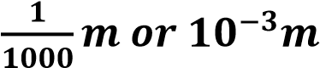
Centimetres (cm) = 0.01m or 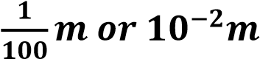
Kilometer (km) = 1000m

Common measuring instruments for length

(a) Meter rule
How to read a metre rule
- Metre rule reads distances in centimetres to 1 dip e.g., 0.0cm, 10.1 cm. 94.5cm
- A metre rule is suitable for distances from 0. 0cm to 100cm such as dimensions of books, small boxes, tables, chairs and so on.
- To accurately take a reading, the eye must be right over the mark on the scale as show below
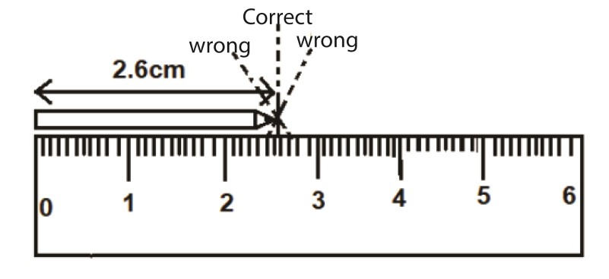
- If required to measure distances in metres; first measure the distances in cm and then change the readings to metres by dividing by 100. For instance,
10.1 cm = 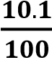 = 0.101m
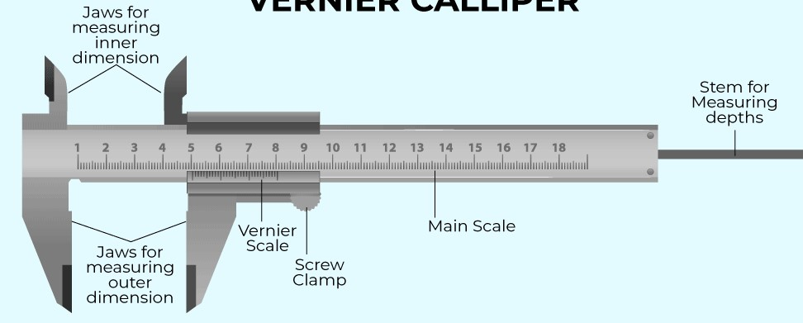
(
b
)

Vernier calipers

How to read a Vernier Calipers
Reading a Vernier caliper involves understanding both the main scale and the Vernier scale to obtain precise measurements. Here’s a simple step-by-step guide:
- Read the Main Scale – Identify the nearest whole number or decimal value on the main scale where the zero of the Vernier scale aligns.
- Read the Vernier Scale – Find the first mark on the Vernier scale that perfectly aligns with a mark on the main scale.
- Add the Values – Combine the main scale reading with the Vernier scale reading to get the final measurement.
- Vernier calipers in physics laboratory often measure from 0.00cm to 15cm or 20.00cm

Example 1

Reading a Vernier caliper
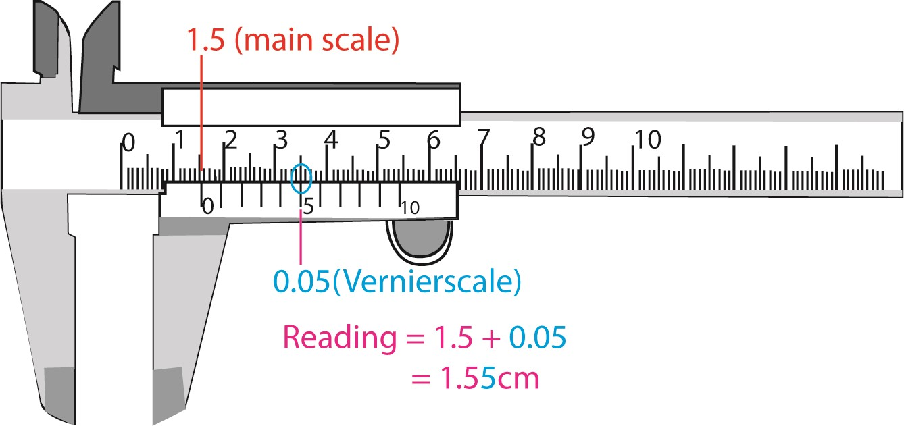
(
i
)

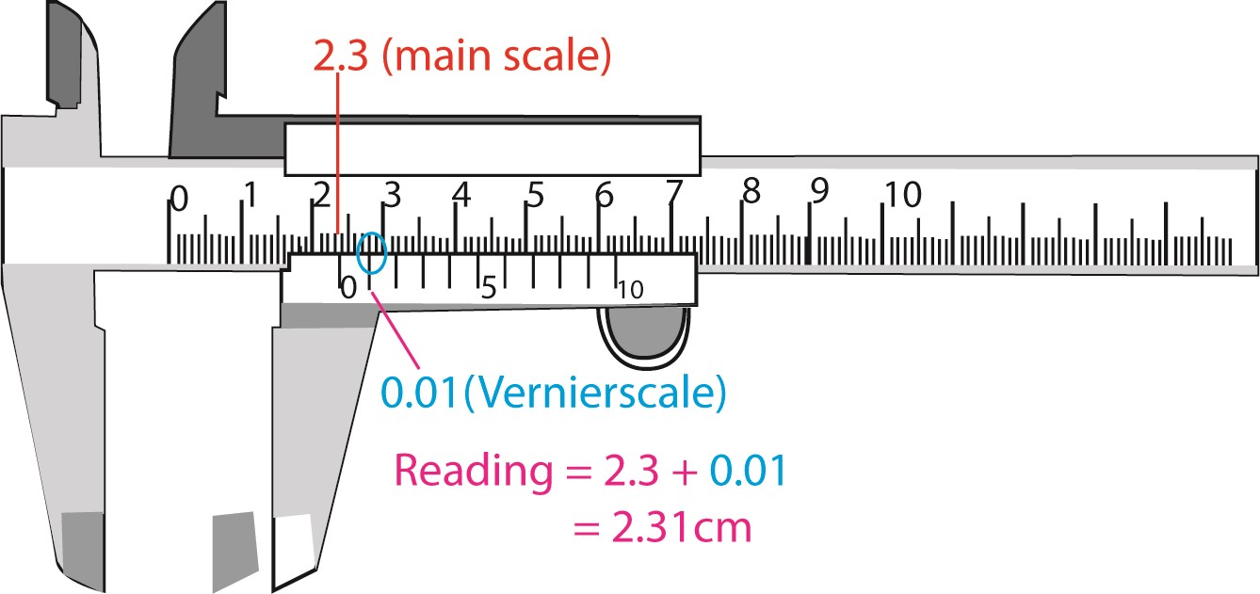
(
ii
)

Trial 1: Find the readings on the following Vernier calipers
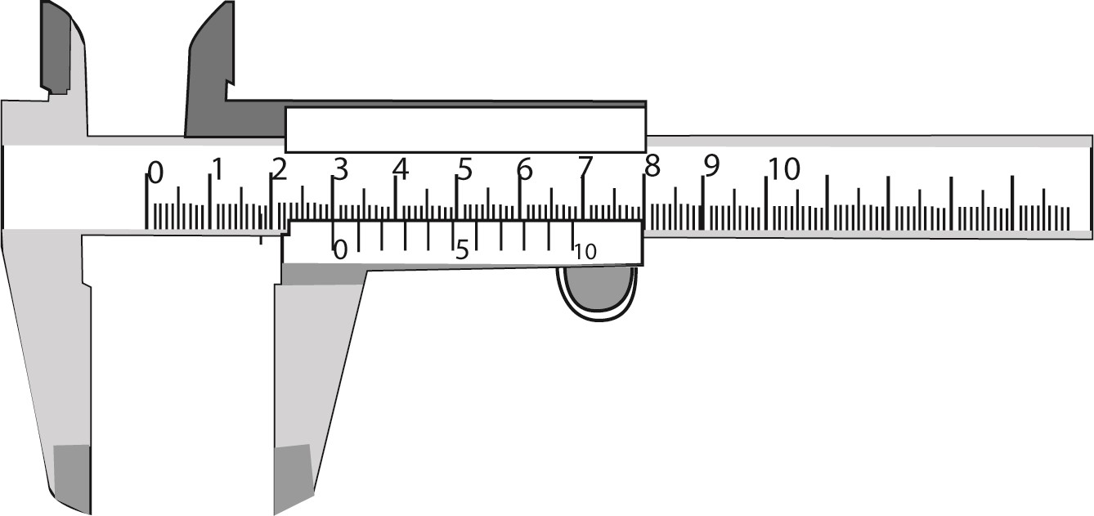
(
i
)

[3.00
cm
]

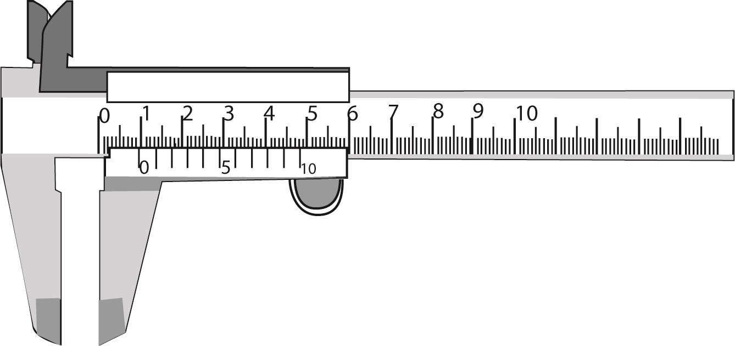
(
ii
)

[0.94
cm
]

(c) Micrometer screw gauge
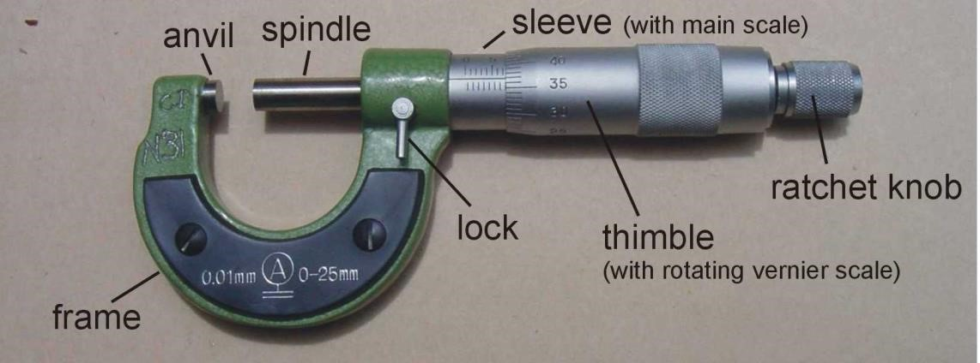
How to read a micrometer screw gauge

(a) Key Parts
- Sleeve/Barrel: Contains the main scale (usually in millimeters).
- Thimble: Contains the rotating scale.
- Ratchet Stop: Helps apply the correct force for measurement.

(b) Read the Main Scale (Sleeve)
- Using the adjust the anvil to set the micrometer screw gauge to 0.00mm before making any readings
- Hold the object between the anvil and spindle and rotate the thimble until the object is secured and a clicking sound is heard.
- Read the visible marking on the sleeve just before the rim of thimble. Each small division on the upper side of the horizontal middle line represents 1 mm while lower division subdivides the upper division in the middle.

(c) Read the Thimble Scale
- Read the thimble until mark that coincides with the horizontal line of the main scale.
- Each division on the thimble represents 0.01 mm.
- Micrometer screw gauge measures distances from 0.01mm to 25mm

(d) Find the Total Measurement
- Add the sleeve reading to the thimble reading.
- Example: If the sleeve shows 5.0 mm and the thimble shows 0.35 mm, the total measurement is: 5.0 mm + 0.35 mm = 5.35 mm Example 2
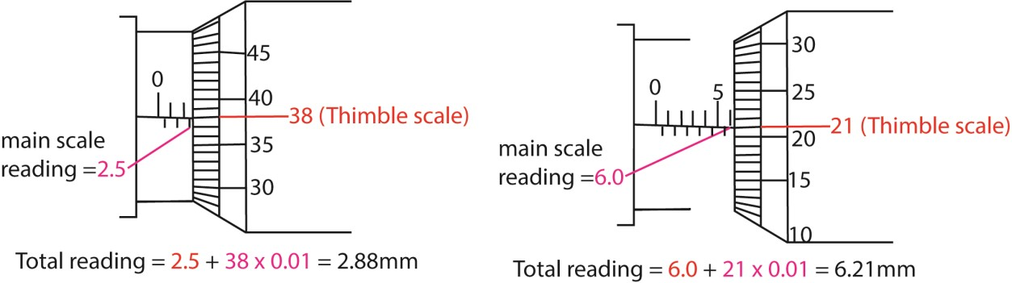
Trial 2:
Find the readings on the following micrometer screw gauges
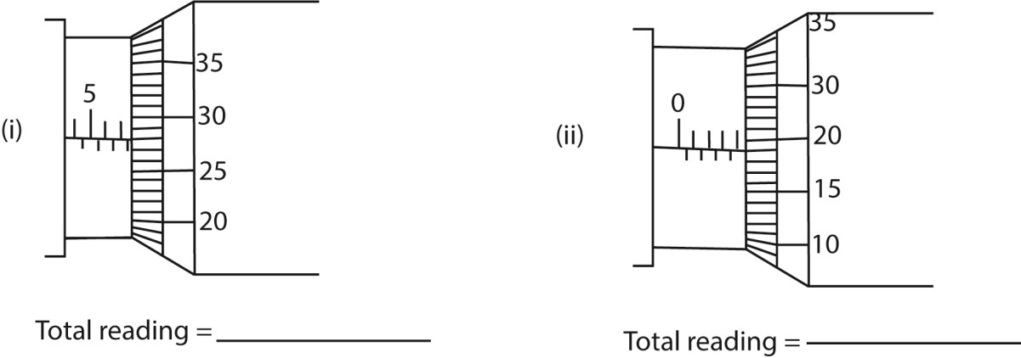

7.5 +

28

x 0.01= 7.78mm

4.0 +
19 x 0.01= 4.19mm

Trail 3:
- Convert the following to metres
  - 10mm
  - 5cm
  - 4km
  - 2000cm
- Convert the following as instructed
    - 2m to cm
    - 30cm to mm
    - 0.5km to mm
    - 500mm to km
    - 20cm to m
- Name the instrument you would use to accurately measure the following giving reasons for your answer
  - Thickness of pin
  - Length and width of classroom
  - Diameter of beaker
  - Thickness of paper (e) Length of table
(f) Thickness of paper

Area
This is the amount of space an object occupies.
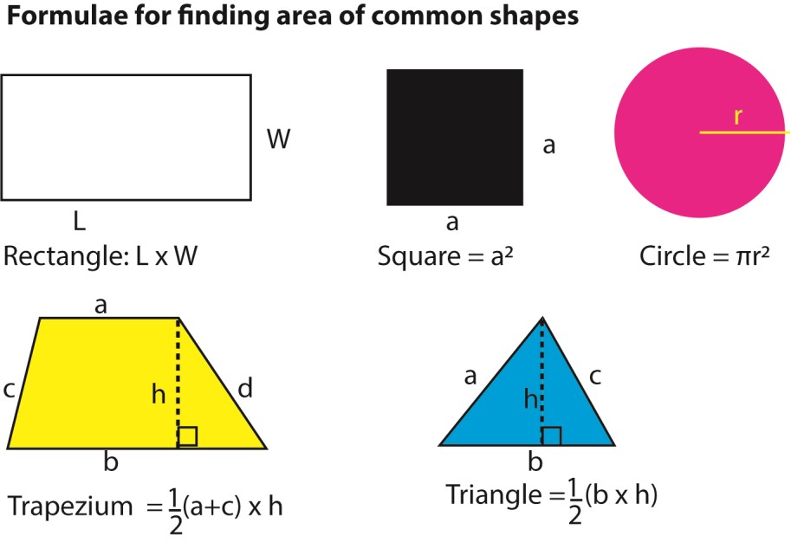
Trial 4: Find the area of each of the following:
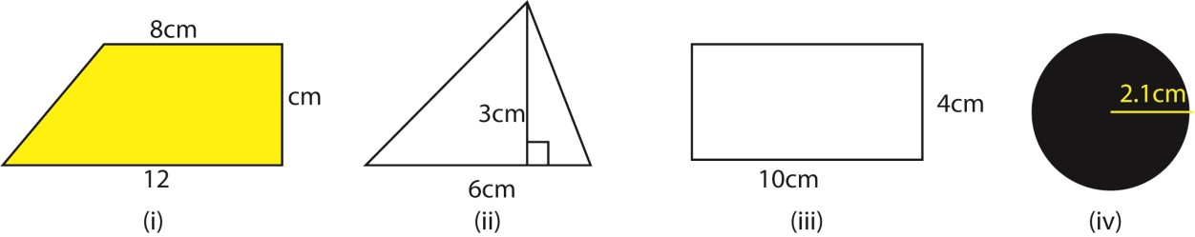

Converting units of area
To convert the units of area one may change the units of the dimensions to the preferred units and then multiply the results; or obtain the area and then convert the units directly.

Example 3
The dimensions of a maize field are given in diagram below
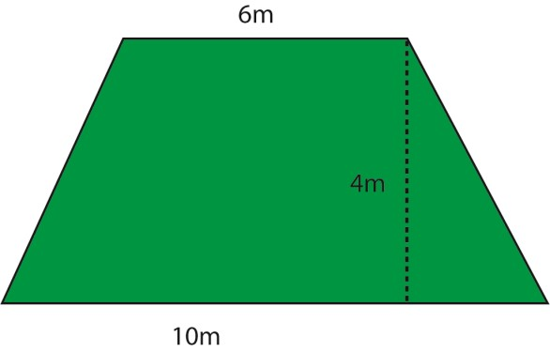
Find the area of the field in
(i) cm²
Method I1m = 100cm
6m = 600cm; 10m = 1000cm and 4m = 400m
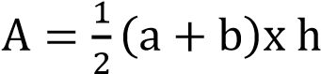
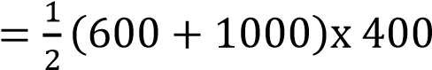
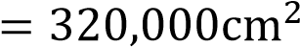

Method II
Area in metres = 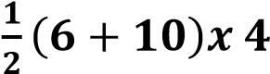 = 32m²
But 1m² = 100cm x 100cm = 10,000cm²
32m² = (32 x 10,000)cm²
= 320,000cm²
(ii) km²
Method I 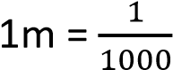cm
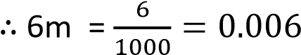km; 10m = 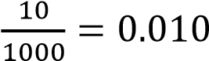km and 4m = 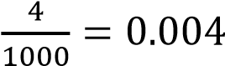km
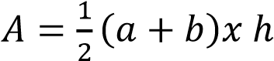
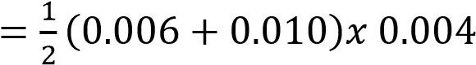
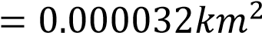
Method II
Area in metres = 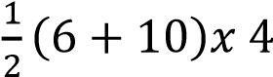 = 32m²
But 1m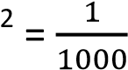 km x 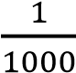 km = 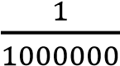 km²
32m² = (32 x 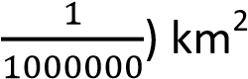
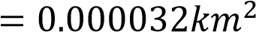
Trial 4:
- Calculate following units as instructed
  - 30mm² to cm²
  - 100mm² to m²
  - 24m² to cm²
  - 32km² to m²
- A house requires tiles for a hall measuring 30m by 15 m. If a tile measures 20cm by 10cm, how many tiles are requires.

Cross-sectional Area
The cross-sectional area of an object refers to the surface area of its slice perpendicular to its length. It’s commonly used in engineering, physics, and construction.
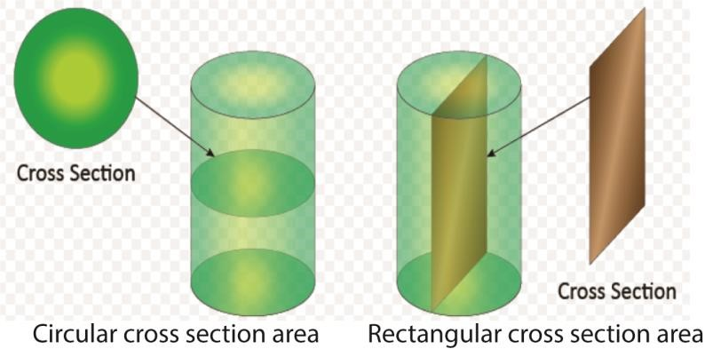

How to Calculate Cross-Sectional Area
The formula depends on the shape of the object:
- Circle: A= πr² (where r is the radius)
- Rectangle: A= width× length
- Square: A= side²

• Triangle: A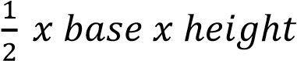=
• Hollow Pipe: A=π(R²−r²) (where R is the outer radius and r is the inner radius)
Trial 5:
Find the cross sectional areas of the following objects in m².
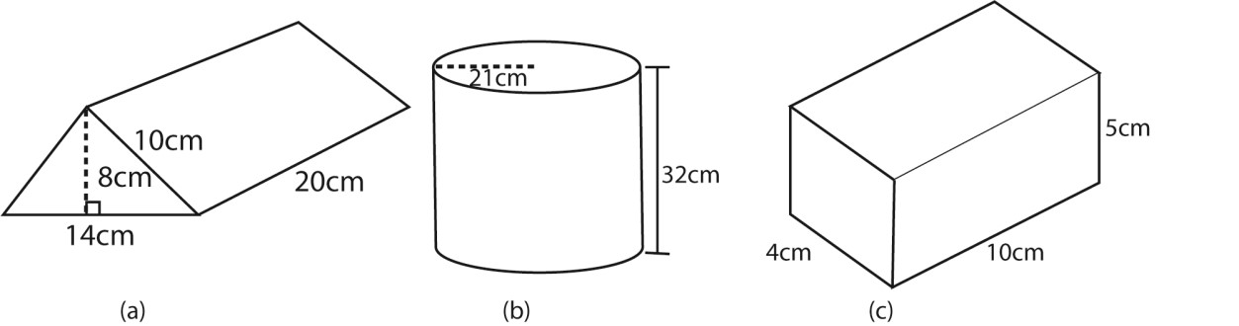

Total surface area
The total surface area of an object is the sum of the areas of all its faces or surfaces. The formula depends on the shape:
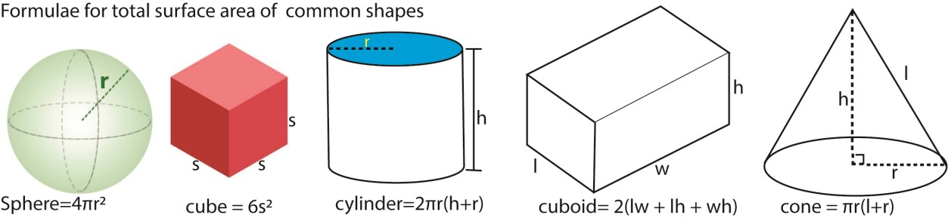
Trial 6:
Find the total surface areas of the following objects in m².
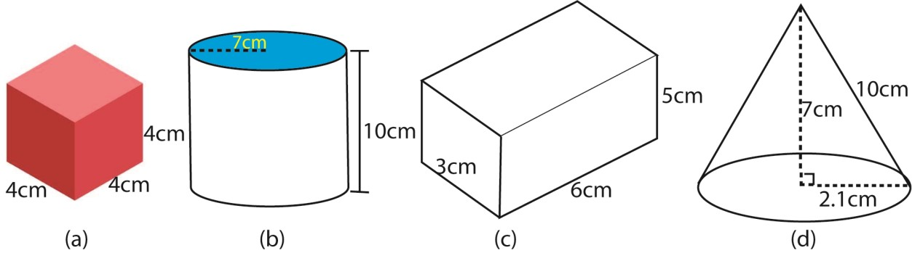

How to find area of an irregular object
(i) Place the object on a graph paper and trace out its boundary. (ii) Area of object =

Example 5
Find the area of the shape below
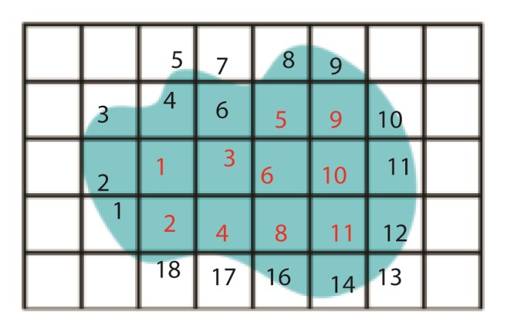
The area of the shape = 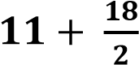 = 20 squares
If the area of one square is 0.25cm²
The area of the shape = 20 x 0.25cm² = 5cm²

Trial 7: Estimate the area for the following shapes below.
[the area of each square is 4cm²]
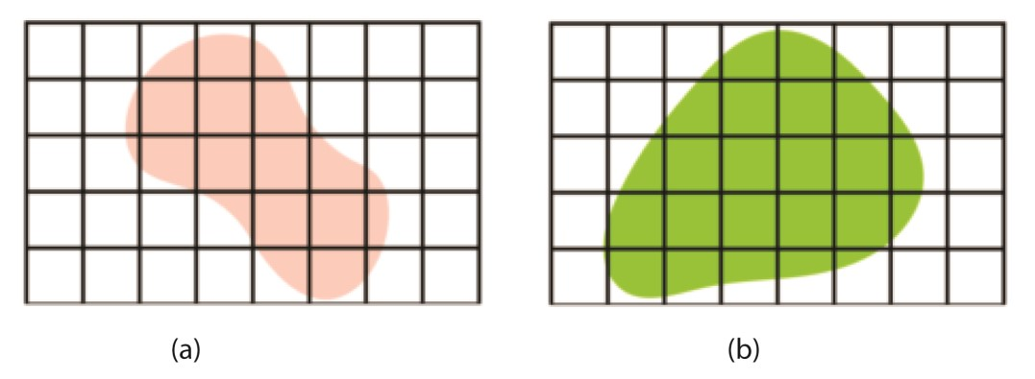

Volume
Volume is the amount of space that an object or substance occupies. It is measured in cubic units such as cubic centimeters (cm³), cubic meters (m³), or liters (L).
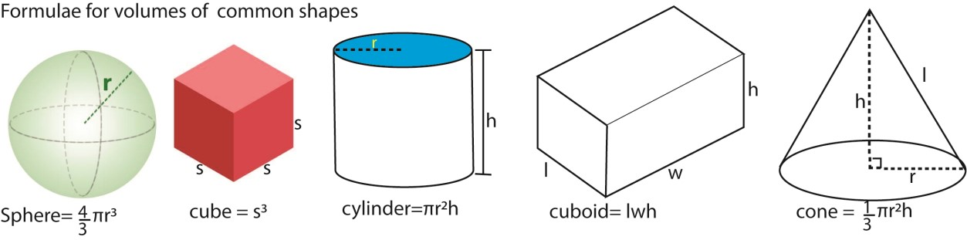
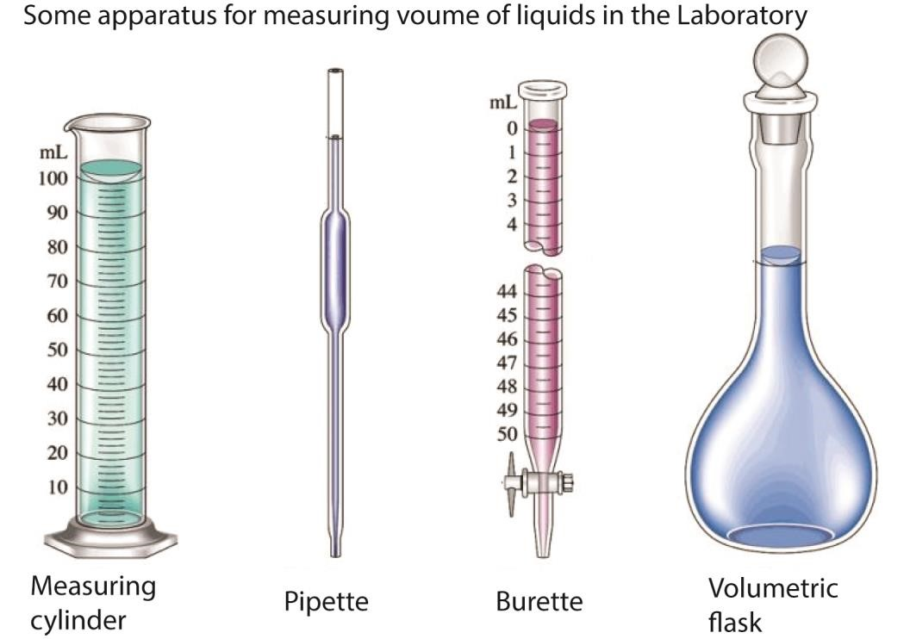
Measuring volume of irregular objects

(a) Water Displacement Method (For Solid Objects)

(i) Fill a graduated cylinder or container with water and record the initial volume. (ii) Submerge the irregular object completely in the water. (You may use a small string] (iii) Record the new water level.
- Volume = Final Volume - Initial Volume.
- 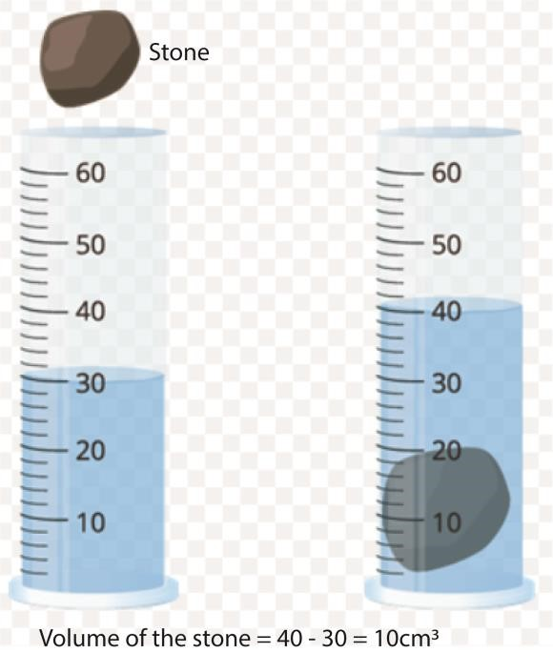

(b) Using overflow can
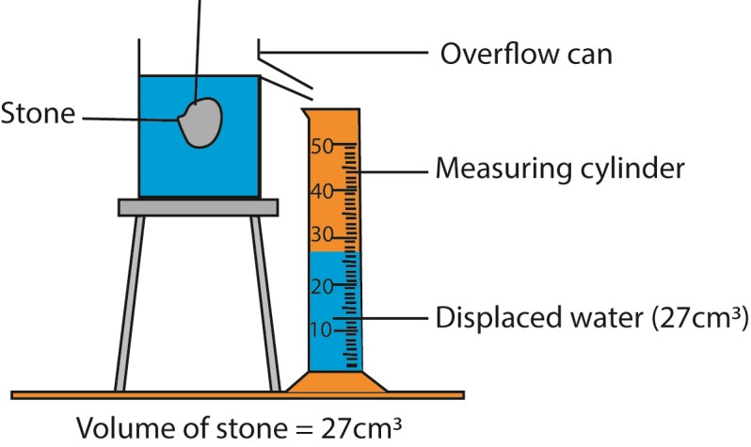

Step-by-Step Method
- Fill the Overflow Can: Fill the can with water until it just reaches the spout. Let any excess water drain out to ensure an accurate measurement.
- Submerge the Irregular Object: Gently place the object into the water, ensuring it is fully submerged. The displaced water will flow out of the spout.
- Collect the Overflow Water: Place a measuring cylinder or another container under the spout to collect the displaced water. Be precise—avoid splashes or evaporation.
- Measure the Volume Read the graduated scale on the measuring cylinder.
- The volume of the collected water is equal to the volume of the object.

Trial 8:
- Convert the following units as instructed
  - 200cm³ to m³
  - 20 liters to cm³
  - 4m3 to mm³
  - 6litres to m³
- Bbosa has 40,000cm³ of milk and sells a litre at UGX 500. How much will he earn from this milk.
- After dropping a stone into a measuring cylinder containing 50cm³ of water, the volume raised to 80cm³-mark. Find the volume of the stone.
- Explain how the volumes of an Irish potato can be measured.

Time
Time is a fundamental concept that helps us measure the duration between events. Scientifically, time is the ongoing progression of existence, SI unit of time is seconds (s) but it can be measured in minutes, hours, days and years.
Relationships among seconds, minutes, hours and days
1day = 24hours
1hour = 60 minutes
1minute = 60 seconds Measuring time
Measuring time involves using different tools and units depending on the level of precision needed. Instrument for measuring time
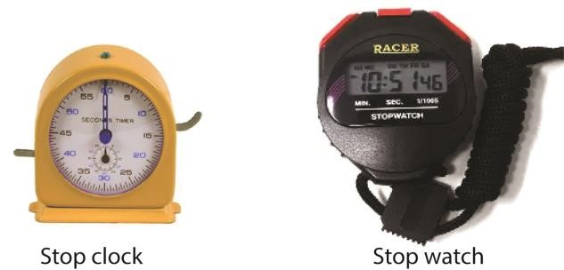
Trial 9:
- Convert the following
  - 2.5hour to seconds
  - 48hours to days
  - 1 day to minutes and then seconds
  - 72minutes to hours
- How many seconds are in
  - 4 milliseconds
  - 30 microseconds

Mass
Mass is the quantity of matter contained in the body. SI unit of mass is kilogram. Other units are grams, and tonnes.

Apparatus for measuring mass in school laboratories
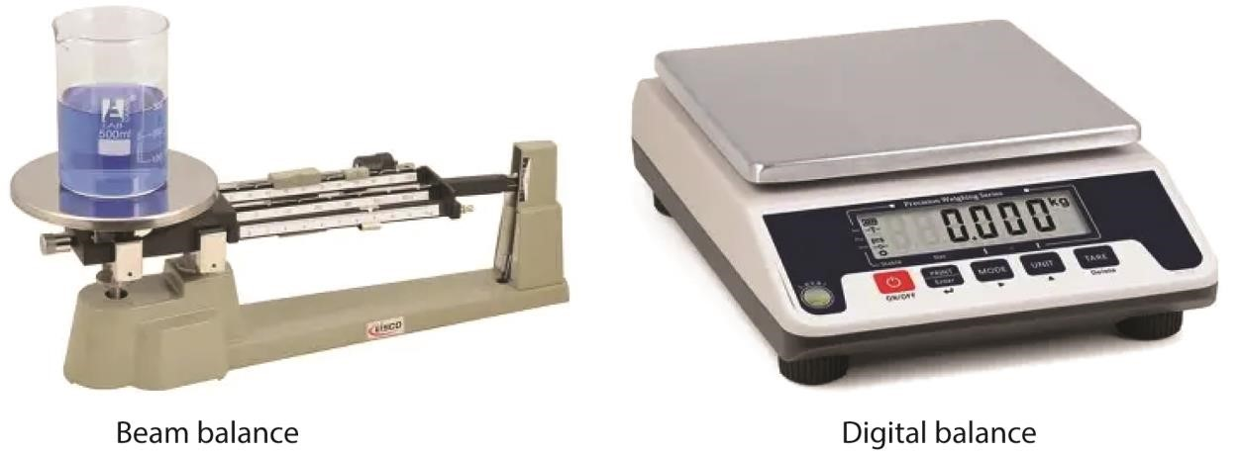

Trial 10:
Convert the following to kg
- 10mg
- 100g
- 2 tonnes

Scientific significant figures
Significant figures are the digits in a number that contribute to its precision. They are important in scientific measurements and calculations to ensure accuracy without unnecessary rounding or exaggeration.

Rules for Determining Significant Figures
- Nonzero digits are always significant (e.g., 123 has 3 significant figures).
- Leading zeros (zeros before the first nonzero digit) are not significant (e.g., 0.0032 has 2 significant figures).
- Zeros between nonzero digits are significant (e.g., 103 has 3 significant figures).
- Trailing zeros in a decimal number are significant (e.g., 2.400 has 4 significant figures).
- Trailing zeros in a whole number without a decimal point may or may not be significant, depending on notation (e.g., 1500 has 2 significant figures, but 1500. has 4).

Why Significant Figures Matter
- They help indicate measurement precision.
- They prevent overestimating accuracy in scientific calculations.
- They ensure consistency in rounding when performing mathematical operations. Rounding off numbers
Rounding off numbers helps simplify values while maintaining reasonable accuracy. The rounding method depends on the place value you’re focusing on. Here’s how it works:

General Rounding Rules
- Identify the place value to round to (e.g., nearest ten, hundred, decimal place).
- Check the next digit:
  - If it’s 5 or more, increase the rounding digit by 1.
  - If it’s 4 or less, keep the rounding digit the same.
- Replace remaining digits with zeros (for whole numbers) or remove them (for decimals).

Example 6
- Rounding 376 to the nearest ten → 380 (since 6 is 5 or more, increase the 7 to 8).
- Rounding 2.347 to the nearest hundredth → 2.35 (since 7 is 5 or more, increase the 4 to
5).

Multiplication of numbers
- When multiplying or dividing numbers with differing significant figures, the resultant takes the lower number of significant figures used in obtaining the result
- For addition or subtraction of numbers, the result takes the lower number of decimal places.

Example 7
- Find the difference between 1.456 and 0.9
1.456 – 0.9 = 0.556
= 0.6 [ 0.9 has least number of d.p (1d.p)]
- Divide 3.42 by 1.645
3.42 1.645 = 2.079
= 2.08[ 3.42 has the least number of significant figures (3)] Trial 11:
- Write the following numbers to 3 s.f.
  - 304678
  - 0.62547
  - 4.267 x 10⁻³
  - 9.4593
  - 5.4754 x 10⁵
- Perform the following arithmetic
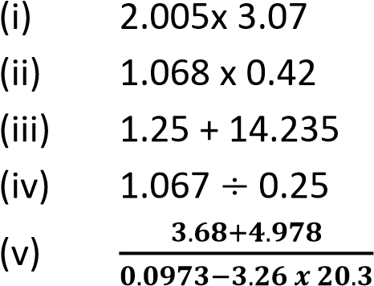
- Round of the following to 2 significant figures
  - 9.4678
  - 0.63247
  - 4.467x 10⁻³
  - 5.4744 x10⁶

Scientific notation (exponential or standard form)
Standard form is a way of writing very large or very small numbers concisely using powers of ten. It is commonly used in mathematics and science.

How to Write a Number in Standard Form
The format is: a x 10^{n}
Where:
- a is a number between 1 and 9
- n is the power of 10 (positive for large numbers, negative for small numbers)

Example 8
- Large number:
  - 5,600,0005,600,000 → 5.6×10⁶ o The decimal point moves 6 places to the left.
- Small number:
  - 0.00042 → 4.2×10⁻⁴ o The decimal point moves 4 places to the right.
Trial 12: Write the following number in scientific notation
- 0.00009
- 4500000
- 0.049
- 527200 to 2 s.f.
Physical quantities
Physical quantities are divided into two groups

Fundamental quantities
These are physical quantities which cannot be expressed in form of other quantities using any mathematical equations.

They include
Quantity | S.I unit | Symbol of S.I unit
Mass | kilogram | kg
Time | second | s
Length | metres | m
Temperature | Kelvin | K
Current | Ampere | A

Dimensional/derived quantities
These are physical quantities which can be expressed in terms of fundamental quantities. For example velocity, work, volume, density

Dimensions of physical quantities
This is a way in which derived quantities can be expressed in form of fundamental quantities. i.e.
Mass- M
Length- L
Time –T
The square bracket, [ ] is used to show dimensions
For example
- [Area] = length x length or length x width L x L = L²
- Volume = length x width x height
= L x L x L = L³
- Density = 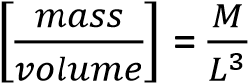 or ML⁻³

- Velocity = 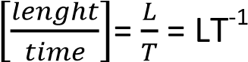

- Acceleration =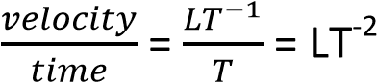

- Force = mass x acceleration
= M x LT⁻² = MLT⁻²

Application of dimensions
- To check the validity of equation (equations that are not dimensionally consistent are obviously wrong expression and should be discarded.
- To derive equations: for correct equation, the units of the left hand side must be similar to the units of the right hand side.
All right equations must be dimensionally consistent but not all dimensionally consistent equations are correct.

Examples 9
- The centripetal force F on a body of Mass M moving at constant speed V round a circular path of radius, r, is given by F = 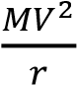.
Show that the equation is dimensionally consistent

Solution
LHS = F = Ma = M x LT⁻² = MLT⁻²
RHS = 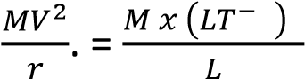= MLT⁻²
Since [LHS] =[RHS], the equation is dimensionally consistent.
- Show that the second equation of motion is dimensionally correct s = ut + ½ at² [LHS] = [s] = L
[RHS]= [u][t] + ½ [a][T]²
-1 -2 2
=LT x T + ½ LT xT
= L + ½ L =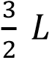
Since is a constant,
[LHS] =[RHS] showing that the equation is dimensionally consistent.

- The equation of a transverse wave of a rod of youngers modulus (E) and density, ρ, is given by v = . Show that it is dimensionally consistent.
√

Solution
[LHS] = [v] = LT⁻¹

[RHS]
E = 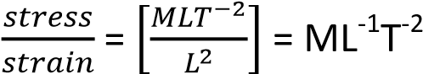
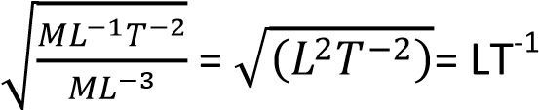
[LHS] =[RHS] , the equation is dimensionally consistent

Derivation of equation the method of dimensions can be used to derive equations.

Examples 10
The period (T) of a pendulum bob depends on the length of the pendulum (L), mass of the pendulum ball, M, and acceleration due to gravity, g. Determine an expression for the period of a simple pendulum T in terms of the quantities mentioned.

Solution
T 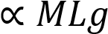
T = kM^{x}L^{y}g^{z} where k is dimensionless constant
[T] =[M]^{x}[L]^{y}[g]^{z}
[LHS] = [T] = T
[RHS] = M^{x}L^{y}[LT⁻²]^{z}

Equate powers of T, M,L

For T; -2z = 1
z = -½
For L; y + z =0 y – ½ = 0 y = ½
For M, x = 0

Therefore, T = K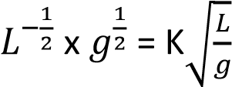
T = K
√

Trial 13
- The sphere of radius, α, moving through a liquid of density, ρ, and velocity, v, experiences a retarding force given by F = kα^{x}ρ^{y}v^{z}, where K is a non-dimensional constant. Use dimensions to find the values of x, y and z. [Ans, y =1, z =2 , y = 2]

- Use dimensional analysis to show how the process of velocity transverse process vibration of a stretched string depends on its length, L, mass, m, and the tension F of the string V = KL^{x}M^{y}F^{z}, where k is a non-dimensional constant. Find the values of x, y, z. [Ans, x = ½ , y = - ½ , z = 1/2]
- A cylindrical vessel of cross section area, A, contains air of volume, V, atmospheric pressure, ρ, trapped by frictionless down and released.
If the piston oscillates with simple harmonic motion, show that the frequency is given by f = 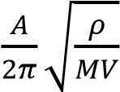 and show that the expression is correction.

- The equation for volume, V, of a liquid flowing through a pipe in time, t, under steady flow id given by, 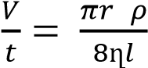
r = radius of the pipe
ρ = pressure difference between the two ends of the pipe l = length of the pipe
ղ =coefficient of viscosity of the liquid
If the dimensions of ղ are ML⁻¹T⁻¹ show that the above equation is dimensionally consistent.
- For streamline flow of a non-viscous incompressible fluid , the pressure, ρ, at a point is related to height, h. and velocity, V, by the equation
(p-a)=pg(h-b) + ½ p(v² –d)
Where a, b, and d are constant and p is the density of fluid and g is the acceleration due to gravity. Given that the equation is dimensionally consistent. Find the dimensions of a, b, and d.
Solution
Hint, we add or subtract quantities that have the same dimensions
{ans. [a] has the same units as pressure = ML⁻¹T⁻², [b] has the same dimension as h = L, [d] has the same dimensions as v² = L²T⁻²}

TOPIC 2/6: STATICS
Scalar and vector quantities
Scalar quantities are physical quantities which have only magnitude; for, example speed, mass, volume, energy, time and temperature.
Vector quantities are physical quantities which have both magnitude and direction, for, example acceleration, momentum, weight, velocity, magnetic flux, force, pressure and displacement.

Resultant and composition of vectors or resolving vectors
Consider a force R acting of particle O at an angle θ to the horizontal shown the figure below
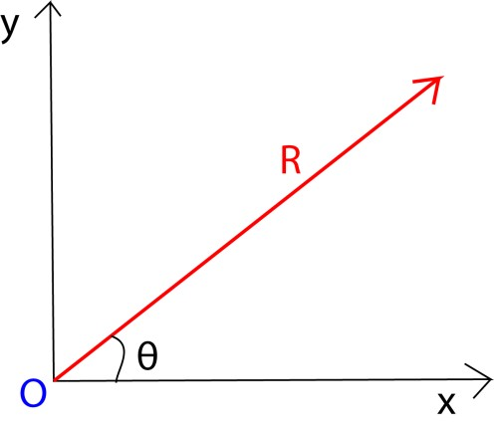

The horizontal component, x, of the vector = Rcos θ.
The vertical component, y, of the vector R = Rsin θ
It Implies that
R = and θ = tan⁻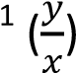
√

Example 1
Three forces of 3.5N, 4.0N and 2N, act on point O as shown in the figure below. Find the resultant force.

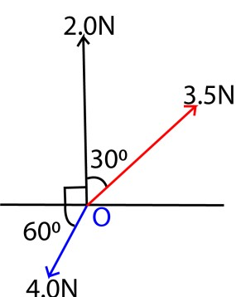

Solution

Magnitude of force

F_{x} = 2.0cos 90 + 3.5cos 60 – 4.0cos 60 = -0.25N
F_{y} = 2.0sin 90 + 3.5sin 30 – 4.0sin 60 = 1.567N

Resultant force , F =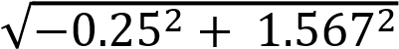 = 1.5868N
Direction of resultant force
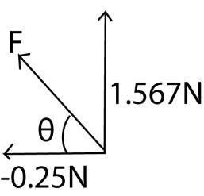
θ = tan⁻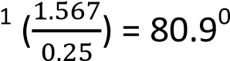
The resultant force is 1.5868N acting in the direction of 80.94⁰ to the horizontal.

Example 2
- Define vector and scalar quantities and give an example each.
- A body M of mass 6k is acted on by the forces of 5N, 20N, 25N and 30N as shown in the figure below. Find the acceleration of M
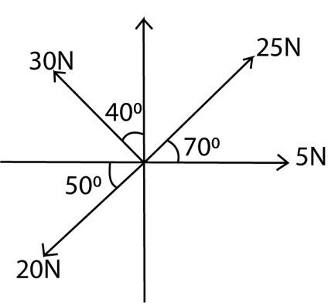

Solution
F_{x} = -30cos 50 + 25cos 70 + 5cos 0 – 20 cos50 = - 18.59N
F_{y} =30sin 50 + 25sin 70 + 5 sin 0 – 20sin50 = 31.15N
Resultant F = =36.28N
But F = ma
a = 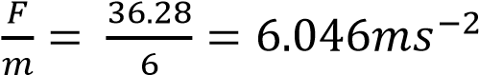

Example 3
Four forces of ai + (a-1)j, 3i + 2aj, 5i -6j, and –i -2j act on a particle. The resultant forces make an angle of 45⁰ with horizontal. Find a. Hence determine the magnitude of the resultant force.


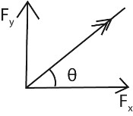
( ) ( ) ( ) ( )
𝑎
+

𝑎

9

tan

=

1

a + 7 = 3a
–

9
, a =
8

𝑅

(
𝑎

𝑎

)

(

𝑥

)

(

)

𝑅

√

=
21.21N

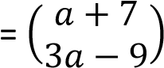

Exercise 1
- Find the resultant force in the figure below

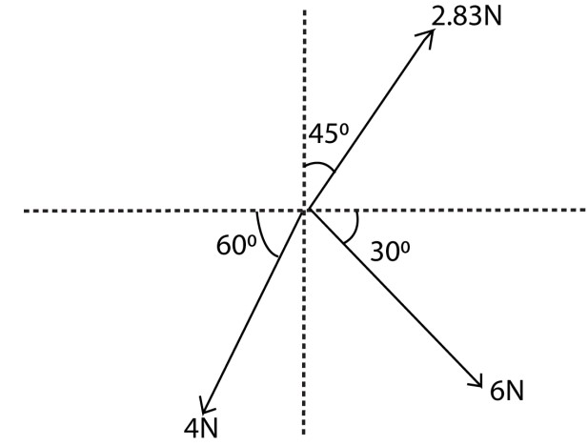
*Ans. 6.85N at angle θ =40.6⁰ to the horizontal]
- Three forces as shown below act on a body of 5.0kg. Find the acceleration of the body.
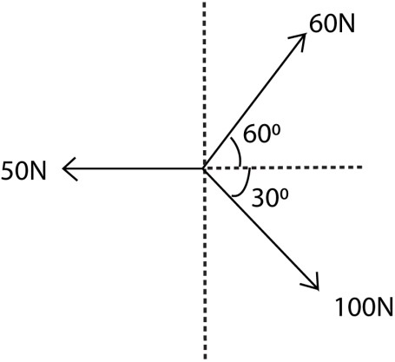

[Ans. 13.33ms⁻²]

- Find the resultant of each of the following forces (a) (6i + 2j)N, (-5i + j)N, (3i – 3j)N. [(4i)N]
  - (2i + 4j)N, (3i -5j), (6i +2j)N, (-7i – 7j)N. [(4i -6j)N]
  - (2i + 3j -7k)N, (2i + 5k)N, (3j + 4k)N. [(4i + 6j + 2k)N]
- The resultant of forces (5i + 7j), (ai + bj) and (bi –aj)N is a force (11i + 5j)N. Find a and b. [a = 4, b = 2]
- Find the magnitude and direction of the resultant of each of the following;
  - (-2i + 5j)N, (I + 2j)N. [ 7.07N at 98.1⁰]
  - (6i + 2j)N, (4i – 3j)N. [10.05N at 354.3⁰]
  - (3i + 2j), (-5i + j)N. [3.61N at 124⁰]
- A force of magnitude 50N acts on a body in the direction 24i + 7j. Find the force. [(48i + 14j)]
- Two forces F₁ and F₂ have magnitude αN and βN and act in the direction i -2j and 4i + 3j respectively. Given that the resultant of F₁ and F₂ is (48i + 14j). Find the magnitude of αN and βN. *α = 8N and β = 50N+
√

- If a = 3i + 4j, b = 4i + 20j and c = 5i – 19j; find the
  - resultant of a and b [(7i + 24j)]
  - resultant of a and c [(8i – 15j)]
  - vector is parallel to a and has magnitude of 15 unit [(9i + 12j)]
  - vector parallel to (a + b) and has a magnitude of 100 units [(28i + 96j]
- If a = 2i + 5j, b = -7i + 7j and 14i. Find the;
  - resultant of a and b [(-5i + 12j)]
  - resultant of a, b and c [(9i + 12j)]
  - |b| [7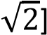
  - |a + b + c| [15units]
- If a = i -3j + 2k, b = 5i + 4j and c = 3i + j + 4k. Find the
  - resultant of a and b [(6i + j + 2k)]
  - resultant of a, b and c. [(9i + 2j + 6k)
  - |a| [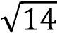]
  - |a + b + c|[11units]
- If a = 2i + 7j + 7k, b = 6i -3j + 2k and c = -4j -3k. find the
  - resultant a and b [8i +4j + 9k]
  - resultant a and c [2i + 3j + 4k

Moments

This is a product of the force multiplied by the perpendicular distance between its line of action and the axis of rotation.

The moment is also known at turning force or torque

Moment (Nm) = Force (N) x perpendicular distance (m)

A couple
Two forces that are equal in magnitude but opposite in direction (and acting along parallel lines), thus creating the turning effect of a torque or moment.

Principle of moments
For an object to be in equilibrium (with no movements about a turning point), the sum of anticlockwise moments is equal to the sum of clockwise moments.

Examples 4
A rod mass 8kg and 2m long is balance horizontally by two inextensible string tied to the end A and B of the rod when a mass of 20kg hangs 0.5m from A. Find the tensions in the strings at A and B. [ take g = 10ms⁻²]

Solution

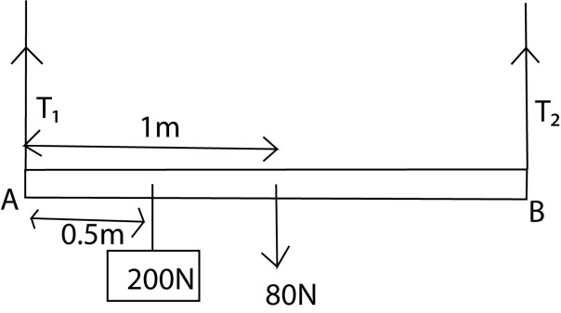

The sum of moments of initial at A = 0
0 = 0.5 x 200 + 1 x 80 – T₂ x 2
T₂ = 90
But T₁ + T₂ = 200 + 80
T₁ + 90 = 280
T₁ = 190N

Example 5
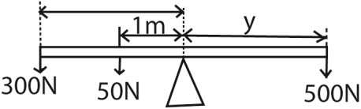
Given the diagram below. Find the value of y

500
x y = (300 x 3) + (50 x
1)

y =
9

𝑚

Example 6
A uniform beam of weight 50N and length 2m rests horizontally on two supports pivoted at each end. A load of weight 500N is placed 0.5m from one end. Find the reaction on each support.
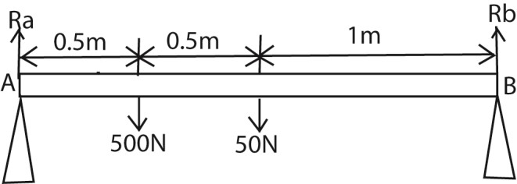

B:

Ra x 2 =50 x 1 + 500 x 1.5

2
Ra = 50
+ 750

Ra = 400N
Also Ra + Rb = 500N + 50 N
Rb = 550N – 400N = 150N

Example 7
A uniform beam of mass 50kg and length 4m rests horizontally on two supports pivoted at each end. A load of 20kg is placed 1m from one end. Find the reaction on each support
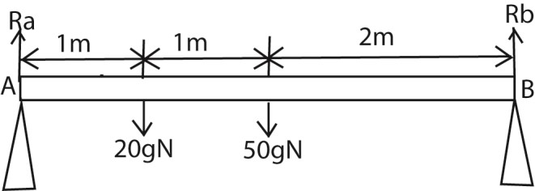

B:

Ra x 4 =50g x 2 + 20g x 3

4
Ra = 100g + 60g = 160 x
9.8

Ra = 392N
Also Ra + Rb = 500N + 50 N
Rb = 20gN + 50gN – 392N = 294N

Example 8
A non- uniform beam AB of length 4m has its weight 5N acting at a point 1.8m from end A. The beam rests horizontally on two supports pivoted at each end. Find the reaction on each support.
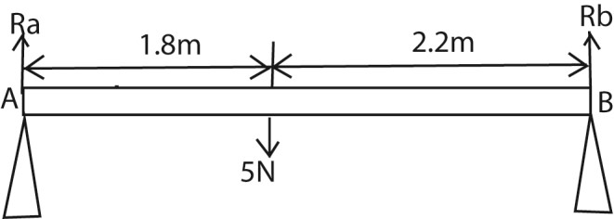

B:

Ra x 4 =
5
x

2.2 =11

Ra = 2.75N

Also Ra + Rb = 5N
Rb = 5N – 2.75N = 2.25N

Example 9
A force of 200N hangs on a uniform rod of weight 80N and held at equilibrium by a string as shown in the figure below.

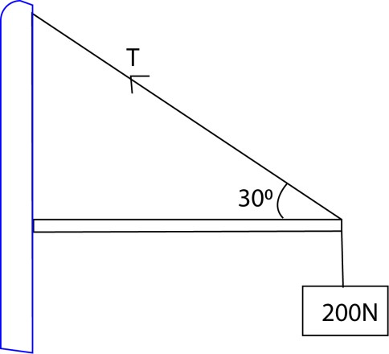
Calculate the tension in the string

Solution
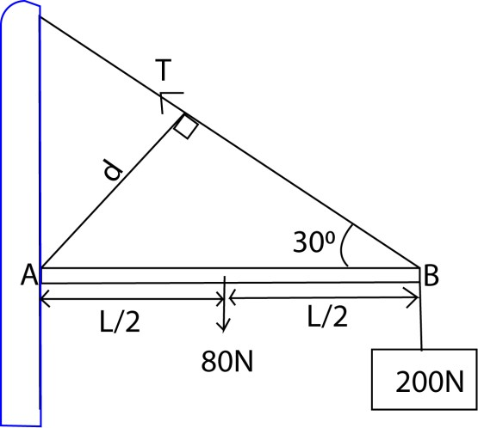

Taking moments at A
T x d = 80 x + 200L

But d = L sin 30

TLsin 30 = 240L
T = 480N

Example 10
A rod of length L weighing 200kg is held by a horizontal string BC in equilibrium with a mass of 50kg as shown in the diagram below. Find the tension T.
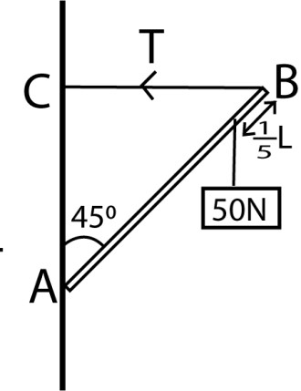

Solution
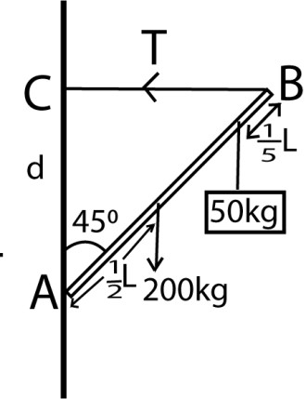

Moments about A
T x d = (200 x 9.8) x 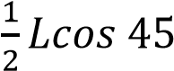 + (50 x 9.8) x 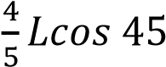
But d = Lcos 45

Therefore,
T x Lcos 45 = (200 x 9.8) x 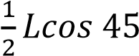 + (50 x 9.8)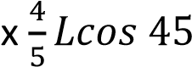

T = 1372N

Example 11
A rod of 500 N is balanced by a string AB and a mass of 200kg as shown in the diagram below. Find the tension in the string.
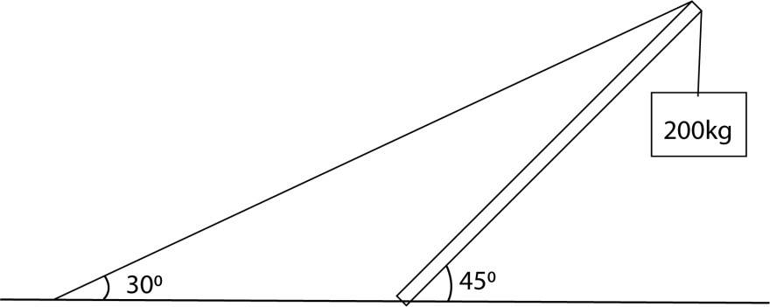

Solution
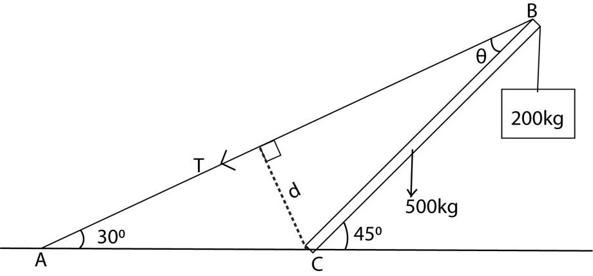
Taking moments at C
Let the length of the rod b L

T x d = (500 x 9.8) x cos 45 + (200 x 9.8) x Lcos 45

But d = Lsinθ 45⁰ = 30⁰ + θ
θ = 15⁰

It implies that
T x Lsin 15 = (500 x 9.8) x cos 45 + (200 x 9.8) x Lcos 45
T =12047N

Exercise 2
- A mass of 5kg is suspended from end A of a uniform bean of mass 1kg and length 1m. the end B of the beam is hinged to a wall. The beam is kept horizontal by a wire attached to point A and C on the wall at a height 0.75m above B.
  - Draw a sketch diagram to show the forces acting on the beam
  - Calculate the tension in the wire. [T = 90N]

  - What is the force exerted by hinge on the beam [F = 72.1N]
- A uniform ladder AB of length 12m is placed at an angle of 60⁰ to the horizontal with one end B leaning against the wall and the other end A on the ground. Calculate the reaction force R of the wall at B and force F of the ground at A if the weight of the ladder AB is 200N. [ R = 200N, F = 57.7N]

Center of gravity
This is a point where the resultant force of attraction of a body acts

Center of gravity of regular object
For regular shape bodies, the center of gravity is at the geometric center of the body e.g. the center of gravity of a Uniform meter ruler is at 50cm mark, for circle, it is at the center. For a rectangular and square body it is at the point of intersection of the diagonals.

Center of gravity of Irregular body
The best way of finding the center of gravity of an irregular object is by use a plumb line. A plumb line is made from a thread of cotton with a loop at one end and a weight tied at other end.
For a irregular card board for instance, three small holes are made at well-shaped intervals around the edge of the card

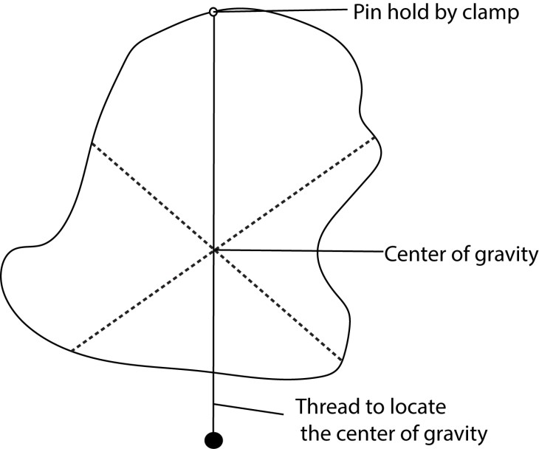

A pin is then put through one of the holes and firmly by a clamp and stand so that the card board swings on it.

The card board will come to rest with its center of gravity below the point of support along the vertical line of plumb line.

The cardboard is hung through another hole, the point of interception of the two vertical lines is the center of gravity.

Factors that affect stability
- The position of center of gravity, should be low.
- Width of the base: the wider the width of the base, the more stable the body is.

Way of increasing stability
- Increasing the base area
- Lowering the center of gravity

Application of center of gravity
1. cars have very heavy framed to lower center of gravity 2. Racing cars have wide wheel base to lower center of gravity.

Dealing with Force on a ladder leaning against the wall

(a) The ground is rough the wall is smooth
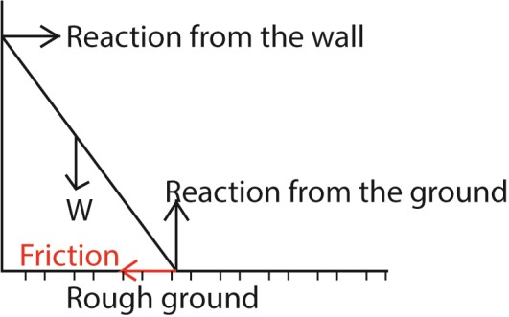
At equilibrium
The resultant forces = 0
(): Reaction from the wall = friction
(): Reaction from the ground = weight

Example 13
A uniform ladder of length 2L and mass 20kg rests in equilibrium with its base on rough horizontal floor and its top against a smooth vertical wall. The ladder is inclined at 60⁰ to the horizontal. If the ladder is on the point of slipping and the coefficient of friction is μ. Find the value of μ, the reactions at the wall and the floor.
Solution
Let the normal reaction at the floor = R1; the normal reaction at the wall= R₂; weight of the ladder be W and friction on the ground = F
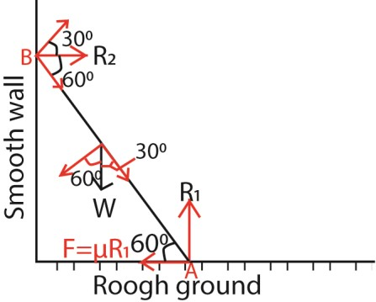

(): R₁ = W = 20 x 9.8 = 196N ………………. (i)

(): R₂ = F
= μR₁
= 196μ ……………………………………(ii) Taking moments at A:
(A): R₂cos30(2L) = WCos60 (L)
R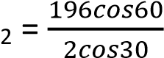
= 56.58N
NB: cos 30 = sin60 From equation (ii)
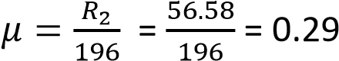

Example 14
A uniform ladder which is 5m long and mass of 20kg leans with its upper end against a smooth vertical wall and its lower end on a rough ground. The bottom of the ladder is 3m from the wall. Calculate
- The frictional force between the ladder and the ground
- The coefficient of friction
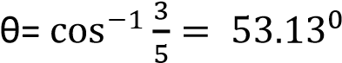







(i) (↑) R_{B} = 20g = 20 x 9.8 = 196N
T
aking moments about B

R
A

x 5sinθ =20g x 2.5cosθ

R
A

x 5sin53.13 =20g x 2.5cos53.13

R
A

=
73.5N

Frictional force = 73.5N

(
ii) R
A

=
µ
B

R
B

= 196

µ
B

73.5 = 196

µ
B

µ
B

= 0.375

A

B

20
g

O

θ

R
A

R
B

2.5
m

2.5
m

µ
B

R
B

(→) R_{A} = µ_{B} R_{B} = 196 µ_{B}

Example 15
A non-uniform ladder AB 10m long and 8kg lies in limiting equilibrium with its lower end resting on a rough horizontal ground and the upper end resting against a smooth vertical wall. If the centre of gravity of the ladder is 3m from the foot of the ladder and the ladder makes an angle of 30⁰ with the horizontal, find the
(i) Coefficient of friction between the ladder and the ground (ii) Reaction at the wall

(→) R_{A} = µ_{B} R_{B} = 78.4 µ_{B}
R
A

x 10sinθ =8g x 3cosθ

R
A

x 10sin30 =8g x 3cos 30

R
A

=
40.738N

Reaction at

the wall = 40.738N

R
A

=
µ
B

R
B

= 78.4

µ
B

78.4

µ
B

= 40.738

µ
B

= 0.5196

)
i
(

↑) R
(
B

8g = 8 x 9.8 = 78.4N
=

A

B

8
g

O

θ

R
A

R
B

m
7

3
m

µ
B

R
B

Taking moments about B

Example 16
A uniform ladder AB 10m long and mass 30kg lies in a limiting equilibrium with its lower end resting on a rough horizontal ground and its upper end resting against a smooth vertical wall. If the ladder makes an angle of 60⁰ with the horizontal, with a man of mass 90kg standing on the ladder at a point 7.5m from its base, find
- Magnitude of normal reaction and friction force at the ground
- The minimum value of the coefficient of friction between the ladder and the ground that would enable the man to climb to the top of the ladder


T
aking moments about B

R
A

x 10sin60 =30g x 5cos60 + 90g x 7.5cos60

R
A
=
466.788N

µ
B

R
B

R
=
A

1176

µ
B

= 466.788

µ
B

= 0.397

A

B

g
30

O

θ

R
A

R
B

5
m

µ
B

R
B

g
90

- (↑) R_{B} = 30g + 90g = 120 x 9.8 = 1176N
(→) R_{A} = µ_{B} R_{B} = 1176 µ_{B}

- Taking moments about B
R_{A} x 10sin60 =30g x 5cos60 + 90g x 10cos60 R_{A} = 594.093N µB RB = RA
1176 µ_{B} = 594.093 µ_{B} = 0.5052

Revision exercise 3
- A non- uniform ladder AB 10m long and mass 8kg lies in limiting equilibrium with its lower end resting on a rough horizontal ground of angle of friction 17⁰ and the upper end resting against a smooth vertical wall. if the centre of gravity is at point C and the ladder makes an angle of 63⁰ with horizontal, find the length AC. [6m]

- A uniform ladder of mass 30kg lies in limiting equilibrium with its lower end resting on a rough horizontal ground of coefficient of friction 0.4 and the upper end resting against a smooth vertical wall. If the ladder makes an angle of 60⁰ with the horizontal, find the magnitude of the frictional force at the ground. [158.4N]
- A ladder 12m long and weighing 200N is placed 60⁰ to the horizontal with one end B leaning against a smooth vertical wall and the other end A on a rough horizontal ground. Find:
  - Reaction at the wall [57.7N]
  - Reaction at the ground [208.2N at 73.9⁰ to the horizontal]
- A uniform ladder of length 10m and weight w lies in limiting equilibrium with its lower end resting on a rough horizontal ground of coefficient of friction and the upper end resting against a smooth vertical wall. The ladder makes an angle of θ with the horizontal where tanθ = 1.7. A man of weight
2w starts to climb the ladder. Find
  - How far up the ladder the man can climb before slipping can occur. [6m]
  - Find in terms of w, the magnitude of the frictional force at the ground to enable the man reach the top.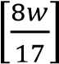
- A uniform ladder of length 5m and weight 80N lies in limiting equilibrium with its lower end resting on a rough horizontal ground and the upper end resting against a smooth horizontal rail fixed 4m vertically above the ground. If the ladder makes an angle of θ with the vertical where tanθ ≤ 0.75 with the horizontal.
  - Find expressions in terms of θ for
    - Vertical reaction R of the ground [ 80-50sin²θcosθ+
    - Friction F at the ground [50cos²θsinθ+
    - Normal reaction N at the rail *50sinθcosθ+
  - Given that the ladder does not slip, show that F is maximum when tanθ = 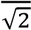 and find its maximum value 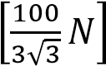

(b) The ground is rough the wall is rough
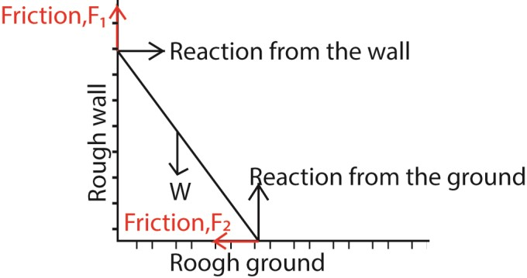

At equilibrium
The resultant forces = 0
(): Reaction from the wall = friction, F₂
(): Reaction from the ground + friction, F₁ = weight

Example 17
A uniform ladder rests with one end on a rough horizontal ground and the other against a rough vertical wall, the coefficient of friction being respectively 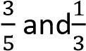. Find the inclination of the ladder to the vertical

when it is about to slip
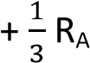
(→) R_{A} 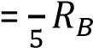

↑) R
(
B

w …….. (i
)
=

A

B

w

O

θ

R
A

R
B

L

µ
B

R
B

L

µ
A

R
A

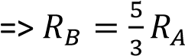
Substituting for R_{B} in equation (i)
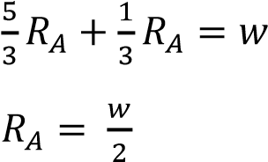

Taking moments about B
R_{A} x 2Lsinθ + R_{A} x 2Lcosθ = w x Lcosθ ...(ii)
Substituting for R_{A} in eqn. (ii)
x 2Lsinθ +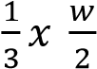 x 2Lcosθ = w x Lcosθ
Sinθ = 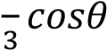
tanθ = θ = 33.7⁰
Angle to the vertical = 90 - 33.7 = 56.3⁰

Example 18
A uniform ladder rests in limiting equilibrium with the top end against a rough vertical wall with coefficient of friction 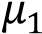 and its base on a rough horizontal floor with coefficient of friction 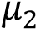.If the ladder makes an angle of θ with the floor, prove that tanθ = 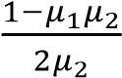
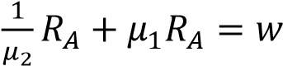

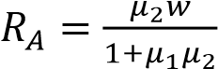
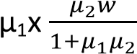
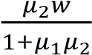
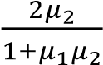
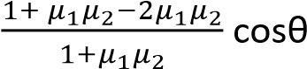
Taking moments about B

A

B

w

O

θ

R
A

R
B

L

µ
2

R
B

L

µ
1

R
A

R_{A} x 2Lsinθ + µ₁R_{A} x 2Lcosθ = w x Lcosθ …….(iii) 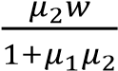 x 2Lsinθ + µ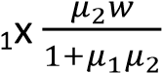 x 2Lcosθ = w x Lcosθ

x 2Lsinθ = w x Lcosθ - x 2Lcosθ
(↑) R_{B} + µ₁ R_{A} = w …….. (i)
sinθ =
(→) R_{A} = µ₂ R_{B} ……….(ii)
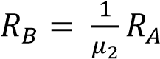 tanθ = 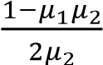
Substituting R_{B} in eqn. (i)

Example 18
The foot of a ladder length of 9m and mass 25kg rests on a rough horizontal surface while the upper end rests in contact with a rough vertical wall. The ladder is in vertical plane perpendicular to the wall. If the first rug is 30cm from the foot and the rest at the interval of 30cm, find the highest rug to which a man of mass 75kg can climb without causing the ladder to slip, when the ladder is inclined at 60⁰ to the horizontal and the coefficient of friction at each end is 0.25.




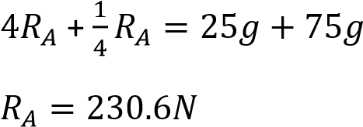
(↑) R_{B} 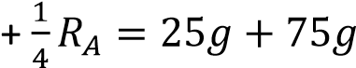…… (i)

A

B

25
g

O

θ

R
A

R
B

4.5
m

µ
B

R
B

m
4.5

µ
A

R
A

g
75

y

(→) R_{A} 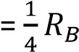
=>  …………... (ii)
Substituting for R_{B} in eqn. (i)
Let the man ascend a distance = ym
Taking moments about B
R_{A} x 9sinθ + R_{A} x 9cosθ = 25g x 4.5cosθ +75g x ycosθ
230.6 x 9sin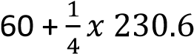 x 9cos60 = 25 x 4.5cos60 +75 x ycos60
y = 4

Example 19
A uniform ladder of length 2L and weight w rests in a vertical plane with one end on a rough horizontal ground and the other against a rough vertical wall, the angle of friction being respectively 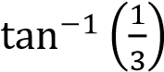 and
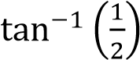.
- Find the inclination of the ladder to the horizontal when it is in limiting equilibrium at either end
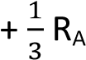
(→) R_{A} 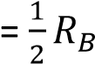

µ
A

=

and
µ
B

=

↑) R
(
B

=
w …….. (i
)

A

B

w

O

θ

R
A

R
B

L

µ
2

R
B

L

µ
1

R
A

 …………….(ii)

- A man of weight 10times that of the ladder begins to ascend it. How far will he climb before the ladder slips



A

B

w

O

θ

R
A

R
B

L

µ
B

R
B

L

µ
A

R
A

w
10

y

Let the man ascend a distance = ym
(↑) R_{B} 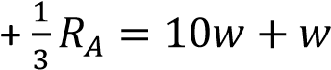…… (i)
(→) R_{A} 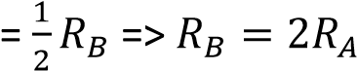 ….. (ii)
Substituting for R_{B} in eqn. (i)
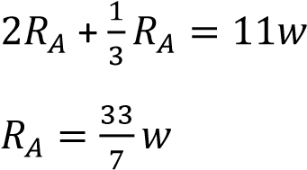
Taking moments about B

Example 20
R_{A} x 2Lsinθ + R_{A} x 2Lcosθ = wLcosθ + 10wycosθ 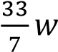 x 2Lsinθ + 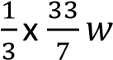 x 2Lcosθ
= wLcosθ + 10wycosθ
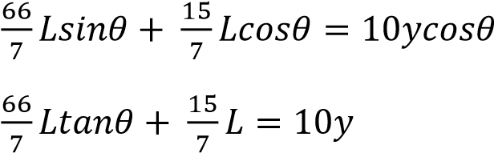
10L = 10y
=> y = Lm

A non-uniform ladder AB is in limiting equilibrium with its lower end A resting on a rough horizontal ground and the upper end B resting against a rough vertical wall. The ladder is in a vertical plane perpendicular to the wall. The centre of gravity of the ladder is t a G = 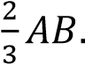The coefficient of friction between the ladder and the wall is twice that between the ladder and the floor. If the ladder makes an angle θ with the wall and the angle of friction between the ladder and the floor is λ;
- Show that 4tanθ = 3tan2λ
- How far can a man of equal mass as the ladder ascend without the ladder slipping given that θ = 45⁰ and coefficient of friction between the ladder and the floor is 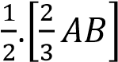

(↑) 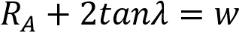……………..(i)

B

A

w

O

θ

R
B

R
A

µ
A

R
A

L

µ
B

R
B

L

(→) 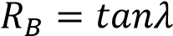 R_{A}……………… (ii)
Substituting R_{B} in eqn. (i)

Revision exercise 4
- A uniform ladder rests in limiting equilibrium with the top end against a rough vertical wall with coefficient of friction 0.25 and its base on a rough horizontal floor with coefficient of friction µ. If the ladder makes an angle of 300 with the vertical; find the value of µ [0.269]
- A non-uniform ladder AB of length 6m is in limiting equilibrium with its lower end A resting on rough horizontal ground with coefficient of friction and the upper end B resting against a rough vertical wall with coefficient of friction . The ladder is in a vertical plane perpendicular to the wall. The centre of gravity of the ladder is at C where AC = 4m. If the ladder makes an acute angle θ with the ground. Show that tanθ =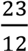.
- A uniform ladder AB is of weight 2w and length 10m rests in limiting equilibrium with the top end against a rough vertical wall with coefficient of friction and its base on a rough horizontal floor with coefficient of friction . If the ladder makes an angle an angle of θ with horizontal, such that tanθ =
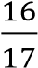. A man of weight 5w starts to climb the ladder.
  - How far up the ladder can a man climb before slipping [9m]
  - When a boy of weight Y stands on the bottom rung of the ladder at A, the man is just able to climb to the top safely. Find Y in terms of W 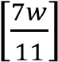
- A non-uniform ladder AB of length 12m and mass 30 is in limiting equilibrium with its lower end A resting on a rough horizontal ground with coefficient of friction 0.25 and upper end B resting against a rough vertical wall with coefficient of friction 0.2. The ladder is in a vertical plane perpendicular to the wall. The centre of gravity of the ladder is at its trisection of the length nearer to A. The ladder makes an angle θ with the horizontal such that tanθ =. A straight horizontal string connects A to a point at the base of the wall vertically below B. A man of mass 9okg begins to climb the ladder
  - How far up the ladder can the man climb without causing tension in the string [8m]
  - What tension must the string be capable of withstanding if the man is to reach the tip of the ladder safely [126N]

(c) The ground is smooth and the wall is rough
In equilibrium the ladder experience a reaction from the wall, a reaction from the ground, weight (w) of the ladder acting from the center and a friction force as shown in the diagram below
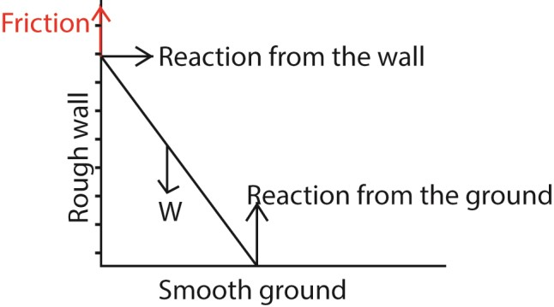

Resolving forces
(): Reaction from the wall
(): Reaction from the ground – weight + Friction
Note that equilibrium will never be attain because the reaction from the wall has no opposing force even if the resultant vertical force = 0 (vertical equilibrium)

For addition examples on forces acting on a ladder leaning against the wall. Refer the file ‘A-level math paper 2 Coplanar forces (rigid bodies)’ on the digitalteachers.co.ug website

TOPIC 3/6: LINEAR MOTION
Competency: The learner investigates the effect of force on the motion of bodies on land, water and air, and devises safety precautions for users of automobiles.

Motion in straight line

Distance and displacement
Distance is a length between 2 fixe points

Displacement is the distance covered in a specific direction Speed and velocity Speed is the rate of change of distance with time
Velocity is the rate of change of displacement with time
Average speed = 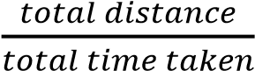
Average velocity = 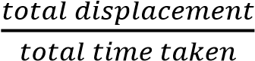

Example 1
Find the distance travelled in 5s by a body moving with a constant speed of 3.2ms⁻¹ Solution
Average speed = 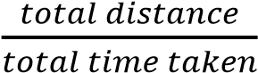
3.2 = 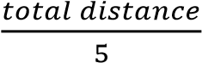
Distance = 3.2 x 5 = 16m

Example 2
John ran 1500m in 3minutes and 33s, find his average speed.
Average speed = 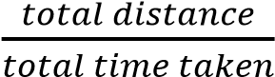
speed = 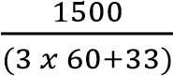
= 7.04ms⁻¹

Acceleration
It is the rate of change of velocity
Acceleration =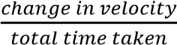
a = 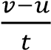 where v = final velocity, u = initial velocity, t = time

Uniform acceleration
This is the constant rate of change of velocity with time

Equations of uniform acceleration 1st equation
Suppose a body moving in a straight line with uniform acceleration a, increases its velocity from u to v in time t, then from the definition of acceleration
a = 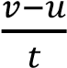
at = v -u
v = u + at …………………………....1

2nd equation
Suppose an object with velocity u moves with uniform acceleration a in time t and attains a velocity v, the distance s travelled by the object is given by: s = average velocity x time
s = 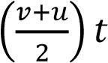 but v = u + at
s = 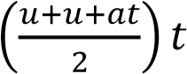 s = 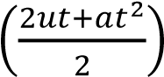
s = ut + 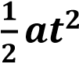 …………………………………2
3rd equation s = average velocity x time
s = 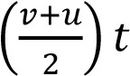 but t = 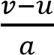
s = 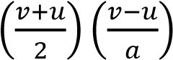
s = 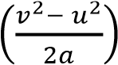
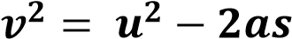 ……………………….…3

Example 3
A car is initially at rest at a point O. The car moves from O in a straight line with an acceleration of 4ms⁻². Find how far the car
- is from O after 2s From s = ut + 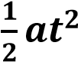;
  - = 0 x 2 + 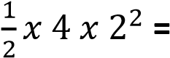 8m
- is from O after 3s
  - = 0 x 2 + 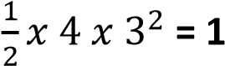 8m
- distance travelled in the third second
= 18 – 8 = 10m

Example 4
A body at O moving with a velocity 10ms⁻² decelerates at 2ms⁻².
- find the displacement of the body from O after 7s From s = ut + 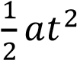
s = 10 x 7 + 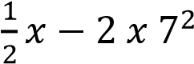 = 21m
- how far from O does the body come to rest and how long does it takes. s = 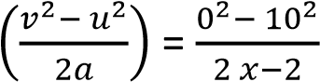 = 25m t = 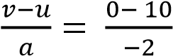 = 5s

Example 5
A taxi approaching a stage runs two successive half kilometres in 16s and 20s respectively. Assuming the retardation is uniform, find
- Initial speed of the taxi s = ut + 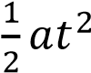
For the first half kilometre or 500m
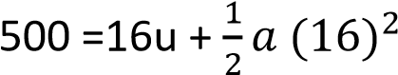 …………..… (i) For the kilometre or 1000m
1000 = 36u +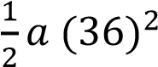 ………….. (ii)
From eqn. (i) and eqn. (ii) a =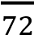 and u = 34.028ms⁻¹

- the further distance, the taxi runs before stopping s = 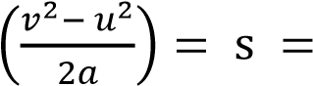
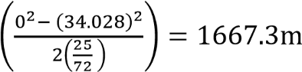
Extra distance = 1667.3 – 1000 = 667.3m

Example 6
An overloaded taxi travelling at constant velocity of 90km/h overtakes a stationary traffic police car. 2s later, the police car sets in pursuit, accelerating at a uniform rate of 6ms⁻². How far does the traffic car travel before catching up with the taxi? Solution t₁ = time taken by the taxi t₂ = time taken by the police car t₁ = 2 + t₂
Speed of the taxi in m/s
90km/h = 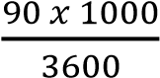 = 25ms⁻¹ s = ut + 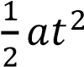
s_{T} = 25t₁
s_{C} = 0 x t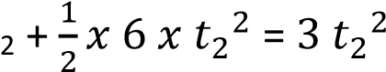
For the car to catch taxi; s_{T} = s_{C}
25t₁ =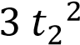
25(2 + t₂) =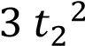 t₂ = 10s or t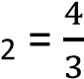s
The car leaves 2s later then 10s is the correct time since it gives positive distance
s_{C} = 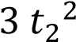 =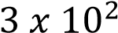 = 300m

Example 7
A lorry starts from a point A and moves along a straight horizontal road with a constant acceleration of 2ms⁻². At the same time a car moving with a speed of 20ms⁻¹ and a constant acceleration of 3ms⁻¹ is 400m behind the point A and moving in the same direction as the lorry. find:
- how far from A the car overtakes the lorry.
Solution
A car over takes the lorry; both move in the same time, t s = ut + 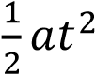 distance moved by the car =
400 + distance moved by the lorry
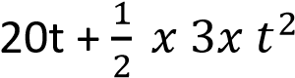= 400 + 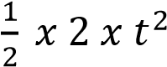
t² + 40t – 800 = 0; t = 14.64s or t = -54.64s
Hence t = 14.64s
s_{L} 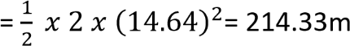
Hence distance moved by lorry
= 214.33m
- the speed of the lorry when it is being overtaken
v = u + at
= 0 + 2 x 14.64 = 29.28ms⁻¹ Example 8
The seed of a taxi decreases from 90kmh⁻¹ to 18kmh⁻¹ in a distance of 120 metres. Find the speed of the taxi when it had covered a distance of 50metres. (05marks)

Solution
Given u = 90kmh⁻¹,
v = 18kmh⁻¹,
s = 120m = 0.12km Using v² = u² + 2as 18² = 90² + 2a(0.12) a = -32400kmh⁻²
When s = 50m = 0.05km, u = 90kmh⁻¹,
a = -32400kmh⁻² Using v² = u² + 2as v² = 90² – 2 x 32400 x 0.05 = 4860
v = 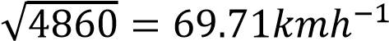

Example 9
- Show that the final velocity v of a body which starts with an initial velocity u and moves with uniform acceleration a consequently covering a distance x, is
given by v = 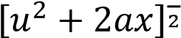
Solution x = average velocity x time x = 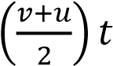 but t = 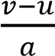
  - = 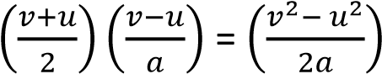
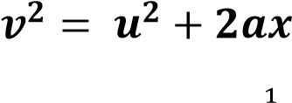
v = 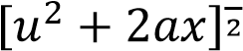

- Find the value of x in (a) if v = 300m/s, u
= 10m/s and a = 5m/s Solution
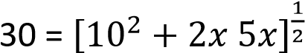 900 = 100 + 10x
  - =80m

Velocity-time graphs

Example 10
A car started from rest and attained a velocity of 20m/s in 40s. It then maintained the velocity attained for 50s. After that it was brought to rest by a constant breaking force in 20s.
- Draw a velocity-time graph for the motion
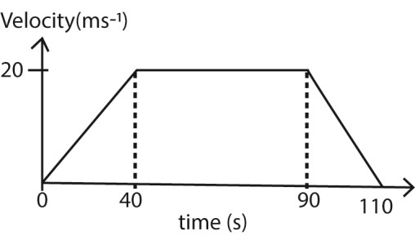
- using the graph, find the total distance travelled by the car
Total distance = total area under the graph
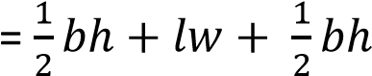
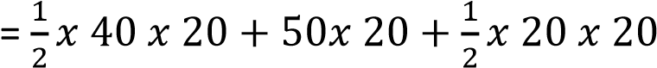
= 1600m
Method II (area of a trapezium)
A = 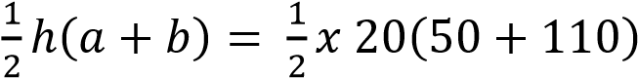
= 1600m
(iii) what is the acceleration of the car?
a= 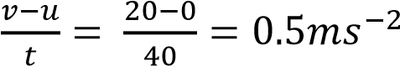

Example 11
A car from rest accelerates steadily to 10s up to a velocity f 20ms. It continues with uniform velocity for further 20s and then decelerates so that it stops in 20s.
- Draw a velocity-time graph to represent the motion
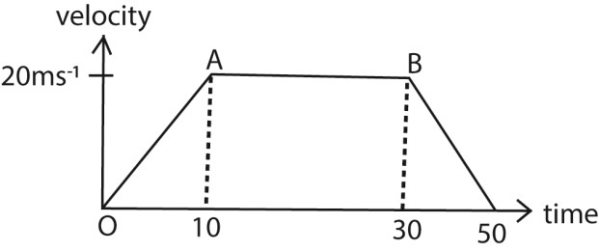
- Calculate
  - acceleration
a= 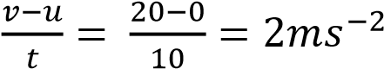
  - deceleration
a= 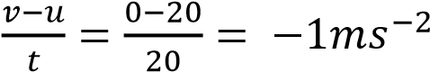
- Distance travelled
Method I
Distance = area under the graph

A = 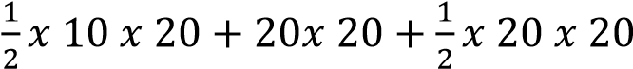
= 700m
Method II (area of a trapezium)
A = 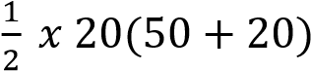
= 700m
(d) Average speed
Average speed = 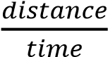
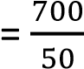
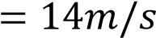

Example 12
The graph below shows the motion in the body.
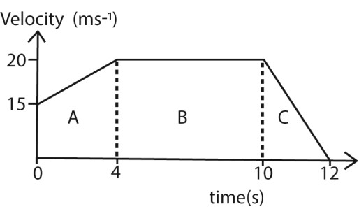
- Describe the motion of the body A body with initial velocity of 15m/s accelerates steadily to a velocity of 20m/s in 4s, it then continues with a uniform velocity for 6s and brought to rest in 2s.
- Calculate the total distance travelled
Distance
= 4 x 15 + 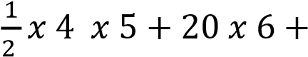
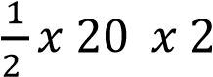= 210m

Revision exercise 1
- P, Q and R are points on a straight road such that PQ = 20m and QR = 55m. A cyclist moving with uniform acceleration passes O and then notices that it takes him 10s and 15s to travel between P and Q and Q and R respectively. find the acceleration [ a =
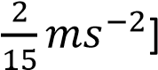
- A car travels from Kampala to Jinja and back. It takes average speed on the return journey is 4km/h greater than that on the outward journey and it takes 12 minutes less. Given that Kampala and Jinja are 80km apart, find the average speed on the outward journey.[30.05kmh]
- Car A traveling at 35ms⁻¹ along a straight horizontal road, accelerates uniformly at 0, 4ms⁻². At the same time, another car B moving at 44ms⁻¹ and
accelerating uniformly at 0.5ms⁻² is 200m behind A
  - Find the time taken before car B over takes car A. [20s]
  - speed with which B over takes
A. [55m/s]
- A car is being driven along a road at 72kmh⁻¹ notices a fallen tree on the road 800m ahead and suddenly reduces the speed to 36kh⁻¹ by applying brakes. For how long were the brakes applied [53.33s]
- A train starts from station a with a uniform acceleration of 0.2ms⁻² for 2 minutes and attains a maximum speed and moves uniformly for 15 minutes. it is then brought to rest at constant retardation of 5/3ms⁻² at station B. find
the distance between A and B.
[23212.8m]
- A motorcycle decelerated uniformly from 20kmh⁻¹ to 8kmh⁻¹ in travelling 896m. find the rate of deceleration in ms2 [0.0145ms⁻²]
- A body moves with a uniform acceleration and covers a distance of 27m in 3s; it then moves with a uniform velocity and covers a distance of 60m in 5s. Find the initial velocity and acceleration of the body. [6ms⁻¹, 2ms⁻²]
- A particle is projected away from an origin O with initial velocity of 0.25ms⁻¹. The particle travels in a straight line and accelerates at 1.5ms⁻². find
  - how far the particle is from O after 4s [7.5m]
  - the distance travelled by the particle during the fourth second after projection. [5.5m]
- A taxi which is moving with a uniform acceleration is observed to take 20s and 30s to travel successive 400m. find (i) initial speed of the taxi.
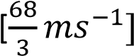
(ii) the further distance it covers before stopping [163.3m]
- Two cyclist A and B are 36m apart on a straight road. Cyclist B starts from rest with an acceleration of 6ms⁻² while A is in pursuit of B with velocity of 20ms⁻¹ and acceleration of 4ms⁻¹. Find the time taken when A overtakes B [1.3466s]

Relative velocity
This is the velocity a body would have as seen by an observer on another body. Suppose A and B are two moving bodies, the velocity of A relative to B is the velocity of A as it appears to observer on B
It is denoted by V_{AB} = V_{A} – V_{B}
Note that V_{AB} 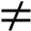 V_{BA} since V_{BA} = V_{B} – V_{A}.

Numerical calculations
There are two methods used in calculations
- Geometric method and
- Vector method (i) Geometric method.
If V_{A} and V_{B} are not given in vector form and the velocity of A relative to B is required, then we can reverse the velocity of B such that V_{AB} =V_{A} +(-V_{B}) and the vector triangle is drawn as below.
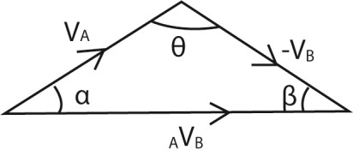
V_{AB}² = V_{A}² + V_{B}² - 2V_{A} x V_{B} cosθ and
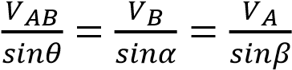
(ii) Vector method Find components of velocity for each separately 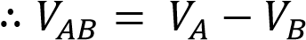

Example 13
Particle A is moving due north at 30ms⁻¹ and particle B is moving due south at 20ms⁻¹. Find the velocity of A relative to B.

Solution
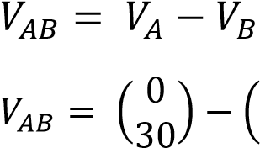
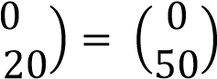
↑V_{A} = 30ms⁻¹ and ↓V_{B} = 20ms⁻¹
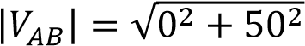= 50ms⁻¹ due north

Example 14
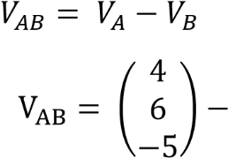
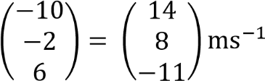
A particle A has a velocity (4i + 6j -5k)ms⁻¹ while B has a velocity of (-10i – 2j + 6k)ms⁻¹. Find the velocity of A relative to B.

Example 15
A girl walks at 5kmh⁻¹ due west and a boy runs 12kmh⁻¹ at a bearing of 150⁰. Find the velocity of the boy relative to the girl

Method I (geometrical)
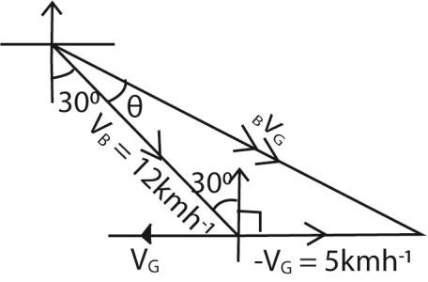
V_{BG}² = V_{B}² + V_{G}² - 2V_{B} x V_{G} cos120⁰
= 15.13ms⁻¹
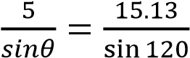
θ = 16.63⁰
The relative velocity is 15.13ms⁻¹ at S46.63⁰E

Method II (Vector)
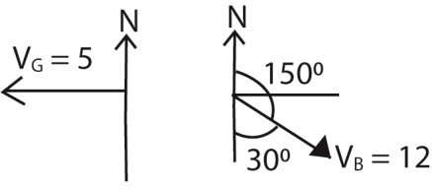
V_{BG} = V_{B} – V_{G}
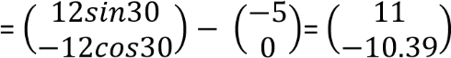
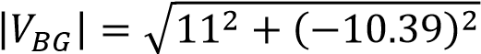
= 15.13ms⁻¹
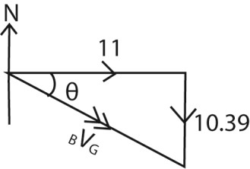
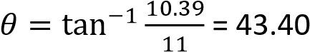
The relative velocity is 15.13ms⁻¹ at S46.63⁰E Example 16
Plane A is flying due north at 40kmh⁻¹ while plane B is flying in the direction N30⁰E at
30kmh⁻¹. Find the velocity of A relative B
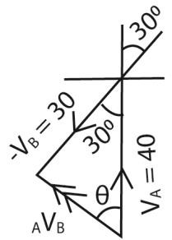
V_{AB}² = V_{A}² + V_{B}² - 2V_{A} x V_{B} cos30⁰
= 20.53kmh⁻¹
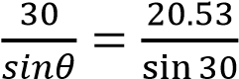 ; θ = 46.94⁰
The relative velocity is 20.53kmh⁻¹ at N46.9⁰W
Method II (vectors)
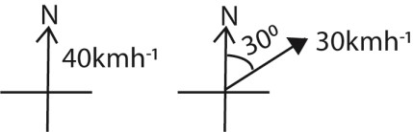
V_{AB} = V_{A} – V_{B} 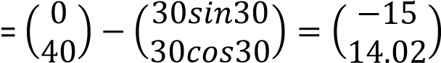

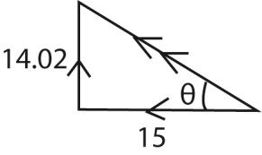
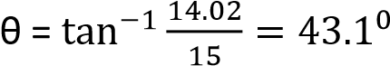
The relative velocity is 20.53kmh⁻¹ at N43.1⁰W Example 17
Ship P is steering 60kmh⁻¹ due east while ship Q is steering in the direction N60⁰W at 50kmh⁻¹. Find the velocity of P relative to Q.

Method I (Geometrical)
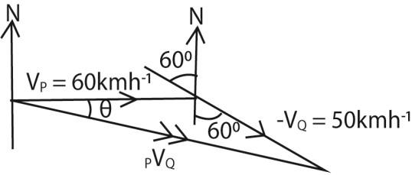
V_{PQ}² = V_{P}² + V_{Q}² - 2V_{P} x V_{Q} cos150⁰
= 106.28kmh⁻¹
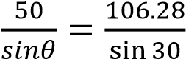 ; θ = 13.6⁰
The relative velocity is 106.28kmh⁻¹ at S76.4⁰E

Method II (Vector)
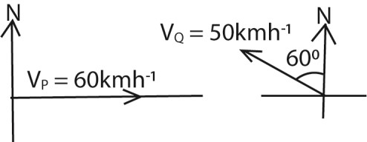
V_{PQ} = V_{P} – V_{Q}
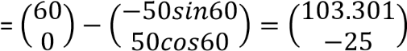
=106.3kmh⁻¹
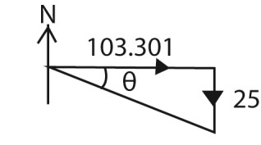
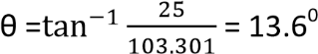
Direction S(90⁰ – 13.6⁰)E
The relative velocity is 106.28kmh⁻¹ at S76.4⁰E

Finding true velocity Example 18
To a cyclist riding due north at 40kmh⁻¹, a steady wind appears to blow from west at 30kmh⁻¹. Find the true velocity of the wind
Solution
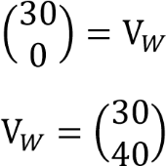
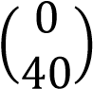
V_{WC} = V_{W} – V_{C}
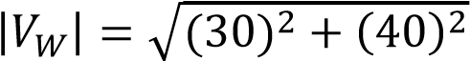= 50kmh⁻¹
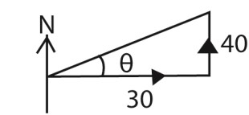
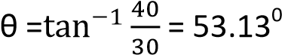
Direction N (90 – 15.13)⁰E = N36.87⁰E Example 19
To a motorist travelling due north at 40kmh⁻¹, a steady wind appears to blow from N60⁰E at 50kmh⁻¹.
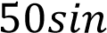
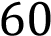
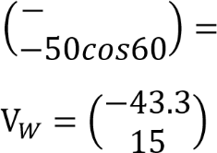
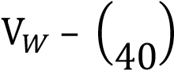
- find the true velocity of the wind V_{WM} = V_{W} – V_{M}
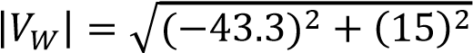= 46kmh⁻¹

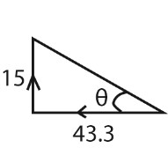
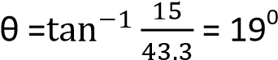
Direction: N71⁰W
- If the wind velocity and direction remain constant but the speed of the motorist is increases, find his speed when the wind appears to be blowing from the direction N45⁰E. V_{WM} = V_{W} – V_{M}
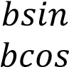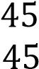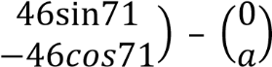
  - components : -bsin45 = 46sin71 b = 61.5096
  - components: -bcos45 = -46cos71 – a
a = 61.51cos45 - 46cos71
a = 28.51kmh⁻¹

Example 20
To a man travelling due north at 10kmh⁻¹, a steady wind appears to blow from East. When he travels in the direction N60⁰W at 8kmh⁻¹, it appears to come from south. Find the velocity of the wind.
V_{WM} = V_{W} – V_{M}
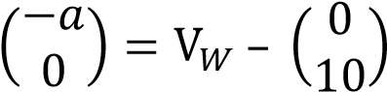
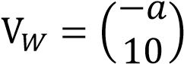 …………………………….(i)
Also
V_{WM} = V_{W} – V_{M}
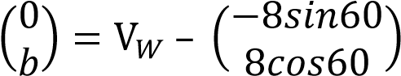
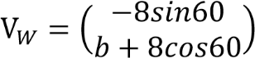 …………………………….(i)
(i) and (ii)
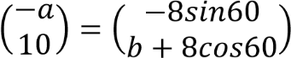
a = 8sin60 = 4 10 = b + 8cos60 b = 6
√

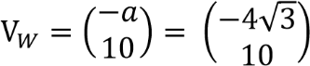
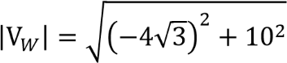= 12.17kmh⁻¹
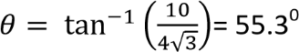
Direction: N(90 -53.3)⁰W= N34.7⁰W Example 21
To a cyclist riding due north at 40kmh⁻¹, a steady wind appears to blow eastwards. On reducing his speed to 30kmh⁻¹ but moving in the same direction, the wind appears to come from southwest. Find the velocity of the wind
V_{WC} = V_{W} – V_{C}
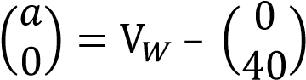
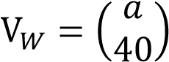 …………………………….(i)
Also
V_{WC} = V_{W} – V_{C}
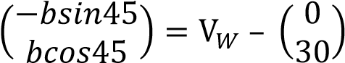 …….. (ii)
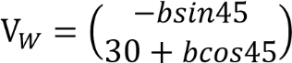 …………………………….(i)
(i) and (ii)
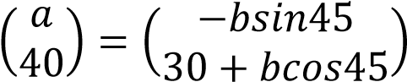
40 = 30 + bcos45
b = 10
√

a =- bsin45 = 10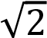sin45 = -10
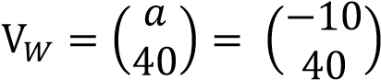
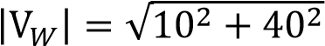= 41.23kmh⁻¹
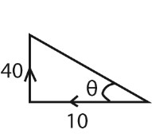
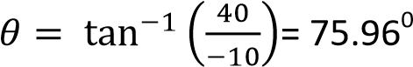
Direction: N(90 -76)⁰E= N14⁰W

Exercise 2
- Car A moving Eastward at 20ms⁻¹ and car B is moving Northward at 10ms⁻¹. Find the
  - velocity of A relative to B
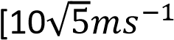
  - velocity of B relative to A
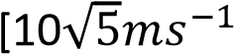
- A yatch and a trawler leave a harbour at 8am. The yatch travels due west at
10kmh-1 and trawler due east at
20kmh⁻¹
  - what is the velocity of the trawler relative to yatch
[30kmh⁻¹ east]
  - how far apart are the boats at
9.30am [45km]
- At 10.30am a car travelling at 25ms⁻¹ due east overtakes a motor bike travelling at 10ms⁻¹ due east. What is the velocity of the car relative to the motor bike and how far apart are the
vehicle at 10.30am. [15ms⁻¹ east,
900m]
- Bird A has a velocity of (7i + 3j +
10k)ms⁻¹ while bird B has a velocity (6i – 17k)ms⁻¹. Find the velocity of B relative to A [(-i -3j – 27k0ms⁻¹]
- Joe rides his horse with a velocity 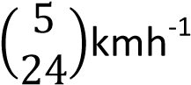 while Jill is riding her horse
with velocity 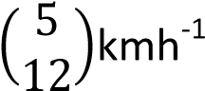
  - Find Joe’s velocity as seen by Jill
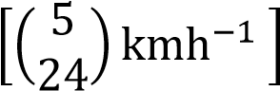
  - What is Jill’s velocity as seen by
Joe.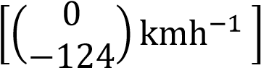
- In EPL football match, a ball is moving at 5ms⁻¹in the direction of N450E and the player is running due north at 8ms⁻
1 . Find the velocity of the ball relative to the player. [5.69ms⁻¹ at S38.38⁰E]
- An aircraft is flying at 250kmh⁻¹ in direction N60⁰E and a second aircraft is flying at 200kmh⁻¹ in the direction N20⁰W. Find the velocity of the first aircraft as seen by the pilot of the second aircraft. [292kmh⁻¹ at S77.9⁰E]
- A ship is sailing southeast at 20kmh⁻¹ and a second ship is sailing due west at 25kmh⁻¹. Find the magnitude and direction of the velocity of the first ship relative to the second.
[41.62kmh⁻¹ at S70.13⁰E]
- What is the velocity of a cruiser moving at 20kmh⁻¹ due to north as seen by an observer on a liner moving at 15kmh⁻¹ in the direction N30⁰W [10.3kmh⁻¹ at N46.9⁰E]
- A car is being driven at 20ms-1 on a bearing of 0400. Wind is blowing from 3000 with speed of 10ms-1. Find the velocity of the wind as experienced by the driver of the car.
[48.13ms⁻¹ at S18.13⁰W]
- An aircraft is moving at 250kmh⁻¹ in direction N60⁰E. The second aircraft is moving at 200kmh⁻¹ in a direction N20⁰W. Find the velocity of the first aircraft as seen by the pilot of the second aircraft. [292kmh⁻¹ at S77.9⁰E]
- To a pigeon flying with velocity of (-2i + 3j + k)ms⁻¹, a hawk appears to have a
velocity of (i – 5j -10k)ms⁻¹.Find the true velocity of the hawk[(-i -2j –
9k)ms⁻¹]
- To a cyclist riding at 3ms⁻¹ due east, the wind appears to come from the south
with the speed 3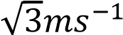. Find the true speed and direction of the wind. [6ms⁻¹ from S30⁰W]
- To the pilot of an aircraft A travelling at300kmh⁻¹ due south, it appears that an aircraft B is travelling at 600kmh⁻¹ in a direction N60⁰W. Find the true speed and direction of the aircraft B.
[520kmh⁻¹ west]
- Jane is riding her horse at 5kmh⁻¹ due north and sees Suzan riding her horse apparently with velocity 4kmh⁻¹, N60⁰E.
Find Suzan’s true velocity. *7.81kmh⁻¹
N26.3⁰E]
- A eagle flying at 8ms⁻¹ on a bearing of
240⁰ sees a chick apparently running at 5ms⁻¹ on bearing300⁰. Find true velocity of the chick. [11.4ms⁻¹ at 262.4⁰]
- A train is travelling at 80kmh⁻¹ in direction N15⁰E. A passenger on the train observes a plane apparently moving at 125kmh⁻¹ in the direction N50⁰E. Find the true velocity of the plane. [196kmh⁻¹ N36.5⁰E]
- To an athlete jogging at 12kmh⁻¹ on a bearing of N10⁰E, the wind seems to come from a direction N20⁰W at 15kmh⁻¹. Find the true velocity of the wind. [7.57kmh⁻¹ N72.5⁰W]
- To a passenger on a boat which is travelling at 20kmh⁻¹ on a bearing 230⁰, the wind seems to be blowing from 250⁰ as 12kmh⁻¹. Find the true velocity of the wind [9.64kmh⁻¹ N24.8⁰E]
- On a particular day wind is blowing N30⁰E at a velocity of 4ms⁻¹ and a motorist is driving at 40ms⁻¹ in the direction of S60⁰E.
  - Find the velocity of the wind relative to the motorist. [40.2ms⁻¹ at N54.28⁰W]
  - If the motorist changes the direction maintaining his speed and the wind appears to blow due east. What is the new direction of the motorist [N85.03⁰W]
- A, B and C are three aircrafts. A has velocity (200i + 170j)ms⁻¹. To the pilot of A it appears that B has velocity (50i – 270j)ms⁻¹. To the pilot of B it appears that C has a velocity (50i + 170j)ms⁻¹. Find the velocities of B and C [(250i -
100j)ms⁻¹, (300i + 70j)ms⁻¹]
- To a bird flying due east at 10ms⁻¹, the wind seems to come from south. When the bird alters its direction of flight to N30⁰E without altering its speed, the wind seems to come from the north-
west. Find the true velocity of wind.
[10.6ms⁻¹ from S69.9⁰W]
- To an observer on a trawler moving at 12kmh⁻¹ in the direction S30⁰W, the wind appears to come from N600W. To

an observer on a ferry moving at 15kmh⁻¹ in a direction S80⁰E, the wind appears to come from the north. Find the true velocity of the wind. [26.8kmh1 0
N33.4 W]

Relative position
Consider two bodies A and B moving with V_{A} and V_{B} from points with position vectors OA and OB respectively.
Position of A at time t is R_{A(t=t)} = R_{A(t=0)} + t x
VA
Position of A at time t is R_{Bt=t)} = R_{B(t=0)} + t x V_{B}
Position of A relative to B at time t is R_{ABt=t)}
= RA(t=0) – RB(t=0)
RABt=t) = (RA(t=0) + t x VA) – (RB(t=0) + t x VB)
RABt=t) = (RA(t=0) - RB(t=0)) + (VAB)t

Example 22
The velocities of ships P and Q are (i +6j)kmh⁻¹ and (-i + 3j)kmh⁻¹. At a certain instant, the displacement between the two ship is (7i + 4j)km. Find the
- Relative velocity of ship P to Q V_{PQ} = V_{P} – V_{Q}
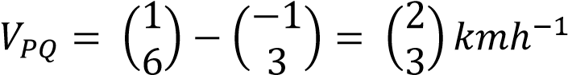
- Magnitude of displacement between ships P and Q after 2hours.
RPQt=t) = (RP(t=0) – RQ(t=0)) + (VPQ)t
R_{PQt=t)} 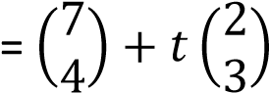
R_{PQt=2)} 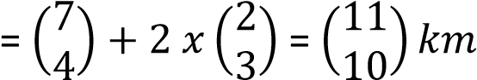

Example 23
Two ship A and B move simultaneously with velocities 20kmh⁻¹ and 40kmh⁻¹. Ship A moves in the northern direction while ship B moves in N60⁰E. Initially ship B is 10km due west of A. Determine
- the relative velocity of A to B.
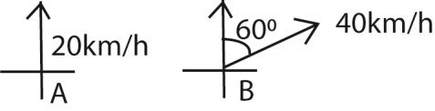
V_{AB} = V_{A} – V_{B}
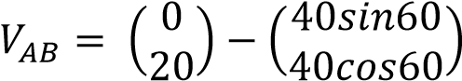
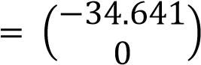

- the position of A relative to B at any time t
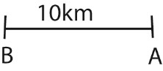
RAB(t=t) = (RA(t=0) – RB(t=0)) + (VAB)t
R_{AB}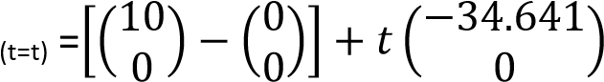
Shortest Distance and time of closest approach or (Shortest distance and time of shortest distance)
R_{AB}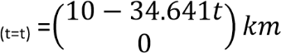

When two particles are moving
simultaneously with specific velocities, time will come when they are closest to each other without colliding.
There are three methods used for the distance and time of closest approach, i.e. Geometrical, vector and differential method.
- vector method Consider particle A and B moving with velocities VA and VB from point with position vector OA and OB respectively. For minimum distance to be
attained then 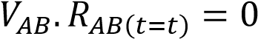. This gives the time. Then shortest distance,
d = 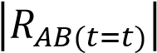
- Differential method The minimum distance is reached when 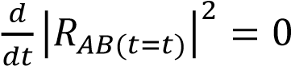. This gives

time Then shortest distance,
d = 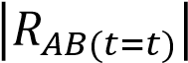

3. Geometrical method
If V_{A} and V_{B} are not given in vector form, then the velocity of B is reversed such that 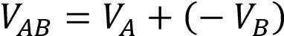 and the vector triangle is drawn as below. The shortest distance, d will be perpendicular to _{VAB}
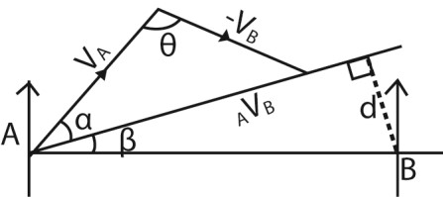
V_{AB}² = V_{A}² + V_{B}² – 2_{A}V_{B}cosθ
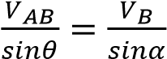
Shortest distance, d =ABsinβ
Time to the shortest distance, t = 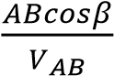

Example 24
A particle P starts from rest from a point with position vector (2j + 2k)m with a velocity (j + k)ms⁻¹. A second particle Q starts at the same time from a point whose position vector is (–11i – 2j – 7k)m with a
velocity of (2i + j + 2k)ms⁻¹. Find
- the shortest distance between the particles
- how far each has travelled by this time.

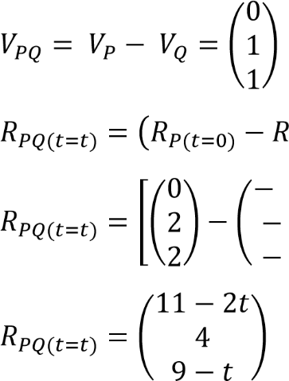
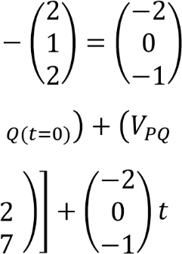

Method 1
For minimum distance: 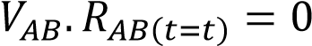.
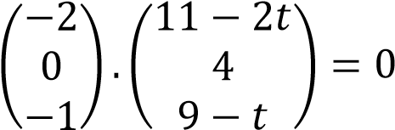
-22 + 4t + 0 -9 + t = 0
t = 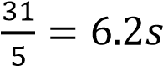

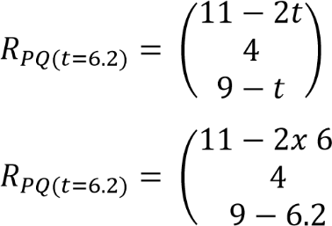
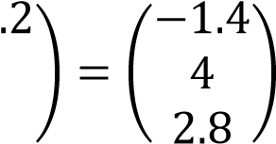
(i) Then shortest distance, d = 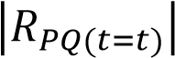
= 5.08m
(ii) How far each has travelled
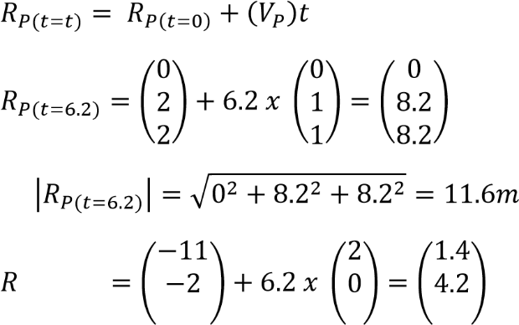
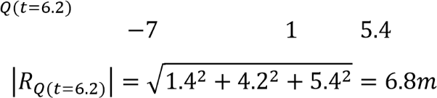
Method II
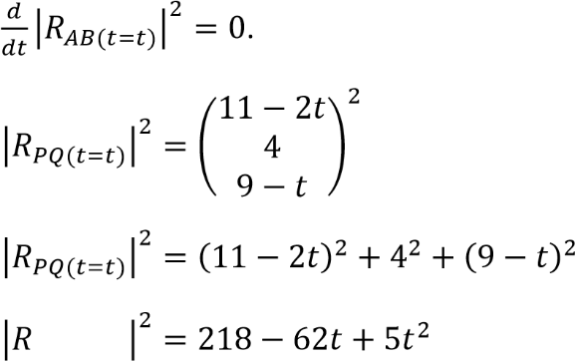
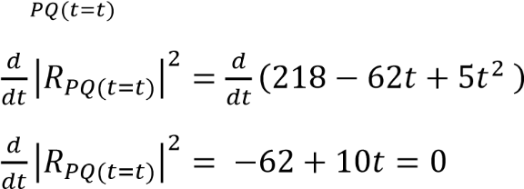
t = 6.2s
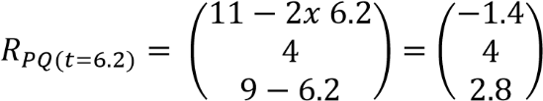
= 5.08m

Example 25
At 12 noon the position vectors r and velocity vectors v of ship A and ship B are as follows r_{A} = (-9i + 6j)km, v_{A} = (3i + 12j) kmh⁻¹ and
r_{B} = (16i + 6j), v_{B} = (-9i+ 3j)kmh⁻¹ respectively
- Find how far apart the ships are at noon
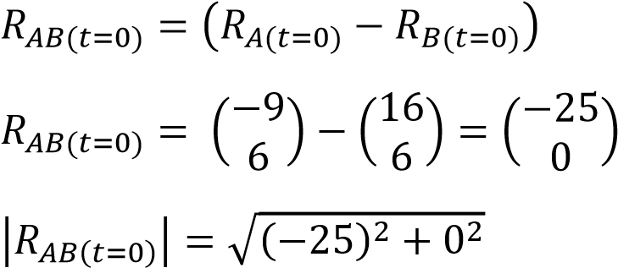
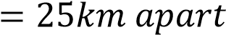
- Assuming velocities do not change, find the least distance between the ships in the subsequent motion
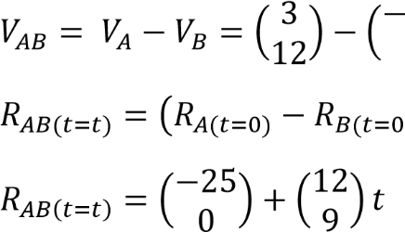
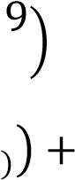
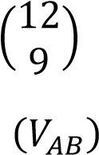
=

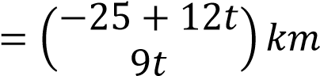
For minimum distance: 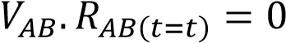.
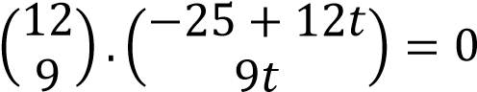
-300 + 144t + 81t = 0
t = 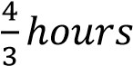
Shortest distance, d 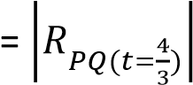
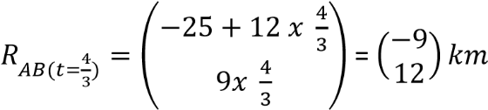
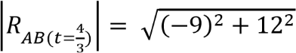= 15km

(iii) Find when their distance of closest approach occurs and the potion vectors of A and B
It occurs at 12.00 + 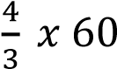 = 1.20pm how far each travelled
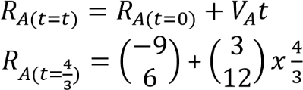
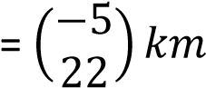
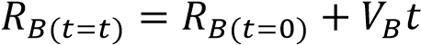
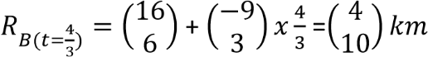

Example 26
At a certain time, the position vectors r and velocity vectors v of ship A and ship B are as follows r_{A} = (20j)km V_{A} = (9i -2j)kmh⁻¹ at 14.00hrs
r_{B} = (i + 4j)km V_{B} = (4i + 8j)kmh⁻¹ at
15.00hrs
Assuming velocities do not change, find
- the position vector of A at 15.00hrs
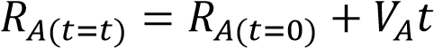
At 16.00hrs: 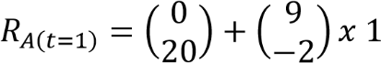
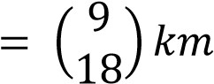
- the least distance between A and B in the subsequent motion
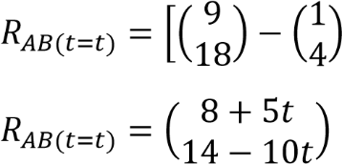
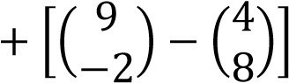t

For minimum distance: 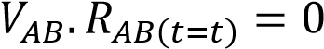.
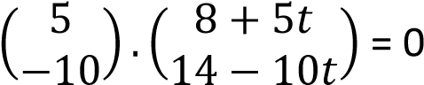
t = = 0.8hrs
(c) time at which this least separation occurs. 15.00 + 0.8 x 60 = 15.48hrs
Shortest distance, d = 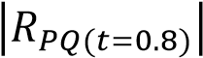
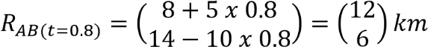
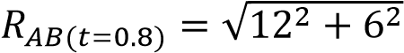= 13.42km

Example 27
At a certain time, the position vectors r and velocity vectors v of ship A and ship B are as follows
r_{A} = (-2i + 3j)km,
v_{A} =(12i -4j)kmh-1 at 11.45am
r_{B} = (8i + 7j)km
v_{B} = (2i – 14j)kmh-1 at 12.00 noon
Assuming velocities do not change, find
(a) The least distance between A and B in the subsequent motion
OA = 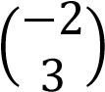 and v_{A} 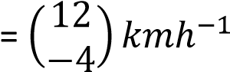
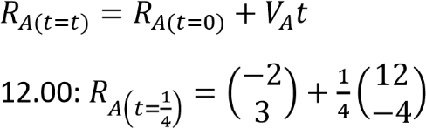
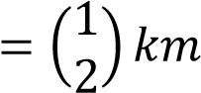
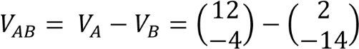
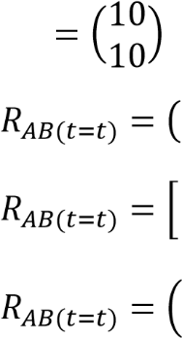
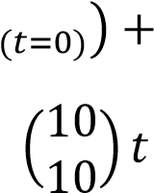
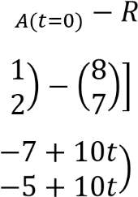
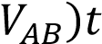
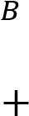
For minimum distance: 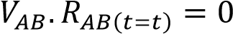.
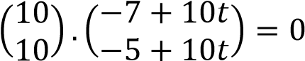
t = 0.6hrs
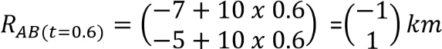
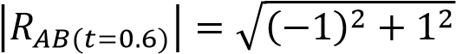=1.4142km

(b) length of time for which A is within range, if ship B has guns within a range of up to 2km
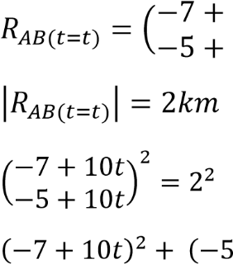
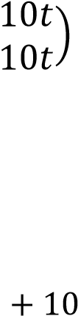
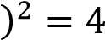
100t² -12t + 35 = 0 t = 0.7hrs or t = 0.5hrs
Time for which they are in range
= 0.7 – 0.5 = 0.2h

Example 28
At 10am, ship A moves with a constant velocity (4i+ 20j) kmh⁻¹ and ship B due north of A moves with a constant velocity (-3i – 4j) kmh⁻¹.
- Find the velocity of A relative to B
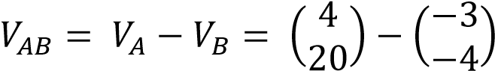
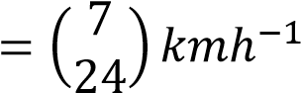
- If the shortest distance between the two ships is 4.2km. Find the
  - time to the nearest minute when they are closest together
  - original distance apart at 10am
  - the bearing of B from A when they are closest together.

Solution
(i) Let a km be the distance apart at
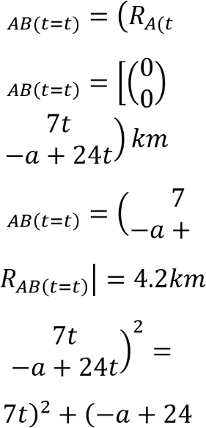
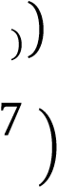
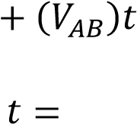
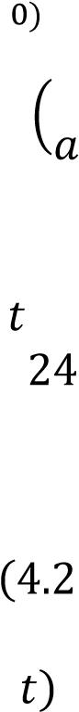
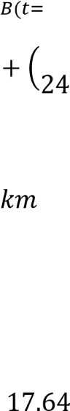

10am
625t² – 48at + a² = 17.64 ………….(i)
For minimum distance: .
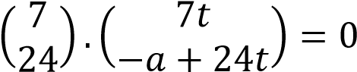
49t – 24a + 576t = 0
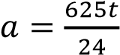 …………………………………..(ii)
Substituting for a in eqn. (i)
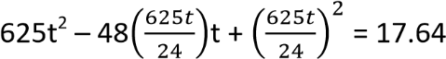
53.1684t² = 17.67
t =
(ii) a = 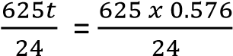 = 15km
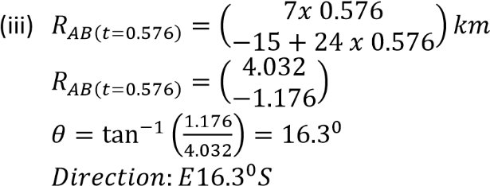

(c) length of time for which A is within range, if the visibility of ship B is within
12km
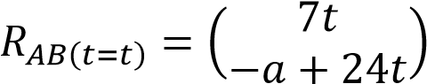
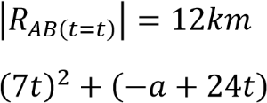
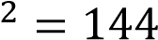
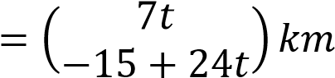
625t² – 720t + 81 = 0 t = 1.026h or t = 0.126h
= 1.026 – 0.126 = 0.9h
Revision exercise 3
Time for which they are in range

1. 1.At 8am ship A and ship Bare 11km apart with B due west of A. a and B move with a constant velocities (-4i
+3j)kh/h and (2i + 4j)km/h respectively. Find the the
- least distance between the two ship in the subsequent motion[1.81km]
- time to the nearest minute at which this situation occurs[9.47am]
2. 2. At 7.30am, two ship A and B are 8km apart with B due north of A. A and B move with constant velocities (12j)km/h and (-5i)km/h respectively. Find the
- least distance between the two ship in the subsequent motion[3.08km]
- time to the nearest minute at which this situation occurs[8.04am]
- A and B are two tankers at 13.00hrs, tanker B bas position vector of (4i+8j)km relative to A. A and B move with constant velocities (6i + 9j)km/h and (-3i + 6j)km/h respectively. Find the
    - least distance between the two ship in the subsequent motion[6.32km]
    - time to the nearest minute at which this situation occurs[13.40hrs]
- At 12 noon the position vectors r and velocity vectors v of two ship A and B are as follows
r_{A} = (5i + j)km, V_{A} = (7i + 3j)km/h and r_{B} = (8i + 7j)km, V_{B} = (2i –j)km/h
    - Assuming velocities do not change , find the least distance between the ships in subsequent motion [2.81]
    - Find the time when their distance of closest approach occur [12.57pm]
- At a certain time, the position vectors r and velocity vectors V of two ship A and B are as follows
r_{A} = (3i + j)km, V_{A} = (2i + 3j)km/h at 11.00am
r_{B} = (2i - j)km, V_{B} = (3i + 7j)km/h at
12.00noon
Assuming velocities do not change; find the
    - The position vector of A at noon
[5i + 4j]
    - Distance between the ships at
12.00 noon [5.83km]
    - The least distance between A and B in the subsequent motion[1.7km]
    - Time at which the least separation occurs [1.21pm]

- At 12 noon, the position vectors r and velocity vectors V of two battle ship A and battle B are as follows r_{A} = (13i + 5j)km, V_{A} = (3i - 10j)km/h r_{B} = (3i - 5j)km, V_{B} = (15i + 14j)km/h
    - Assuming the velocities do not change, find the least distance between the ships in subsequent motion [4.47km]
    - The battle ship has guns with a range of up to 5km, find the length of time during which the cruiser is within range of the battle ships [10minutes]
- At tine t = 0 the position vectors r and velocity vectors V of two battle ship A
and battle B are as follows

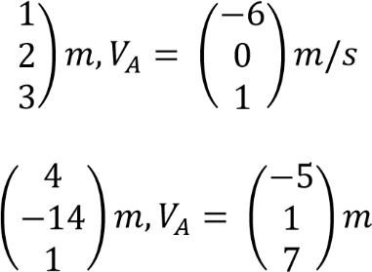
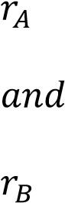
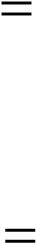
Assuming velocities do not change, find
    - The potion vectors of B relative to A at time t seconds
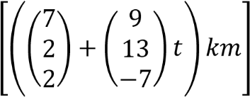
    - The least distance between the ships in the subsequent motion
[15.9m]
    - The time taken to the closest distance 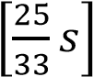
- At time t = 0 the position vectors r and velocity vectors V of two battle ship A and battle B are as follows
r_{A} = (3i + j + 5k)m, V_{A} = (4i + j –
3k)m/s
r_{B} = (i - 3j+ 2k) m, V_{B} = (i + 2j +
2k)m/s
Assuming velocities do not change, find
    - The position vector of B relative to A at time t second
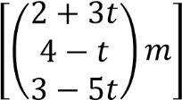
    - The value of t when A and B are closed 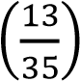
    - Least distance between A and B
[4.917m]
- At tine t = 0 the position vectors r and velocity vectors V of two battle ship A and battle B are as follows
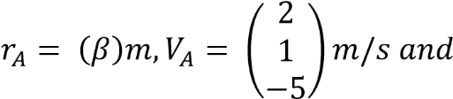
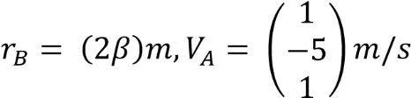
Where β is a constant, assuming velocities do not change show that the least distance between the ships in the subsequent motion is 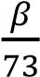 and their distance of closest approach is 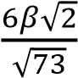.
- A lizard on a wall at point A, has a
position vector 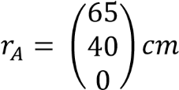. At time
t= 0 seconds a fly has a position vector 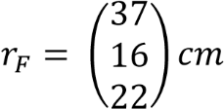 and velocity vector
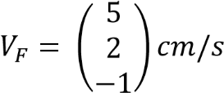
If the fly were to continue with this velocity, find the closest distance it would come to the lizard and the value
of t when it occurs [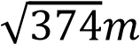, 7s]
- A particle P move with constant velocity
(2i + 3j + 8k)m/s passes a point with position vector (6i – 11j + 4k)m. At the same instant particle Q passes through a point whose position vector is (i -2j + 5k)m moving at constant velocity of (3i + 4j- 7k)m/s. Find
    - Position of Q relative to P at that instant. [10.344m]
    - Shortest distance between the particles [10.32m]
    - Time that elapses before the particles are nearest to each other
[0.0485s]

- Two particles P and Q move with constant velocities (4i + j – 2k)m/s and (6i + 3k)m/s respectively. Initially P is at a point whose position vector is (i – 20j + 21k)m and Q is at a point whose position vector is (i + 3k)m. find
    - Time for which the distance between P and Q is least [2.2s]
    - Distance of P from the origin at the time when the distance between P
and Q is least [28.8m]
    - Least distance between P and Q [24.14m]

Crossing a river
There are two cases to consider when crossing a river
Case I: Shortest route
If the water is not still and boatman wishes to cross directly opposite to the standing point. In order to cross from point A to point B directly opposite A (perpendicularly), then the course set by the boat must be upstream of the river.
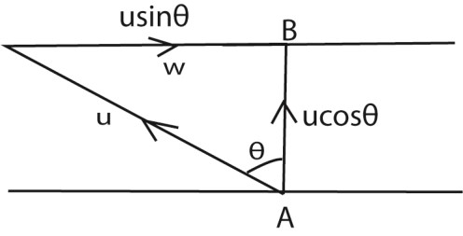
u = speed of the boat in still water w= speed of running water At point B: w = usinθ
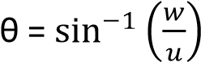
θ = is the direction to the vertical but the direction to the bank is (90 – θ)⁰
Time taken = 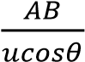
Example 29
A man who can swim at 6km/h in still water would like to swim between two directly opposite points on the river banks of the river 300m flowing at 3km/h. Find the time taken to do this.
AB = 0.3km
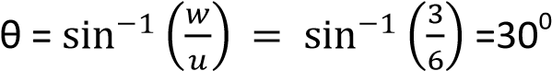
Time taken = 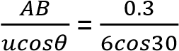
time = 0.058hrs = 3.46minute
He must swim at 300m to AB in order to cross directly and it takes him 3.46minutes.
Alternatively
Using Pythagoras theorem
6² = 3² + V_{AB}²
V_{AB} 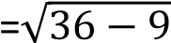= 5.1962km/h
Time = 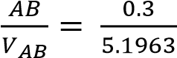 = 0.058hrs
Example 30
Two points A and B are on opposite banks of a river flowing at 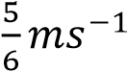. A man who can swim at 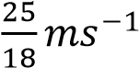 in still water would like to swim
directly from A to B. Find the width of the river if he takes 2minutes to cross the river.

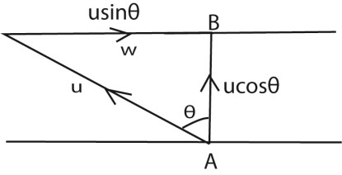
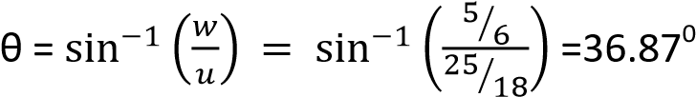
Time taken = 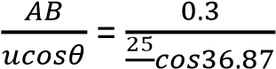
AB = 133.333m
Alternatively: using Pythagoras theorem
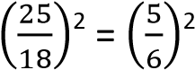+ VAB2
V_{AB}=
Time taken =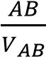
2 x 60 = 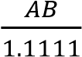
Case II: the shortest time taken/ as quickly as possible
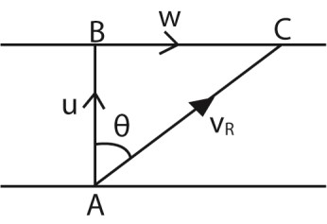
If the boatman wishes to cross the river as quickly as possible, then he should steer his boat directly from A to B as shown. The river pushes the boat down stream

AB = 133.333m
Time taken to cross the river, t = 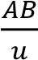
Distance covered downstream = wt Where w is the velocity at which the river flows
u is the velocity of the boat
Or
Distance downstream = 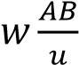
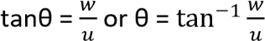
The resultant velocity downstream V_{R}
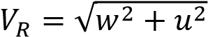
Example 31
A man who can swim at 2ms⁻¹ in still water wishes to swim across a river 120m wide as quickly as possible. If the river flows at 0.5ms⁻¹, find the time the man takes to cross far downstream he travels.
Solution
u = 2ms⁻¹, w = 0.5ms⁻¹, AB = 120m
t = 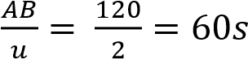
Distance = wt = 0.5 x 60 = 30m

Example 32
A boat can travel at 3.5ms⁻¹ in still water. A river is 80m wide and the current flows at 2ms⁻¹, calculate
- the shortest time to cross the river and the distance downstream the oat is carried.
  - = 3.5ms⁻¹, w = 2ms⁻¹, AB = 80m
t = 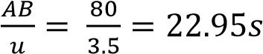
Distance, BC = wt = 2 x 22.95 = 45.8m

- the course that must be set to point exactly opposite the starting point and time taken for crossing
  - = 3.5ms⁻¹, w = 2ms⁻¹, AB = 80m
course, θ = 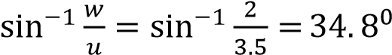
Time for crossing = 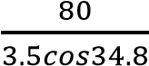 = 27.8s

Revision exercise 4
- A man who can row at 0.9ms⁻¹ in still water wishes to cross a river of width 1000m as quickly as possible. If the current flows at a rate of 0.3ms⁻¹. Find the time taken for journey. Determine the direction in which he should point the boat and position of
the boat where he lands. [111.11s, 71.57⁰ to the bank, 333.33 downstream]
- A man swims at 5kmh⁻¹ in still water. Find the time it takes the man to swim across the river250m wide, flowing at 3kmh⁻¹, if he swims so as to cross the river
  - the shortest route [225s]
  - in the quickest time[180s]
- A boy can swim in still water at 1ms⁻¹, he swims across the river flowing at 0.6ms⁻¹ which is 300m wide, find the time he takes
  - if he travels the shortest possible distance [375s]
  - if he travels as quickly as possible and the distance downstream, [300s, 180m]
- A boy wishes to swim across a river 100m wide as quickly as possible. The river flows at 3kmh⁻¹ and the boy can swim at 4kmh⁻¹ in still water. Find the time that the boy takes to cross the river and how far
downstream he travels. [90s, 75m]

Linear momentum
Linear momentum is a product of the body’s mass and its velocity.

The S1 unit of momentum is kgms⁻¹

When a force F is applied to a body, it changes the body’s velocity from u to v, the size of the force and the time for which it acts on a body.

From F = ma a = 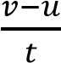
F = 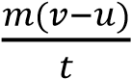
Ft = m(v-u)
Impulse of force is the product of force and the duration of its action or impulse is the change in momentum of the body which is acted on by the force

Example 33
A body of mass 3kg initially moving with a velocity of 5ms⁻¹ is acted on by a horizontal force of 15N for 2s. Find the impulse and final speed. Solution
Impulse = Ft
= 15 x 2
= 30N
Impulse = change in momentum
30 = m(v-u)
30 = 3(v-5) v = 15ms⁻¹

Example 34
A tennis ball has a mass of 0.07kg. it approaches a racket with a speed of 5ms⁻¹ and bounces off and returns to the way it come with a speed of 4ms⁻¹. The ball is in contact with the racket for 0.2 seconds.
Calculate
- The impulse given to the ball
- The average force exerted on the ball by the racket.
Solution
- Impulse = Ft = m(v-u)
= 0.07(-4-5)
= -0.63Ns
- F = 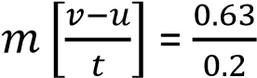 = 3.15N

Collisions and principles of conservation of linear momentum
When two or more bodies collide, the total momentum of the system is conserved provided there is no external force on the sysytem.

Consider a body of mass m1 moving with a velocity u1 to the right. Suppose the body makes a head on collision with a nother body of mass m2 moving with velocity u2 in the same direction

Let v₁ and v₂ be the velocities of the 2 bodies respectively after collision
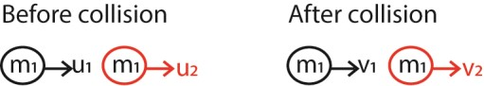
Let F1 be the force exerted on m₂ by m₁ and F₂ the force exerted on m₁ by m₂ using Newton’s 2nd law.
F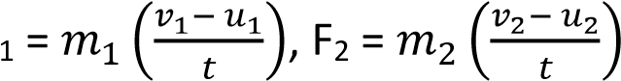, where t
is the time of collision
Using Newton’s third law
F₁ = -F₂

Types of collision
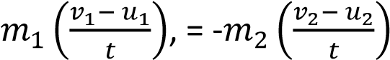,
m₁v₁ + m₂v₂ = m₁u₁+m₂u₂ Hence, total momentum before collision = total momentum after collision, in other words momentum is conserved.

When two bodies collide, there is a short period of contact during which each exerts a force on each other at that instant, the force which each exert on each other is equal and opposite.
Collisions can be categorized as inelastic collision, perfectly inelastic, elastic or perfectly elastic collisions.

Elastic or perfectly elastic collision | Inelastic collision | Perfectly inelastic collision
Kinetic energy is conserved | Kinetic energy is not conserved | Kinetic energy is not conserved
Linear momentum is conserved | Linear momentum is conserved | Linear momentum is conserved
Bodies separate after collision, e.g. collision of gas  molecules | Bodies separate after collision e.g. a ball bouncing from a concrete floor | Bodies stick together and move with a common  velocity. E.g. a trailer colliding with a saloon car.

Elastic collision
Momentum is conserved 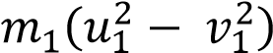 = 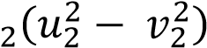 ………….. (ii) m1v1 + m2v2 = m1u1+m2u2
m₁(u₁ –v₁) = m₂(v₂ – u₂) ……………………(i) Equation (i) (ii)
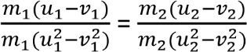
Kinetic energy is conserved
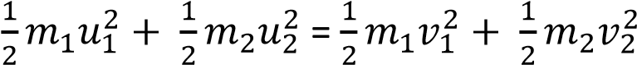

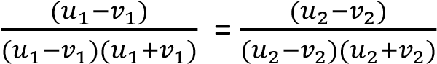

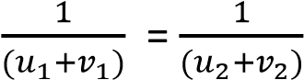

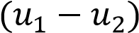 =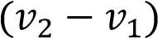

Example 35
A 200g block moves to the right at a speed of 100cms⁻¹ and meets a 400g block moving to the left with a speed of 80cms⁻¹. Find the final velocity of each block if the collision is elastic. Solution
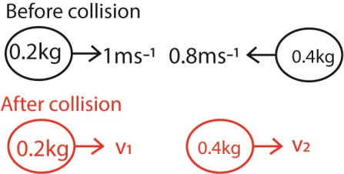

(v₂ – v₁) = -(-0.8 – 1)
(v₂ – v₁) = -1.8 ……………………….………… (i) Using conservation of momentum m₁v₁ + m₂u₂ = m₁v₁ + m₂v₂
(0.2 x 1) + (-0.4 x 0.8) = 0.2v₁ + 0.4v₂
-0.12 = 0.2v₁ + 0.4v₂
-0.6 = v₁ + 2v₂ ………….(ii) Eqn (i) and Eqn (ii) v₂ = -1.8 + v₁
-0.6 = v₁ + 2(-1.8 +v₁)
V₁ = 1ms⁻¹
V₂ = -0.8ms⁻¹

Example 4
A particle of mass m₁, travelling with velocity u₁ makes a perfectly elastic collision with a stationary particle of mass m₂. After the collision, the first particle moves a velocity v₁ while the second particle moves in the same direction with velocity, v₂. Show that
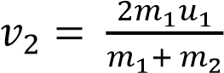 and 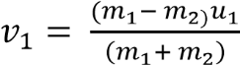

Solution
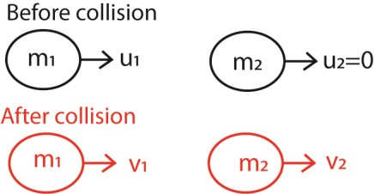
From the principle of conservation of
momentum
Momentum before collision = momentum
after collision m₁u₁ + m₂(0) = m₁v₁ + m₂v₂
v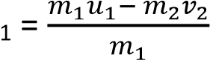 ……………………………..……(i)
From conservation of kinetic energy
Kinetic energy before collision = kinetic energy after collision
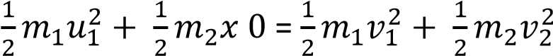
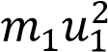 = 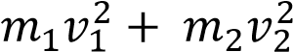 …… (ii)
Substituting equation (i) into equation (ii)
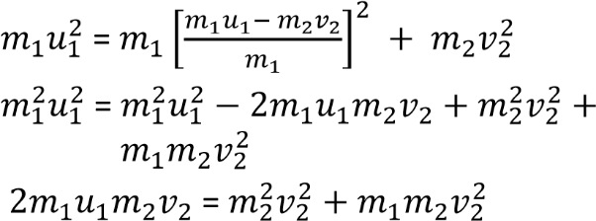
Dividing through by 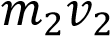
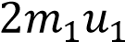 = 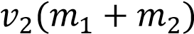
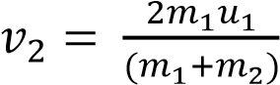
From the principle of conservation of
momentum
Momentum before collision = momentum
after collision m₁u₁ + m₂(0) = m₁v₁ + m₂v₂
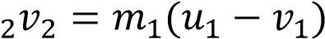
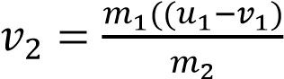
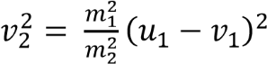 ……………………..(i) m1u1 + m2(0) = m1v1 + m2v2
v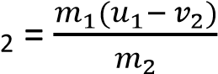
From conservation of kinetic energy v2 = b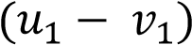 …………(i)
Kinetic energy before collision = kinetic energy after collision | From conservation of kinetic energy  Kinetic energy before collision = kinetic
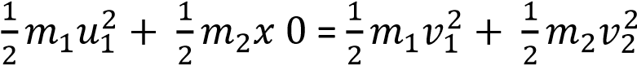 energy after collision
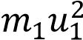 = 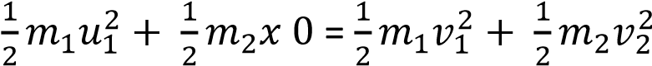
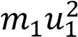
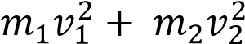
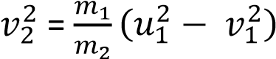 ….. (ii) ⁼
Equation (i) and (ii)
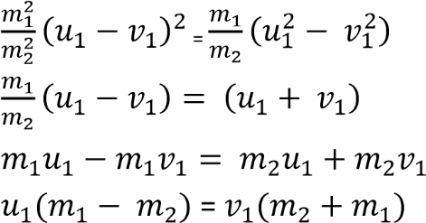
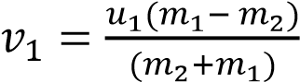

Example 36
A particle P of mass m₁, travelling with a speed u₁ makes a head on collision with a stationary particle Q of mass m₂. If the collision is elastic and speed of P and Q after impact are v₁ and v₂ respectively show that if b = 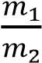
- 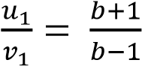

- 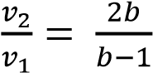
Solution
From the principle of conservation of
momentum
Momentum before collision = momentum
after collision
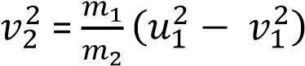
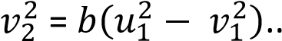….. (ii)
Squaring equation (i)
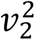= b²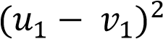 …………………….……(iii)

Equation (ii) and (iii)
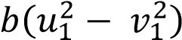 = b²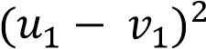
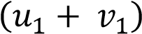 = b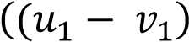
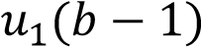 = 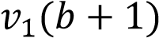
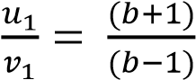 …………………… (iv)
(ii) Consider 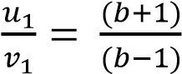
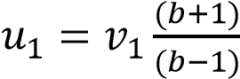 …………….(v)
Substitution Eqn (v) into (i)
v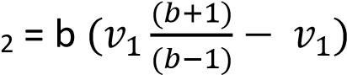
Dividing through by v₁
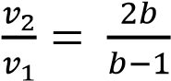

Example 6
An object X of mass m moving with velocity 10ms⁻¹ collides with a stationary object Y of equal mass. After collision, x, moves with speed u at an angle 30⁰ to its initial direction, while Y moves with a speed of V at an angle 90⁰ to the new direction of x.
- Calculate the speed u and v.
- Determine whether the collision is inelastic or not.
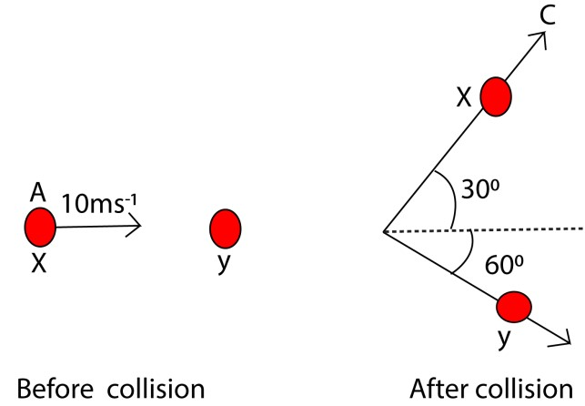

Consider horizontal momentum
From the principle of conservation of conservation of momentum m x 10 + m x 0 = m x ucos 30⁰ + mvcos 60⁰
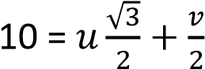 ………..………..(i)
Consider vertical momentum
m x 0 + m x 0 =

√

u = v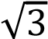 ……………………………(ii)
Putting Eqn (ii) into Eqn (i)
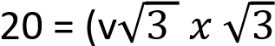+ v
20 = 4v v = 5ms⁻¹
u = 5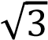 ms⁻¹
(ii) Kinetic energy before =
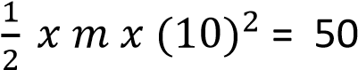m J
Kinetic energy after collision =
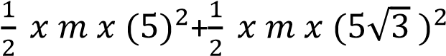
=50m J
Hence the collision is elastic

Exercise 5
- A bullet of mass 300g travelling at a speed of 8ms⁻¹hits a body of mass 450g moving in the same direction as the bullet at 1.5ms⁻¹. The bullet and the body move together after collision. Find the loss in kinetic energy. [Ans.
3.8025J]
- A particle A of mass 4kg is incident with velocity V on a stationary helium nucleus B of mass 4kg. After collision, A moves in direction BC with velocity v/2 where BC makes an angle of 60⁰ with the initial direction of AB and the helium nucleus moves along BD.
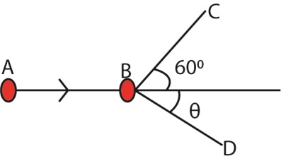
Calculate the angle made in direction
AB and the velocity of the helium along
BD. *θ = 30⁰, velocity = 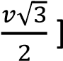

- (a) State Newton’s laws of motion
  - Use Newton’s laws of motion to show that when two bodies collide, their momentum is conserved.
  - Two balls P and Q travelling in opposite direction with speeds 6ms⁻¹ and 15ms⁻¹ inelastic collision. If the masses of P and Q are 8kg and 5kg respectively, find the
    - final velocity [Ans. 2.08ms⁻¹]
    - change in kinetic energy
[Ans. 28.03J]
  - (i) What is an impulse of force?
    - Explain why a long jumper should normally land on sand. [The force exerted on a long jumper on coming to rest is given by F = change in momentum over time taken. Since the change in momentum is constant, it Implies that if the time taken when coming to rest is increased, then the force exerted on the knees of the jumper reduces. Sand increases the time taken for the jumper to stop reducing the damaging force to the knee. ]
- (a)(i) State the law of conservation of linear momentum
(ii) Use Newton’s laws to derive the above.
  - Distinguish between elastic and inelastic collisions
  - An object X of mass m moving with velocity 10ms-1 collides with a stationary object Y of equal mass. After collision, x, moves with speed u at an angle 30⁰ to its initial direction, while Y moves with a speed of V at an angle 90⁰ to the new direction. (i) Calculate the speed u and v.

[Ans. u = 5√ ms⁻¹, v =5ms⁻¹]
    - Determine whether the collision
is inelastic or not. [Ans. kinetic energy on both sides = (50M)J, since kinetic energy is conserved, the collision is
elastic]
- (a) (i) Define linear momentum
    - State the law of conservation of linear momentum.
    - Show that in (ii) above follows Newton’s laws of motion.
    - Explain why, when catching a fast moving ball, the hands are drawn back while the ball is being brought to rest.
  - A car of mass 100kg travelling at uniform velocity of 20ms⁻¹ collides perfectly inelastically with a stationary car of mass 1500kg. Calculate the loss in kinetic energy of the car as a result of collision.
[Ans. 168000J]

Newton’s laws of motion
First Newton’s law of motion. A body remains in its state of rest or uniform motion in straight line unless an external force acts on it.

This law, also called the principle of inertia. Inertia is reluctance of a body to start moving once at rest or stop moving once in motion.

Inertia depends on the mass of the body thus the mass is a measure of inertia.

Second Newton’s Law of motion The rate of change of momentum is directly proportional to the magnitude of the applied force producing it and takes place in the reaction of the applied force. Momentum is the product of mass of the body and its velocity.

F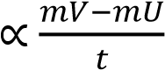
mV- mU = change in momentum
F = 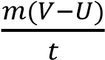
But 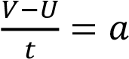
F = kMa, where k is a constant A newton is a force which gives a mass of 1 kg an acceleration of 1ms⁻²
F = 1N M = 1kg a = 1ms⁻¹ 1 = k x 1 x 1 k = 1
F = Ma

Third Newton’s law of motion For every action, there is an equal and opposite reaction.

For example 37
A block of mass 2kg is pushed along a table with constant velocity by force of 5N. When the push is increased to 9N, what is the resultant force and acceleration?
Resultant force F= 9 - 5 = 4N
But
F = ma
4 = 2a
a = 2ms ⁻²

Example 38
Two blocks, A of mass 1kg and B of mass 3kg, are side by side and with contact with each other. They are pushed along the smooth flow under the action of a constant force 50N applied to A.
Find
i) The acceleration of the blocks ii) The force exerted on B by A.

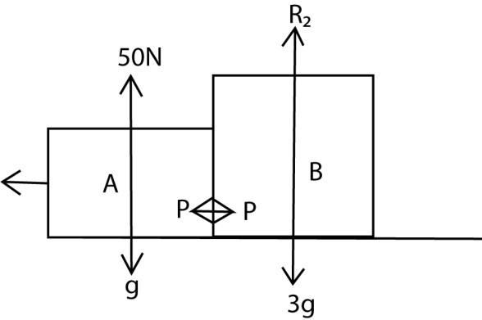

- F =ma 50 = (1+3)a

Acceleration, a = 12.5ms⁻²

- Using A 50 – p = 1 x 12.5
p = 50 – 12 = 37.5N

Example 39
A light cord connects 2 objects of masses 10kg and 6kg respectively over a light frictionless pulley. Find the acceleration and tension in the cord.
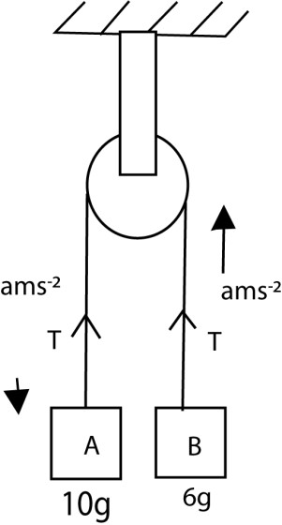
Body A
10g –T = 10a …………………………………….(i)

Body B
T – 6g = 6a ……………………………………. (ii)
Eqn (i) – eqn (ii) 4g = 16a a = 2.45ms⁻²
From equation (ii)
T = 6 x 2.45 + 6 x 9.81 = 73.6N

Example 40
Explain why the tension in a cable of a lift is different when the lift is accelerating upwards from when it is accelerating downwards.

Solution
The tension is greater when the lift is ascending because it has to overcome both the weight of the lift and the force due to its acceleration upwards.

Explanation
When the Lift is Ascending:
- Gravity's Force: The weight of the lift and its contents (passengers, cargo) create a downward force due to gravity. This force is equal to the mass (m) of the lift multiplied by the acceleration
due to gravity (g), resulting in a force
F=mg
- Upward Acceleration: When the lift ascends, it needs to overcome gravity and accelerate upwards. This requires an additional force. The total tension (T) in the cable must provide this extra force to achieve upward acceleration (a). Hence, the total tension is given by T=m(g+a)
When the Lift is Descending:
- Gravity's Force: Similar to ascending, the lift and its contents exert a downward force due to gravity, F=mg
- Downward Acceleration: When the lift descends, it accelerates downwards. However, the cable still needs to control this descent, effectively reducing the tension compared to when it is stationary or ascending. In this case, the
tension (T) in the cable is calculated as T=m(g−a)

Example 41
- Two particles of mass m1 and m2 are connected as shown below by a light inextensible string passing over a smooth fixed pulley. If m1>m2 show that the acceleration of the system is given by
a = g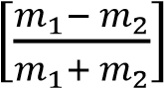
- Find the expression for the tension in the string
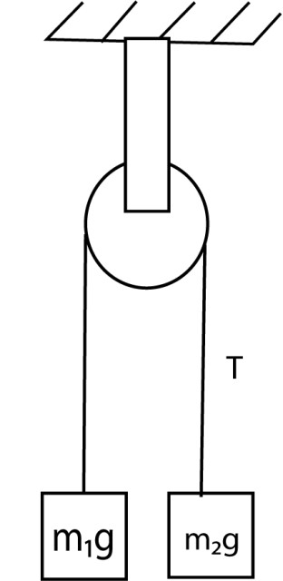
Body m₁
m₁g –T = m₁a ………………………………….(i)

Body m₂
T – m₂g = m₂a ………………………. (ii)
Eqn (i) – eqn (ii)
(m₁-m₂)g = (m₁ + m₂)a
a = g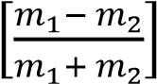

(b) From equation (ii)
T = m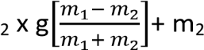g
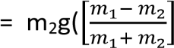 +1)
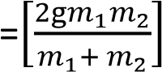

Example 42
A mass m₂ lies on a smooth table connected by a light inextensible string passing over a small smooth pulley at the table to a mass, m₁, hanging freely.
(a) What is the acceleration?

Solution
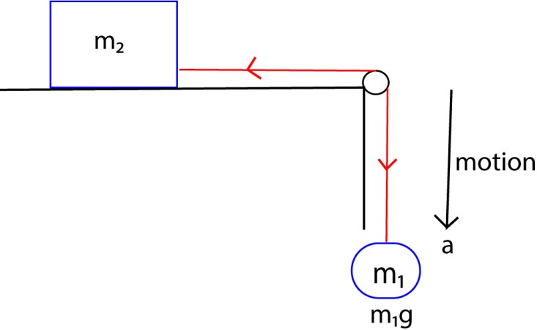

Body m₁
m₁g –T = m₁a ………………………………….(i)

Body m₂
T – 0 = m₂a …………………………………………. (ii)
Substitution Eqn (ii) into eqn (i) m₁g-m₂a = m₁a a = 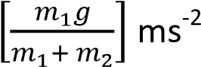
(b) Find the expression for the tension in the string From equation (ii)
T = m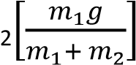
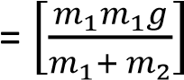

Example 43
The diagram below shows masses m₁, m₂ and m₃ connected by light inextensible string such that m₁ and m₃ hang vertically while m₂ lies on horizontal smooth surface with m₁ greater than m₃. Show that the acceleration due to gravity
a = g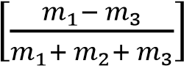

Solution
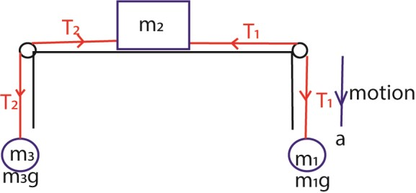

Body m₁ m₁g –T₁ = m₁a ………………………….(i)

Body m₃
T₂ – m₃g = m₃a ………………………. (ii)

Body m₂
T₁ – T₂ = m₂a …………………………. (iii)

Eqn (i) + Eqn (ii) + Eqn (iii) m₁a + m₂a + m₃a = m₁g –m₂g
a = g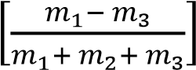

Motion of a particle on an incline
Let the mass of the particle be m and R be the normal reaction. If the plane makes an angle θ to the horizontal, then the forces which act on the body are shown below;
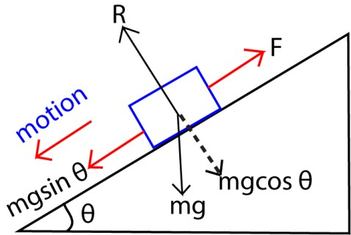
Motion of a particle on inclined
From the diagram
R = mgcosθ Result force = mgsinθ – F ma = mgsinθ – F if the system is at rest where a = 0
m(0) = mgsinθ –F F = mgsinθ

For example 44
A body of 3kg slides down a plane which is inclined at 30⁰ to the horizontal. Find the acceleration of the body if
- the plane is smooth

- there is a frictional resistance of 9N.

Solution
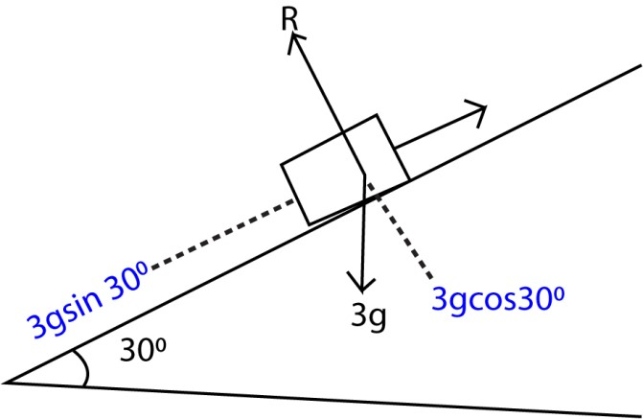
R is the normal reaction

(a) F = ma

3gsin 30⁰ = 3a
a = 4.9ms⁻²

b) F = 3g sin 30⁰ - 9 = 3a
a = 1.9ms⁻²

Note friction force acts in the opposite direction of motion.

Example 45
A body of mass 8kg is released from rest on a surface of a plane. If the resistance to the motion is 1N acting up the plane and the slope of the plane is 1 in 40. Calculate the acceleration of the body down the plane and the speed acquired in 6 seconds after the release if he resistance to the motion is N
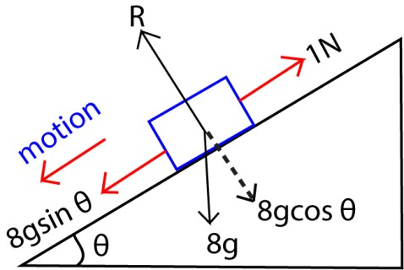

From ma = mgsinθ – friction
But sinθ = 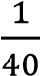
8a = 8 x 9.81 x 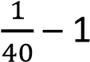
a = 0.12ms⁻²
Using v = u + at
= 0 + 0.12 x 6 =0.72ms⁻¹

Example 16
A block m₁ is connected to another m₂ by a light inextensible string which passes over as smooth pulley. If the inclined plane is smooth and m₂>m₁, show that the acceleration of the system is given by
a = 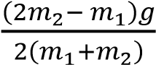
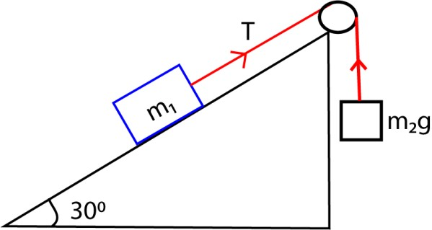
Since m₂>m₁, the acceleration a acts downwards Consider m₂ m₂a = m₂g –T ………………………. (i)
Consider m₁
M₁a = T – m₁gsin30
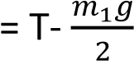 …………………… (ii)
Eqn (i) + Eqn (ii)
M₂a + m₁a = m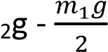
a(m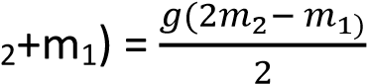
a = 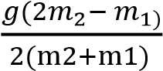

Exercise 6
- A body A rests on a smooth horizontal table. Two bodies of mass 2kg and 10kg hanging freely are attached to opposite ends of A by light inextensible strings which pass over smooth pulleys at the edges of the table. The two strings are taut when the system is released from rest; it accelerates at 2ms⁻². Find the
mass of A
[Answer 27.24kg]
- A rectangular block of mass 10kg is pulled from rest a long a smooth inclined plane by a light inelastic string which passes over a frictionless pulley and carries a mass of 20kg as shown below with the plane inclined at angle

of 30⁰ to the horizontal.
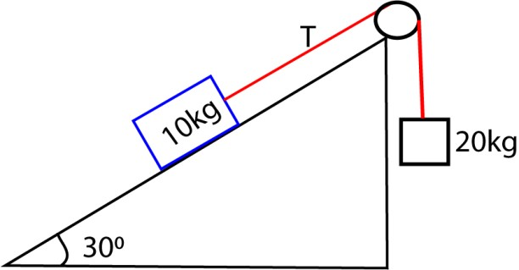
Find (i) the acceleration of the block
(ii) the tension, T, in the string
[Ans. A = 4.905ms⁻², T =98.1N

TOPIC 4/6: MOTION UNDER GRAVITY
Competency: The learner investigates the effect of force on bodies moving under gravity and

the applications of this phenomenon

Motion under gravity
In absence of any resistance, all bodies regardless of their mass fall with same acceleration near the earth’s surface.

Acceleration due to gravity is the rate of change of velocity for freely falling body and it is symbolized as g. g = 9.81ms² and it replaces “a” in equation of motion

For a body falling under gravity, g is positive and g is negative for the object moving upwards.

Example 1
A ball is thrown vertically upwards with initial speed 20ms⁻¹. After reaching the maximum height and on the way down it strikes a bird 10m above the ground.
- Calculate the highest point reached u = 20ms⁻¹, g = -9.8ms⁻¹, v = 0 from v² = u² + 2as
0 = 20² + 2 x -9.8 x s
The highest distance, s = 20.4m
- Calculate the speed at which it strike the bird u = 0, s = (20.4 -10) = 10.4m, g = 9.8ms⁻² From v² = u² + 2as v2 = 0² + 2 x 9.8 x 10.4
v = 14.3ms⁻¹

Example 2
A stone is thrown vertically upwards with a speed of 10ms⁻¹ from a building. If it takes 2.5 seconds to reach the ground, find the height of the building.
Solution
Please find free notes, tests and marking guides of physics, chemistry, biology and mathematics from:
digitalteachers.co.ug P a g e | 1

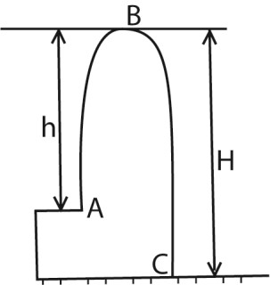
Time taken to move from A to B
v = u -at
0 = 10 – 9.81t; t = 1.02s Height, h
h = ut - ½ gt²
= 10 x 1.02 – ½ x 9.81 x (1.02)²
= 5.1m
Time taken from B to C = 2.5 – 1.02 =1.48s
Distance, H, u = 0, t = 1.48, g -9.81ms⁻²
H = 0 x 1.48 + ½ x 9.81 x 1.48²
= 10.7m
Height of the building = H – h
= 10.7-5.1
= 5.6m

Exercise
- A ball is thrown straight upwards with a speed ams⁻¹ from a point h m above the ground. Show that
time t ground is
t = 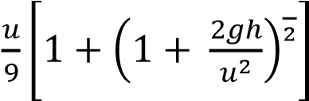
- A motorist travelling at a constant speed of 50 kmh¹ passes a motorcyclist just starting off in the same direction. If the motorcyclists maintains a constant acceleration of 2.8ms⁻² calculate;
- Time taken by motorcyclist to catch up with the motorist.
[9.9s]
- The speed at which the motorcyclist overtakes the motorist. [27.72ms⁻¹]
- The distance travelled by the motorcyclists before overtaking. [137.2m]

3. A stone is thrown vertically upwards from a point at a height, h, above the ground level and initial velocity 20ms⁻¹. If the stone, hits the ground, 5s later; find h
[22.625m]

Projectile
A projectile is anything which is given an initial velocity and left to move on its own in the presence of a constant force field, e.g. gravitation force field. In this case, air resistance is negligible.
Consider a body projected with a speed u at an angle θ to the horizontal
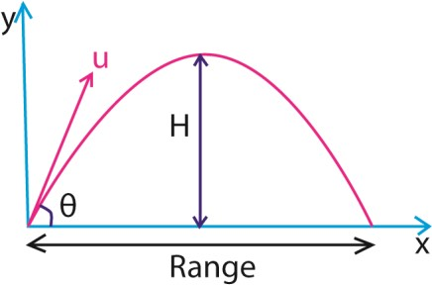
θ = angle of project A –point of projection
H- maximum height of projection
AB –range

The projection has both vertical and horizontal component which are independent of each other. the acceleration due to gravity for the vertical component is g while that of the horizontal component is zero, that is, the horizontal velocity is constant.

Terminology
- Angle of projection is the angle between the direction of the projection and the horizontal.
- Trajectory is the path followed by a projectile
- Maximum height, H, is the distance between the highest point reached and the horizontal plane through the point of projection.
- Time of flight (T) is the time taken by the projectile or particle to move from its initial position to the final position along its path.
- Horizontal range is the distance from the initial to the final position of projection.

Horizontal motion

Horizontal component of velocity is got
by

vx = ux + axt .
Where v_{x}, is the velocity of a body at any time t, while ux and ax are the initial component of velocity and horizontal acceleration respectively.
But ux = ucos, since ax =0

Hence vx = ucosθ
From the above equation

the horizontal velocity is constant throughout motion. The horizontal distance, x, travelled after time t is given by
x = u_{x}t + ½ at²

But ax =0 x = u_{x}t
x= utcosθ

Vertical motion
Time to reach the maximum heights

Using v = u + at

0 =u_{y} + a y t 0 = u sinθ - gt
t 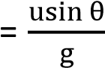

Time of flight, T

The time taken by the projectile to move from the point of projection to a point on the plane through the point of projection where the projection lies
i.e. time taken to move from A to B.

At B, y = 0

y = utsinθ -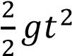
0 = 2utsinθ – gt²
0 = t(2usinθ –gt)
Either t =0 or T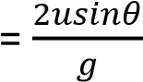
Note: time of flight is twice the time taken to reach the maximum height

Ranges , R:

It is the distance between the point of projection and a point on the plane through the point of projection where the projectile lands i.e. horizontal distance AB. x= ut cosθ When x= R, t = T =
R = u.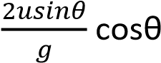
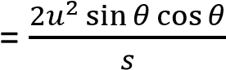

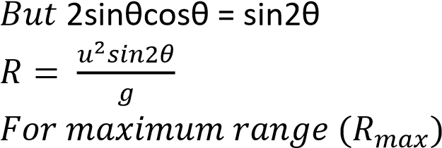
At R_{max}, θ = 45⁰ sin2θ = sin 90
Equation of trajectory
R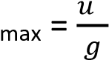

Consider a body project with a speed, u, from the ground and angle θ from horizontal.
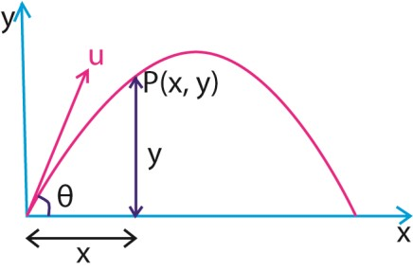

Suppose the body passes through a point P(x, y) after time, t.

Consider vertical motion

x = (ucos θ)t
t = 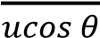
Consider vertical motion
y = (usin θ)t – ½ gt² Substituting for t
y = (usin θ)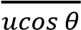 – ½ g(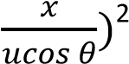
= xtanθ -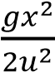 (1 + tan²θ)

Direction of motion
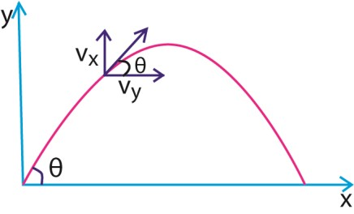
The direction of motion is determined by the direction of velocity of particles at any time, t. and its angle θ to which the velocity makes with the horizontal tan θ = 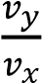
But v= u + at
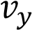 = usin -gt
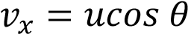
θ = tan⁻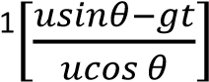
Magnitude of velocity, v=
√
[

]

Example 3
A particle is projected at 35⁰ to the horizontal and just clears a wall 12m high and 40m away from the point of projection. Find
- The speed of projection
- Velocity of particle when it strikes the wall and time taken to reach the wall.
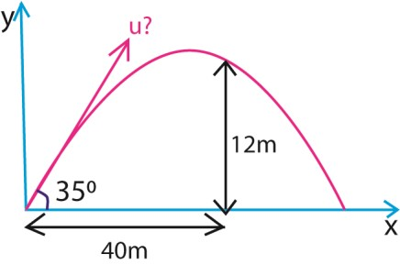
- From y = xtanθ -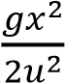 (1 + tan²θ)
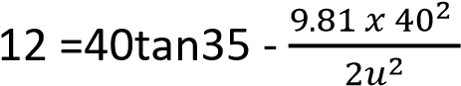(1 + tan² 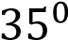)
  - = 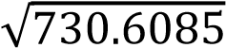 = 27.03ms⁻¹
- From t = 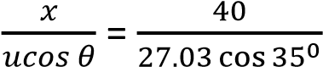
t = 1.8s

Velocity, v
From v=
√
[

]
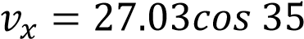
= 22.14ms⁻¹
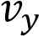 = 27.03sin 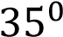 -9.81 x 1.8
= -2.658

  - =
√
[

]
= 22.3ms⁻¹

Example 4
A bullet is fired from a gun placed at a height of 200m with a velocity of 150ms⁻¹ at an angle of 30⁰. Find the
- Maximum height attained
- Time taken for the bullet to hit the ground
Solution
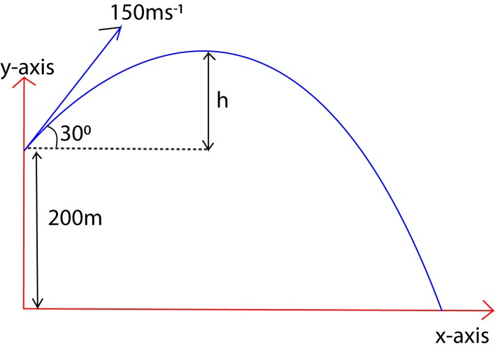
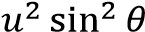
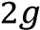

- From h = h =
= 286.7m
H = 200 + h
= 200 + 286.7
= 486.7m
- Let time taken be t
From y = (usin θ)t – ½ gt²
-200 = (150sin 30)t – ½ 9.81t²
t = 17.6s

Example 5
An object P is projected upwards from a height 60m above the ground from a height 60m above the ground with a velocity 20ms⁻¹ at 30⁰ to the horizontal, at the same time an object Q is projected from the ground upwards towards P at 30⁰ to the horizontal. P and Q collided at a height of 60m above the ground. Find
- The speed of projection of the object Q.
- The horizontal distance between the point of projection

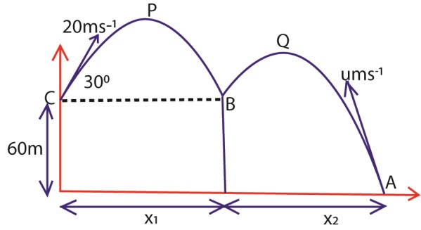
- Speed of Q
Time of flight A and B = time of flight from C to B
T =
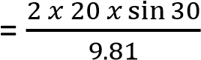
= 2.04s
Speed u of Q
From y = (usin θ)t – ½ gt²
60 = usin30 x 2.04 – ½ x 9.81x (2.04)² u = 78.84ms⁻¹
- Range x₁ =ucos30t
= 20 x cos 30 x 2.04
= 35.33m
Distance x₂ = 78.84 x cos 30 x 2.04
= 139.29m
Distance between the point of projection
= 139.29 + 35.33
= 174.62m

Example 6

Two foot ballers 120m apart standing facing each other, one kicks a ball from the ground such that the ball takes off at a velocity 30ms⁻¹ at 38⁰ to the horizontal. Find the speed at which the second footballer must run towards the first footballer in order to trap the ball as it touches the ground if he starts running at the instant the ball is kicked.
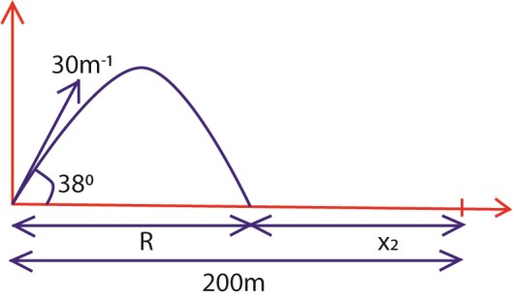
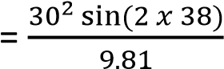

Range, R =

= 89.02m
Time T taken to cover distance, R,
T = 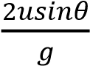
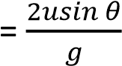
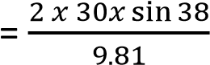
=3.77s
Distance x to be covered by the second footballer = 120 – R
= 120 – 89.02
= 30.98m
Speed =
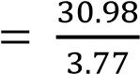
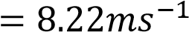

Exercise
- A projectile is fired horizontally from the top of a cliff 250m high. The projectile landed 1.414 x 103m from the bottom of the cliff. Find the (i) Initial speed [198.06ms⁻¹]
(ii) Velocity of the projectile just before it hits the ground.
[210.03ms⁻¹]
- (a) Define the term of flight and range as applied to the projectile motion.
  - A projectile is fired in air with a speed u ms-1 at an angle θ to the horizontal. Find the time of flight of the projectile.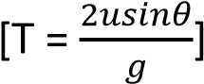
- (a) Define the term of flight and range as applied to the projectile motion.
  - A stone is projected at an angle 200 to the horizontal and just clears a wall which is 10m high and 30m from the point of projection. Find the
    - speed of projection [73.75ms⁻¹]
    - Angle at which the stone makes with the horizontal at it clears the wall.[16.84⁰]
- Prove that the time of flight T and the horizontal range, R, of a projectile are connected by equation, gT² = 2Ttan α. Where α is the angle of projections.
- A projectile is fired from ground level with a velocity of 500ms⁻¹ at 30⁰ to the horizontal. Find the horizontal range, the greatest height to which it rises and time taken to reach the greatest height. What is the least speed with which it could be projected in order to achieve the same horizontal range? [Range = 22069.96m, H = 3185.m, u_{min} =465,3ms⁻¹]
- A body is thrown from the top of a tower 30.4m high with a velocity of 24ms⁻¹ at an elevation of 300 above the horizontal. Find the horizontal

distance from the roof of the tower [ u = 19.39ms⁻¹] of the point where it hits the 9. An object P is projected upwards
ground. [61.1m] from a height of 60m above the
- A body is projected at such an angle ground with a velocity of 20ms⁻¹ at that the horizontal range is three 30⁰ to horizontal. P and Q collide at times the greatest height. Given that a height 60m above the ground the range is 400m, fins the while they are both moving necessary velocity of projection and downward. Find angle of projection. (i) The speed of projection Q.
[velocity = 64ms⁻¹, angle = 53.13⁰] [78.84ms⁻¹]
- A projectile fire at an angle of 60⁰ (ii) The horizontal distance above the horizontal trikes a between the points of building 30 away at a point 5m projection [174.62m]
above the point of projection. Find (iii) The kinetic energy of P (i) The speed of projection. before the collision with Q if
[time = 3.094s] the mass of P is 0.5kg
(ii) Velocity of the projectile
when it strikes the building.

TOPIC 5/6: WORK, ENERGY AND POWER
Competency: The learner investigates the resources and transformations of energy in the environment in order to ensure sustainable and improved efficiency of energy utilisation.

Work, power, energy
Work is the product of force and distance moved. This distance must be in the direction of the force. Consider a body of mass, M, being pulled on a smooth horizontal table by a force F through a distance, s.
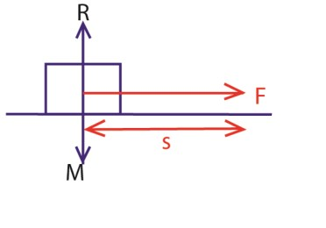
Work done = (F x s) joules When a body is moved and the force acts at an angle θ to the horizontal as shown below. Assuming the flow is smooth
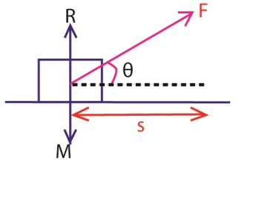
Work = Fcosθ joules

Work is a scalar quantity and its units are joules.

A joule is the work done when a force of 1N moves a distance of 1m in the direction of force from the point of application of force.

Example 1
A car of mass 1000kg moving on a rough horizontal surface is brought to rest in a distance of 10m by steady application of brakes. If the coefficient of sliding frictional force between the surface and the tyres is 0.4, calculate the work done by the frictional force.

Solution
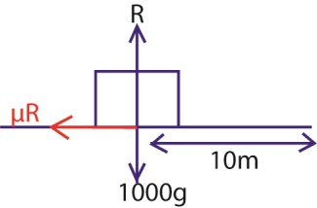

Work done = f x s
But f = μR
R = 1000 x g f = 0.4 x 1000 x 9.81 = 3934N
w = 3934 x 10 = 39,240J

Energy
This is the ability to do work. The S.I units of energy are joule. There are various forms of energy which include the following
- Mechanical energy
- Light energy
- Chemical energy
- Heat energy - Tidal energy
- Magnetic energy

Mechanical energy
This type of energy is divided into two forms potential and kinetic energy.

Kinetic energy
This is the energy possessed by a body by virtue of its motion.

Suppose a constant force F, acts on the body of mass m, which is initially at rest on a smooth horizontal surface and moves distance, s. But F =ma But v 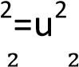+ 2as as = 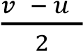
work = mas = m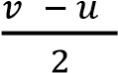
if u = 0 (initially at rest)
Work done = 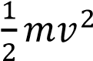
The quantity ½ mv² is called kinetic energy of the body of mass m moving with velocity v with zero initial velocity.

For a body with initial velocity u.
Work done = m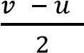
The above expression is called the work energy theorem which states that the work done by an external force is equal to the change in kinetic energy of the body.

Potential energy
This is the energy possessed by a body by virtue of its position.

Potential energy is divided into

Gravitation potential energy
This is the energy possessed by a body by virtue of its position in the gravitational field.

Consider a body of mass m raised from the ground at a position which is at a height, h, above the ground.

Work done against gravity = mgh and this gives the expression for gravitation potential energy.

Elastic potential energy This is the energy possessed by a body when stretched or compressed.

Consider a material with elastic constant, k, which is stretched or compressed by amount, x.
Elastic potential energy = 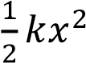

Principle of conservation of mechanical energy
In any mechanical system, mechanical energy is conserved provided there is no
dissipative force acting on the system

Dissipative forces are forces whereby work done against them cannot be recovered e.g. frictional force, air resistance, and viscous drag.

Proof of the principle of conservation of mechanical energy
Suppose, a body of mass, m, is projected vertically upwards with a speed, u, from the ground up to a height, h, and at that point the velocity of the body is v.
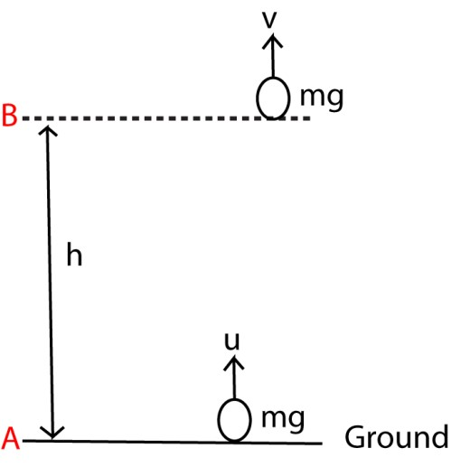

Solution
At A, potential energy = mg(0) = 0
Kinetic energy = 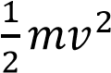
Total mechanical energy
= Kinetic energy + potential energy
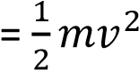+ 0
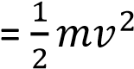 ………………………………….………...(i)
At B, potential energy = mgh
If the velocity at B is v From v² = u² +2as
v² = u² -2gh
Kinetic energy = 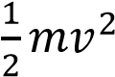
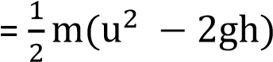
Total mechanical energy
= mgh +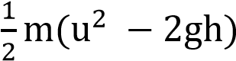
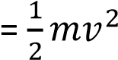 ……………………. (ii)

From (i) and (ii), the mechanical energy at A is equal to mechanical energy at B,
hence mechanical energy is conserved Principle of conservation of energy It state that energy can be changed from one form to another but is neither created nor destroyed.

Conservative force
This is one for which work done to the body from one point to another is independent of the path taken and only depends on initial and final positions of the body.

The work done to move a body round a closed path is zero and mechanical energy is conserved.

Examples include: gravitational force, electrostatic force, and elastic force.

Non conservative forces This is one for which the work is done
against such force moving the path taken

Work done to move a body around a closed path is not zero; mechanical energy is not conserved example include viscous drag, friction force, air resistance, etc.

Work done against gravity and friction When a block is pulled at a uniform speed up the surface of a rough incline plane, work is done both against gravity and against the frictional force which is acting on the body due to the contact with the rough surface of the plane.

Example 2
A rough surface is inclined at tan⁻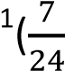) to the horizontal, a body of mass 5kg on the surface and is pulled at uniform speed, a distance of 75cm up the surface by a force acting along a line of greatest slope. The coefficient of friction between the body
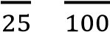
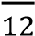
and the surface is . Find 10 second until its speed is 18kmh⁻¹. If the
(a) The work done against gravity resistance to motion is 49N, find the (b) The work done against friction power of the car 10 seconds after the
(c) Total work done ^{start.}

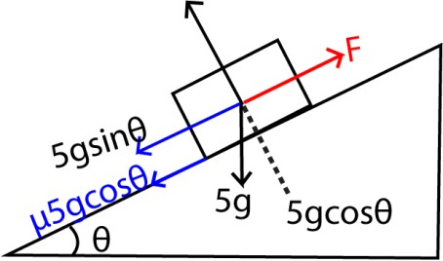
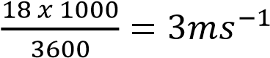
Solution Solution

v =
v = u + at 5 = 0 + 10a
a = 0.5ms⁻¹
ma = F- friction force
750 x 0.5 = F – 49
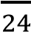
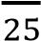
tan θ = , cosθ = , sin θ = F = 424N
But P = Fv = 5 x 424 = 2120 watts
Work done against gravity
= mgsinθ x d ^{Example 4}
A truck of mass 1500kg moves with
= 5 x 9.81 x x ₋₁
= 10.3J
Work done against friction
= μR 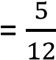 x 5 x 9.81 x 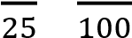 x
= 14.72J
Total work done = (10.3 + 14.72)J
= 25.02J

Power
This is the rate of doing work or the rate of change of energy.

Power = 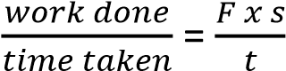 = Fv

Thus, power is proportional to velocity

The S.I units of power are Js⁻¹ or watts

A watt is the rate of transfer of energy at 1 joule per second.

Example 3
A car of mass 750kg stats from rest to a level road and is uniformly accelerated for uniform velocity of 5.0ms up a straight track inclined at an angle 300 to the horizontal. The total frictional resistance to the motion of the truck is 580N.
Calculate
- The power developed by the engine
- If the engine of the track in (i) above cannot develop a power than 75kW. Calculate the maximum speed attained by the track.
Solution

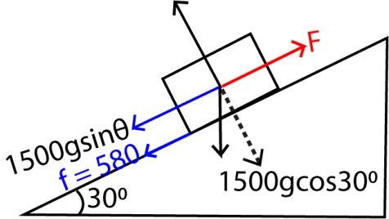

ma = F – (mgsinθ +f)
since the velocity is uniform, a = 0

T = 1500gsin 30 + 580 = 7637.5N

But P = Fv = 5 x 7637.5 = 39687.5W

(ii) P_{max} = Tv_{max}
v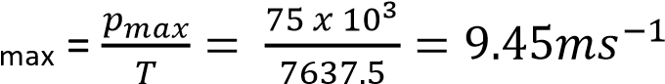

Example 5
A block of mass 6.0kg is projected with v=12ms⁻¹ up a rough plane inclined 45⁰ to the horizontal. If it travels 5m up the plane. Find the frictional force and the coefficient of friction.

Solution
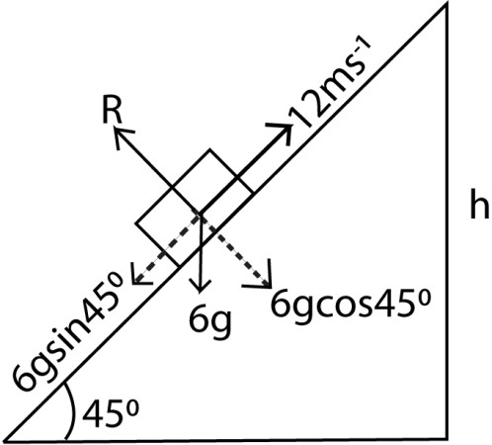

K.E lost = P.E gained + Work done against friction
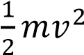 = mgh + fd
But sin 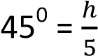
h = 5sin45⁰

⇨ 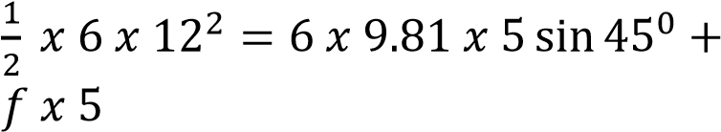
f = 44.8N But f = μR μ =

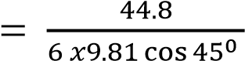
= 1.1

Example 6
A block of mass 3.95kg rests on a smooth horizontal surface. The wooden block is attached to light spring of force constant 100Nm⁻¹, whose other end is fixed. A bullet of mass, 0.02kg is fired into the block embedded itself and the spring is compressed by 0.4m. Find the velocity of the bulled just before it hits the block.

Solution
By conservation of mechanical energy
K.E after collision = elastic potential energy
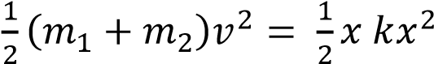

v = 2ms⁻¹
From the principle of conservation of
momentum
m₁u₁ + m₂u₂ = v(m₁ + m₂) 0.02u₁ + 3.98 x 0 = 2(0.02 + 3.98)
u₁ = 400ms⁻¹
therefore the velocity of the bullet before hitting the mass = 400ms⁻¹.

Ballistic pendulum
Consider a bullet of mass, m, travelling with initial velocity, u, being fired horizontally into a stationary block of mass m which is suspended by light vertical string of length, L. If v is the common velocity of the block and bullet just after collision, the following can be noted.

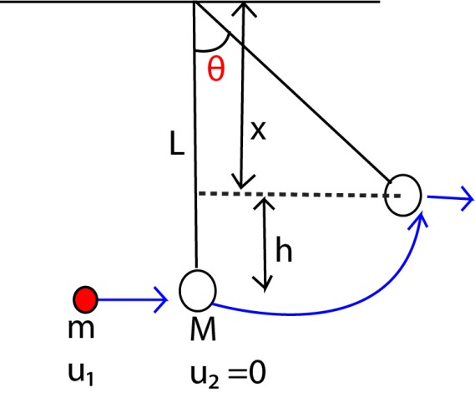
By conservation of momentum mu₁ + M x 0 = (m+ M)v
u = 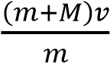
K. E after collision = P.E after collision

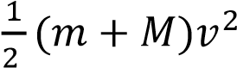 = (m + M)gh
v² = 2gh ……………………… (i) but cos θ =
x = Lcos θ
and h = L-Lcos θ = L(1-cosθ)…………………(ii)
substituting h in (i)
v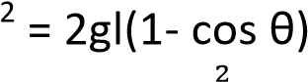
cos θ = 1 -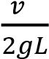
or
θ = cos⁻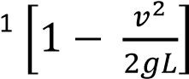

Example 7
A bullet of mass 10g travelling horizontally at 100ms⁻¹ embeds itself in a block of mass 990g suspended by a string so that is can swing vertically. Find the height through which the block can rise.
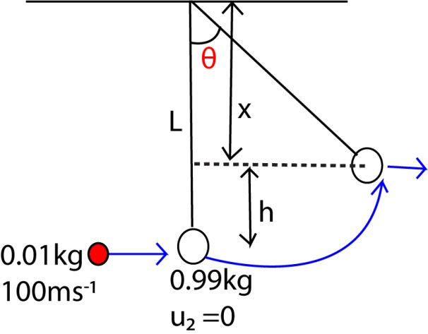
By conservation of momentum mu₁ + Mu₂= (m+ M)v
0.01 x 100 + 0.99 x 0 = (0.01 + 0.99)v v = 1ms⁻¹
From v² = 2gh
h = 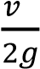
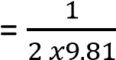
= 0.05m

Example 8
- distinguish between conservative and non-conservative forces
- A bullet of mass 40g is fired from at 200ms⁻¹ and hits a block of mass 2kg which is suspended by a light vertical string 2m long. If the bullet gets embedded in the wooded block;
calculate
  - the maximum angle the string makes with the vertical
  - State a factor on which the angle of swing depends.

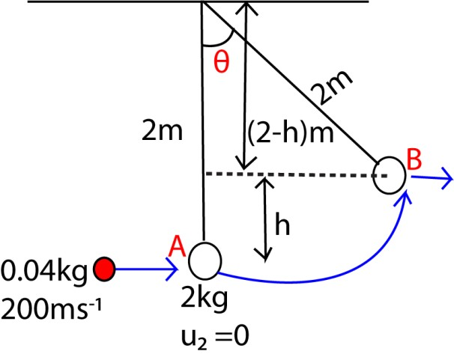
By conservation of momentum mu₁ + Mu₂= (m+ M)v
0.04x 200 + 2 x 0 = (0.04 + 2)v v = 3.92ms⁻¹
From v 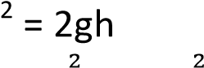 h = 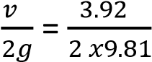= 0.784m
But, cos θ = 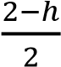
θ = 52.5⁰
(ii) – speed of the bullet
    - Mass of the block
    - Length of the string
    - Air resistance

The structure and the energy production process of the Sun and its implication to life

on Earth
The Sun is a massive sphere of hot gases, structured in distinct layers, and it produces energy through nuclear fusion in its core. This energy sustains life on Earth by providing light, warmth, and driving ecosystems.

Structure of the Sun
The Sun is composed mainly of hydrogen (about 74%) and helium (about 24%), with trace elements. Its structure is divided into several layers:
- Core o Innermost region, about 25% of the Sun’s radius.
  - Temperature reaches ~15 million °C.
  - Site of nuclear fusion, where hydrogen nuclei fuse into helium, releasing enormous energy.
- Radiative Zone o Surrounds the core.
  - Energy moves outward as radiation (photons).
  - Photons can take thousands to millions of years to escape due to dense plasma.
- Convective Zone o Outer layer of the Sun’s interior. o Energy is transported by convection currents—hot plasma rises, cooler plasma sinks.
  - This creates the dynamic surface
activity we observe.
- Photosphere
  - The visible “surface” of the Sun. o Temperature ~5,500 °C.
  - Emits the sunlight we see.
- Chromosphere & Corona
    - Outer atmospheric layers. o Corona extends millions of kilometers into space, with temperatures reaching millions of degrees.
    - Source of solar wind.

⚡ Energy Production Process
- The Sun’s energy comes from nuclear fusion in the core.
- Specifically, the proton-proton chain reaction:
o Four hydrogen nuclei (protons) fuse to form one helium nucleus. o This releases energy in the form of gamma rays, neutrinos, and kinetic energy.
- The released energy gradually travels outward through radiation and convection, eventually escaping as sunlight.

Implications for Life on Earth
- Light & Heat: Essential for photosynthesis, climate regulation, and sustaining ecosystems.
- Solar Energy: Drives weather patterns, ocean currents, and the water cycle. • Habitability: Earth’s position in the “habitable zone” ensures temperatures suitable for liquid water.
- Renewable Power: Humans harness solar radiation for electricity and heating.
- Risks: Solar storms and radiation can disrupt satellites, communications, and power grids, reminding us of our dependence on the Sun.
Renewable energy
In short, the Sun’s layered structure ensures stability, while its fusion process powers life on Earth. Without this constant energy supply, Earth would be a frozen, lifeless rock drifting in space.

Renewable energy is power derived from natural sources that replenish themselves over time, such as sunlight, wind, water, and geothermal heat.

Types of Renewable Energy
- Solar Energy: Captures sunlight using photovoltaic cells to generate electricity.
- Wind Energy: Uses turbines to convert wind movement into electrical power.
- Hydropower: Harnesses the energy of flowing water, often through dams.
- Geothermal Energy: Utilizes heat from beneath the Earth's surface.
- Biomass Energy: Converts organic materials like wood, crops, and waste into fuel.
Non-renewable energy comes from sources that cannot be replenished within a human lifetime. These resources are finite and will eventually run out, making them less sustainable than renewable alternatives.

Types of Non-Renewable Energy
- Fossil Fuels: Includes coal, crude oil, and natural gas, formed over millions of years from decomposed organic matter.
- Nuclear Fuels: Uranium and plutonium are used in nuclear reactors to generate electricity.

Operation of solar thermal technologies
Solar thermal technologies work by capturing sunlight and converting it into heat, which is then used directly for heating or indirectly to generate electricity.

How Solar Thermal Technologies Operate
Solar thermal systems rely on three coordinated components: collectors, heat transfer, and storage.
• Solar Collectors o Devices with absorber surfaces that capture solar radiation.

o They convert short-wave sunlight
into long-wave infrared radiation, trapping heat (similar to the greenhouse effect).
o Types include flat-plate collectors, evacuated tube collectors, and concentrating mirrors.
- Heat Transfer Fluid o A liquid (often water, oil, or molten salt) circulates through the collector. o It absorbs the heat and transports it to where it’s needed.
o In power plants, this fluid drives
turbines to generate electricity.
- Thermal Storage o Heat can be stored in insulated tanks or molten salt reservoirs. o This allows energy use even when the Sun isn’t shining (e.g., at night or on cloudy days).

Types of Solar Thermal Systems
Solar thermal technologies are categorized by operating temperature:
Type | Temperature Range | Main Uses
Lowtemperature (<65 °C) | Domestic hot water, space heating | Homes, swimming pools
Mediumtemperature (100–300 °C) | Industrial heating, cooling | Factories, commercial buildings
Hightemperature  (>500 °C) | Electricity generation | Solar thermal power plants

Applications
- Electricity Generation: Concentrated solar power (CSP) plants use mirrors to focus sunlight, heating fluids to drive turbines.
- Domestic Heating: Rooftop collectors provide hot water and heating for households.
- Industrial Use: Provides process heat for manufacturing, food processing, and desalination.
- Mechanical Energy: Can power engines like Stirling engines for specialized applications.

Implications for Sustainability
- Renewable & Clean: Reduces reliance on fossil fuels, cutting greenhouse gas emissions.
- Scalable: Works for small household systems or large-scale power plants.
- Energy Security: Thermal storage ensures stable supply even when sunlight is intermittent

Operation of solar photovoltaic (PV) systems
Solar photovoltaic (PV) systems operate by converting sunlight directly into electricity using semiconductor materials, typically silicon. The electricity produced is managed through inverters, storage, and distribution systems to power homes, businesses, or feed into the grid.

Core Operation of PV Systems
- Photovoltaic Effect o When sunlight strikes a PV cell, photons excite electrons in the semiconductor material.
  - This creates an electric current as electrons flow through an external circuit.
  - The basic unit is the solar cell, grouped into modules (panels) and then into arrays for larger systems.
- Direct Current (DC) Output o PV cells generate electricity in the form of DC power.
  - Since most appliances and grids use AC power, conversion is necessary.
- Inverter System o A DC–AC inverter converts the electricity into usable alternating current.
  - Advanced inverters also manage grid synchronization, safety shutoffs, and efficiency optimization.

Components of a PV System
- PV Array: Collection of panels that capture sunlight.
- Inverter: Converts DC to AC.
- Battery Bank (optional): Stores excess electricity for use at night or during outages.
- Charge Controller: Regulates voltage/current to protect batteries.
- Monitoring & Control Systems: Track performance, detect faults, and optimize energy flow.

Types of PV Systems
System Type | Operation | Use Case
Gridtied | Connected to  utility grid; excess power exported | Homes, businesses
Off-grid | Uses batteries;  independent of  grid | Remote  areas, cabins
Hybrid | Combines grid connection with storage | Reliable backup + efficiency

Implications for Energy & Sustainability
- Clean Energy: No greenhouse gas emissions during operation.
- Scalability: Works for small rooftop setups or large solar farms.
- Energy Independence: Reduces reliance on fossil fuels and centralized grids.

TOPIC 6/6: SOLID FRICTION
Competency: The learner investigates factors that determine solid friction and its effect on static and dynamic systems, and uses this concept to model efficient systems with minimised

friction.

Frictions
Friction is the forces which oppose the relative motion of two surfaces in contact.
The direction of the friction force is opposite to the direction of motion of the body.
Types of friction
There are 2 types of friction i.e.
- Static friction
- Kinetic friction / sliding friction

Static friction opposes the tendency of one body sliding over the other. Kinetic/sliding/dynamic friction opposes the sliding of one body over the other.
Limiting friction is the maximum friction between on two surfaces.
Laws of solid Friction
- The frictional force between two surfaces opposes their relative motion.
- The frictional force is independent of the area of contact of the given surface when the normal reaction is constant.
- The limiting frictional force is proportional to the normal reaction for case of static friction. The frictional force is proportional to the normal reaction for the case of kinetic (dynamic) friction and is independent of the relative velocity of the surfaces

Molecular Theory and the laws of solid friction

- For any two solid surfaces in contact, there are small humps and hollows that form contact points a, b c ……
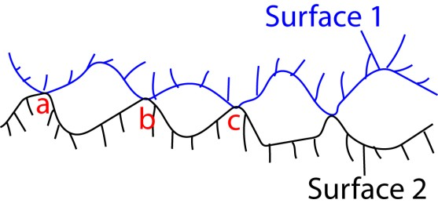
- Therefore, the actual area of contact is indeed small which creates very high pressure at the points of contact.
- This pushes the molecules very close that the forces of attraction between them weld the surfaces at these points.
- Thus, a force that opposes motion in any direction is created.

Coefficient of static friction Coefficient of limiting friction is proportional to the normal reaction or it
weight. i.e.,

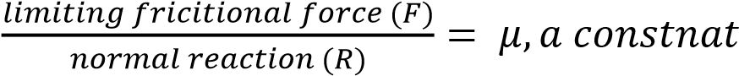

μ is known as the coefficient of friction between the two surfaces. The magnitude of μ depends on the nature of the two surfaces; for example it is about 0.2 to 0.5 for wood on wood, and about
0.2 to 0.6 for wood on metals.

Measurement of coefficient of static friction, µs

Method 1: Using a tilting plane.

A block A is placed on a plane and the plane is tilted until when the block begins to slide. The angle of θ of inclination of the plane surface to the horizontal is measured.
The co-efficient of friction is given by
µ_{s} = tan θ

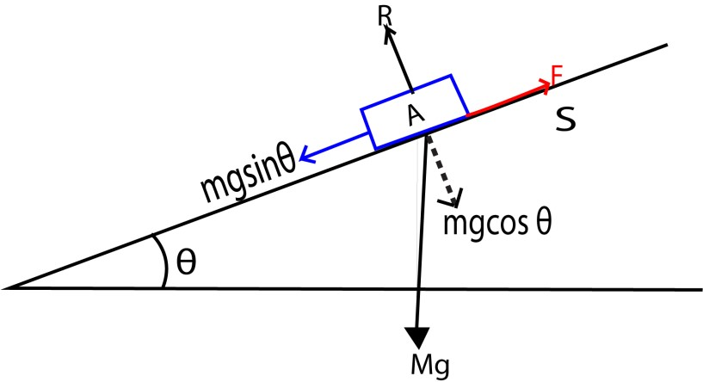

When the block is at the point of sliding
Fr = Wsinθ ………….(i)
R = Wcosθ…………..(ii)
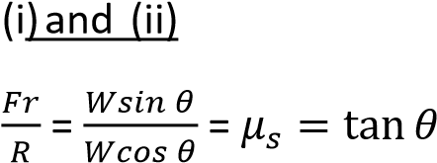

Method 2: To determine the co-efficient of static friction.
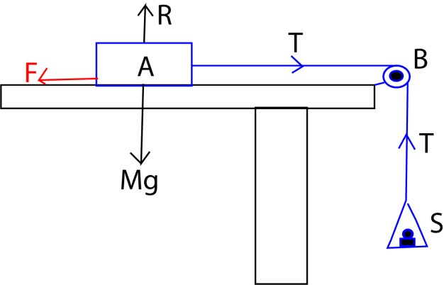

Masses are added to the scale pan until the block just slides. The total mass m of the scale pan and masses added is noted. The procedures are repeated for different values of R obtained by adding known weights to the block.

A graph of mg against R(Mg) is plotted.
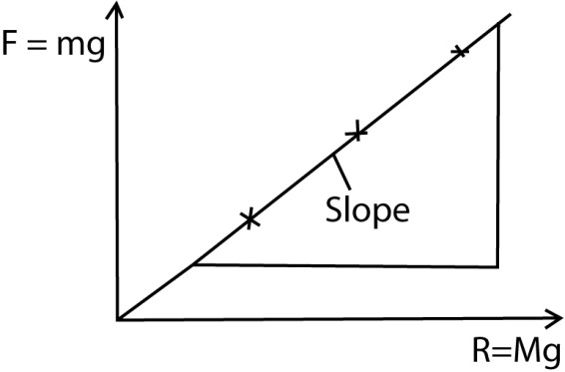
The slope of the graph is µs

Co-efficient of kinetic (dynamic friction)
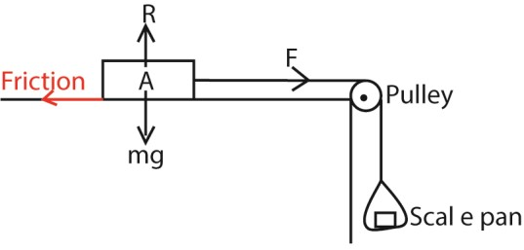
- A block A of mass m is placed on a flat table and connected to a scale pan as shown in the diagram above.
- Weights are added to the scale-pan, and each time A is given a slight push.
- At one stage A continues to move with a constant velocity.
- The coefficient of kinetic friction, μ =
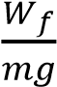; where W_{f} = weight of the scale pan plus added weights.
Advantage of friction
- Used in writing
- Used in lighting match stick - Used in walking
- Gripping objects
- Generating heat by rubbing hands
- Car brakes
Disadvantage of friction - Wears machines
- Wears shoes
- Causes unnecessary noise in moving parts of machines.
- Overheating in moving parts of machines
- Fire risks

Examples 1

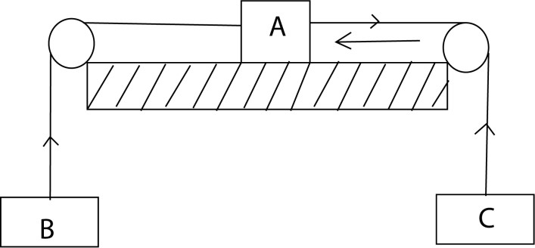

A, B, C are particles with masses 7, 5, 2kg respectively. when the system is released from rest with coefficient of friction 1/5.

Find
- Acceleration of the system
- Tension of the strings
- Distance moved by B after 4s
Solution
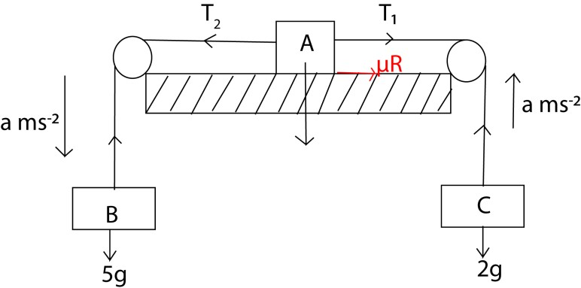
- Consider B
5a = 5g – T₂ ……………..(i)
Consider C
2a = T₁ -2g………………………… (ii)
Consider A
7a = T₂ – (T₁+ μR)
But R = 7g
7a = T₂ – T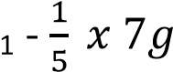 ……….. (iii)
Eqn (i) + Eqn (ii) + Eqn (iii)
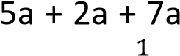 = 5g – T₁ + T₂ – 2g
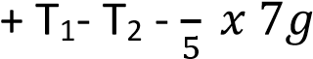
14a = 1.6g
a = 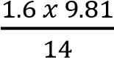 = 1.12ms⁻²
- From (i)
5a = 5g – T₂
5 x 1.12 = 5 x 9.81 – T₂
T₂ = 43.45N
From (ii)
2a = T₁ -2g
2 x 1.12 = T₁ – 2g
T1 = 21.86N
- s = ut + 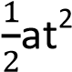
s = 0 x 4 + 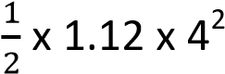
= 8.96m

Example2
A tractor of mass 2000kg is used to pull a car of mass 1000kg to which it is connected by a chain whose mass is neglected. The tractor pulling steadily moves the car from rest along a horizontal road through a distance of 12,5m in 5s. The coefficient of kinetic friction between the tyres of the tractor and the road is 0.4 and that between the tyres of the car and the road is 0.2.
Find the pull exerted by the tractor’s engine.
Solution

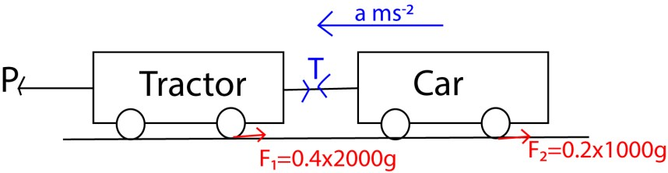
Consider motion of the tractor
2000a = P - (T + F₁)
= P – T- 0.4 x 2000 x 9.81
= P – T – 7848 ………………………(i)
Consider motion of the car
1000a = T – F₂
= T – 0.2 x 1000 x 9.81
= T – 1962 ………………….…….. (ii)
Eqn. (i) + Eqn. (ii)
3000a = P – 9810
From s = ut + 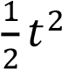
12.5 = 0 x 5 + x 5 x 5 a = 1ms⁻² thus,
P = 3000 x1 + 9810 = 12810N

Example 3
A body of mass 5kg is at rest on a rough horizontal plane of coefficient of friction of 0.6. A force of 20 N at 30⁰ above the horizontal is applied on the body. Find
- normal reaction
- frictional force exerted by the floor on the body.
Solution
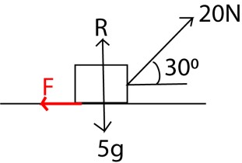

- Resolving vertically R + 20sin 30⁰ = 5g
R = 5 x 9.81 – 10 = 39.05N
- F = μR = 0.6 39.05 = 23.43N

Motion on an inclined plane
- When a body is moving down the slope
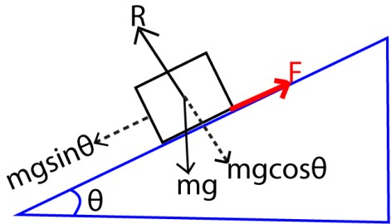
Resulting force = mgsinθ –F ma = mgsinθ –F but F = μR and R = mgcosθ
  - ma = mgsinθ –μcosθ a = g(sinθ –μcosθ)

- when the body is moving up the slope
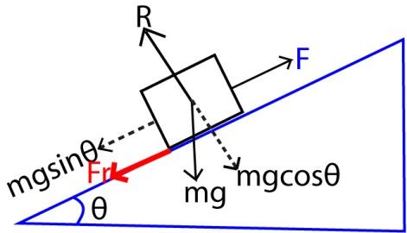
Resultant force = F + mgsinθ ma = mgsinθ + F but F = μR and R = mgcosθ
  - ma = mgsinθ +μcosθ a = g(sinθ + μcosθ)

Example 4
A car of mass 0.25 x 10³kg and a tractive pull of 3450N climbs a truck which is inclined at 32⁰ to the horizontal. The velocity of the car at the bottom of the inclined plane is 27ms⁻¹ and the coefficient of friction between the plane and the car tyres is 0.25. Calculate
- distance travelled along the inclined before the car comes to rest.
- Time taken before the car comes to rest

Solution
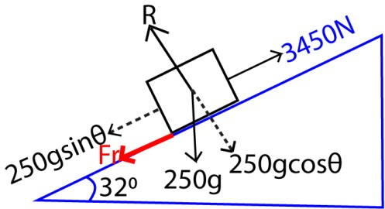
(a) From ma = F – (f + mgsinθ), f = μR = μmgcos32⁰
250a = 3450 – (0.25 x 250x 9.81cos
32⁰ + 250x 9.81sin32⁰) a = 6.52ms⁻²
From v² = u² -2as 0 = 27²-2 x 6.52s s = 55.9m from v = u – at 0 = 27 – 6.52t t = 4.15s

Methods for reducing friction
- Lubrication: Applying a lubricant like oil, grease, or graphite between surfaces creates a film that separates them, reducing friction.
- Polishing surfaces: Smoothing rough surfaces through polishing or other treatments reduces the interlocking of microscopic irregularities, which lowers friction.
- Using ball bearings or rollers: Placing ball bearings or rollers between moving parts converts high-friction sliding motion into much lower-friction rolling motion.
- Streamlining: Shaping objects like cars, airplanes, and boats with a streamlined design reduces drag, which is a form of friction caused by air or water.
- Using low-friction materials: Employing materials with a naturally low coefficient of friction, such as Teflon, can significantly reduce friction.
of contact.

- Reducing contact area: Decreasing the contact area between surfaces can also reduce friction, for example, by using sharp objects that have a smaller point

Exercise

- A car of mass 200kg moving along a straight road at a speed of 96kmh⁻¹ is brought to rest by steady application of the brakes in a distance of 80m. Find the co-efficient of kinetic friction between the tires and the road.
*hint ma = μmg; μ=0.45+
- A car of mass 1.5 x 10³kg and tractive pull 3.5x10³N climbs a truck which is inclined at an angle of 30⁰ to the horizontal. The speed of the car at the bottom of the incline is 20ms⁻¹ and the coefficient of sliding friction is 0.25,
calculate

  - The distance travelled along the
incline before the car comes to a
halt.

  - The time taken travelling along the incline before the car comes to a
halt. [s = 42.6m, t = 4.26s]

- An old car of mass 1500kg and tractive pull 4000N climbs a tract which is inclined at an angle of 30⁰ to the horizontal. The velocity of the car at the bottom of the incline is
108kmh⁻¹ and the coefficient of sliding friction is 0.35.

  - Calculate the distance travelled along the incline before the car comes to a halt. [86.53m]
  - The time taken to travel
along the incline before the car comes to a halt. (5.77s)
- In an experiment to determine the coefficient of static friction between a block and a plane, a student placed the block on a wooded surface and tilted the surface until the block just began to move. He observed that this happened at an angle of inclination of the plane with the horizontal of 20⁰ and the block slid 100cm down the plane in 2s. Calculate the coefficient of static friction. [μ = 0.31+
- Two masses m₁ and m₂ rests on a rough faces of a double inclined plane and connected by a light inextensible string passing over a pulley at the top of the plane. If m1>m2, show that acceleration of the system a =
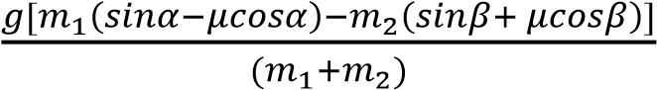, where
α and β are angles of inclination for plane on which m₁ and m₂ are place respectively
- (a) (i) State the laws of solid friction

(ii) With the aid of a well labeled diagram describe an experiment to determine the coefficient of kinetic of kinetic friction between the two surfaces.
  - A body slides down a rough plane at 30⁰ to the horizontal. If the coefficient of kinetic friction between the body and the plane is 0.4. Find the velocity after the body has travelled 6m along the plane.[4.2521ms⁻¹]
- (a)(i) State the laws of friction between solid surfaces
(ii) Explain the origin of friction force between two solid surfaces in contact. (iii) Describe an experiment to measure the coefficient of kinetic friction between two solid surfaces
  - (i) A car of mass 100kg moves along a straight surface with a speed of 20ms-1. When brakes are applied steadily, the car comes to rest after travelling 50m. Calculate the coefficient of friction between the surface and the tyres. *μ =0.4077+
(ii) State the energy changes which occur from the time the brakes are applied to the time to the time the car comes to rest.
[kinetic energy →heat → sound energy]
(c)(i) State the disadvantages of friction
[Wears tyres, produces unnecessary noise]
(ii) Give one method of reducing friction between solid surface.
[by lubrication]
- A block of mass 6.0kg is projected with a velocity of 12ms⁻¹ up a rough plane inclined at 45⁰ to the horizontal. It travels 5.0m up the plane. Find the frictional force. [44.8N]
- (a) state the laws of friction
  - A block of mass 5.0kg resting on the floor is given horizontal velocity of 5.0ms⁻¹ and comes to rest in a distance of 7.0m. Find the coefficient of kinetic friction between the block and the floor.
  - A car of mass 1500kg rolls from rest down a road inclined to the horizontal at an angle of 35⁰, through 50m. The car collides with another car of identical mass at the bottom of incline. If the two vehicles interlock on collision and coefficient of kinetic friction is 0.20, find the common velocity of the vehicles [v =
10.024ms⁻¹]

